United Nations Development Programme
PROJECT DOCUMENT

Project title: Building Partnerships to Assist Developing Countries to Minimize the Impacts from Aquatic Biofouling (GloFouling Partnerships)
Country: Global | Implementing Partner: International Maritime Organization (IMO) |  |  |  | Management Arrangements:  UN Agency implementation
UNDAF/Country Programme Outcome: N/A
UNDP Strategic Plan Output: 1.4.1 Solutions scaled-up for sustainable management of natural resources, including sustainable commodities and green and inclusive value chains
UNDP Social and Environmental Screening Category:  Risk: Low |  |  | UNDP Gender Marker: 2
Atlas Project ID (formerly Award ID): 00112296 |  |  | Atlas Output ID (formerly Project ID): 00110898
UNDP-GEF PIMS ID number: 5775 |  |  | GEF ID number: 9605
Planned start date: 01/09/2018 |  |  | Planned end date: 31/08/2023
PAC meeting date: 13 August 2018
Brief project description: This Project is an intervention at the global, regional and national levels, with the aim to develop best practices and build capacity in developing countries for implementing the IMO and other relevant guidelines for biofouling management and to catalyse overall reductions in the transboundary introduction of biofouling-mediated invasive aquatic species, with additional benefits in the reduction of GHG emissions from global shipping.
Financing Plan
GEF Trust Fund or LDCF or SCCF |  |  | USD 6,980,000
UNDP TRAC resources |  |  | USD
Cash co-financing to be administered by UNDP |  |  | USD
- Total Budget administered by UNDP |  |  | USD 6,980,000
Parallel co-financing
UNDP |  |  | USD 150,000
Government |  |  | USD 14,598,589
IMO |  |  | USD 4,945,815
Other stakeholders |  |  | USD 21,756,883
- Total co-financing |  |  | USD 41,451,287
- Grand-Total Project Financing (1)+(2) |  |  | USD 48,431,287
Signatures
Signature: print name below |  | Agreed by Implementing Partner |  | Date/Month/Year:
Signature: print name below |  | Agreed by UNDP |  | Date/Month/Year:

Executive Summary
Oceans cover 70% of our planet and, with nearly 50% of the world’s population living in coastal areas, the protection of the marine environment is beyond the scope or capacity of any single nation. The transfer of Invasive Aquatic Species (IAS) through biofouling is a global environmental problem which requires intervention at multiple levels.

Biofouling is described as the undesirable accumulation of microorganisms, algae, plants and animals on submerged structures (especially ships’ hulls). The introduction of IAS to new environments has been identified as a major threat to the world’s oceans and to the conservation of biodiversity. A multitude of marine species may survive to establish a reproductive population in the host environment, becoming invasive, out-competing native species and multiplying into pest proportions. Marine bio-invasions are the source of significant environmental and socioeconomic impacts that can affect fisheries, mariculture, coastal infrastructure and other development efforts, ultimately threatening livelihoods in coastal and inland communities.

Because of the technical, scientific, environmental and economic implications, the biofouling issue is one of the most complex pollution threats faced by countries and the global marine ecosystem. Furthermore, under the baseline scenario, rapid and effective implementation of any international guidelines could be severely restricted by a lack of capacity in developing countries. Therefore, it is anticipated that, without further technical cooperation and proper mobilization of existing resources, unilateral management efforts will go through an unnecessarily long process of implementation, leading to the proliferation of detrimental, and sometimes devastating, impacts on populations, the marine environment and aquatic biodiversity. Such a scenario would also result in diminishing the momentum generated by the GEF interventions to address other vectors for IAS transfer (such as the GEF-UNDP-IMO GloBallast Partnerships Programme).

Another root cause of the difficulty in fully and effectively stemming the spread of IAS through biofouling is the complex, multi-sectoral nature of biofouling sources, which makes it essential to tackle biofouling across the full range of anthropogenic structures in the marine environment. In addition to the problem of biofouling on ships, including fishing vessels, there are a growing number and variety of fixed surfaces in marine waters (e.g. oil and gas platforms, aquaculture nets, ocean energy equipment, etc.) that can provide the substrate for potentially invasive species to settle and grow in proximity to ships. These structures thus can serve as a source for organisms which can attach to a ship, with the organisms then transported to a location where they can become invasive. Furthermore, such structures are also capable of translocation between regions, resulting in the potential for transboundary introductions of IAS. Examples include Mobile Offshore Drilling Units (MODUs) which are regularly being moved across ocean basins and Large Marine Ecosystems (LMEs), and structures like aquaculture nets or cages being regularly moved domestically and regionally.

Using the Glo-X implementation model developed by the GEF, UNDP and IMO, the GloFouling Partnerships includes interventions at the global, regional, national and local levels. Based on its initial focus in 12 developing countries in 7 maritime regions, the Project will help develop global best practices and tools, and demonstrate practical ways of overcoming barriers for their implementation, creating and enabling an environment for technology development and transfer. It is expected that by the end of the project all participating countries will demonstrate significant improvement in their legal, policy and institutional structures, with corresponding reduced risks from IAS introduction through biofouling. Participating countries are also expected to lead the outreach to other countries in their region, with a view to harmonize biofouling management at the regional level. In addition to the Legal, Policy and Institutional Reform (LPIR), the GloFouling Partnerships will include a series of activities designed to partner with industry in pursuit of cost-effective technology solutions for biofouling management, catalysing investment and opportunities for North-South, South-South and Triangular cooperation.

Finally, measures related to the management of ships’ biofouling are expected to lead to reductions in fuel consumption by ships, thereby achieving consequential reductions in GHG emissions. In this regard, the project will act as a catalyst for the uptake of biofouling management measures and contribute to efforts that are underway by the maritime industry in fighting climate change.

Table of Contents
Table of Contents 4
Acronyms and Abbreviations 6
1. Development Challenge 8
1.1 Invasive Aquatic Species and biofouling: A Global Environmental Problem 8
1.2 Impacts associated with Invasive Aquatic Species and biofouling 11
1.2.1 Impacts on the marine environment 11
1.2.2 Impacts on tourism 11
1.2.3 Impacts on maritime and coastal property and infrastructure 12
1.2.4 Impacts on resources 13
1.2.5 Impacts on human health 14
1.3 Biofouling and Greenhouse Gas Emissions 14
1.4 Root causes and barriers that need to be addressed 17
1.5 Biofouling: The Baseline Scenario 19
1.5.1 Biofouling and IAS 19
1.5.2 Biofouling and GHG Emissions 21
1.6 The Alternative Scenario to be pursued by the GloFouling Partnerships Project 22
2. Strategy 25
2.1 Project Rationale and Policy Conformity 25
2.1.1 GEF focal areas supported 25
2.1.2 IMO 26
2.1.3 Convention on Biological Diversity 27
2.1.4 UN Sustainable Development Goals 28
2.2 GloFouling Partnerships Strategy 28
2.2.1 The LPIR process, the 4-tiered approach and the Glo-X implementation model 28
2.2.2 Global tier 30
2.2.3 Regional tier 31
2.2.4 National tier 33
2.2.5 Local tier 37
2.2.6 Public Private Partnerships (PPPs) and the cross-sectoral approach 37
2.3 Project objective and expected outcomes 39
2.4 Project Components, Outcomes, Outputs and Activities 42
Component 1 42
Component 2 46
Component 3 53
Component 4 56
Component 5 58
3. Risks and Sustainability 61
3.1 Risks and mitigation measures 61
3.2 Gender equality and empowering women 62
3.3 South-South and Triangular Cooperation (SSTrC) 62
3.4 Sustainability of Resources 63
3.5 Sustaining National and Regional Capacity 64
3.6 Scaling up and Replication 64
4. Project Governance and Management 65
4.1 Global Management Arrangements 65
4.1.1 Governing bodies 65
4.1.2 Project Coordination Unit (PCU) 66
4.1.3 Executing partners 66
4.2 National and Regional Management Arrangements 67
4.3 Financial Management 67
4.4 Project Assurance 67
4.5 Intellectual rights and use of logo 67
5. Project Results Framework 68
6. Monitoring and Evaluation (M&E) Plan 89
6.1 M&E Oversight and monitoring responsibilities 89
6.2 Audit 90
6.3 Additional monitoring and reporting requirements: 90
6.4 M&E Requirements and M&E Budget: 92
7. Financial Planning and Management 95
8. Total Budget and Work Plan 98
9. Legal Context 102
10. Risk Management 102
11. References 105
12. Annexes 109
Annex A: Activity Flow and Multi Year Work Plan 110
Annex B: GEF Tracking Tool at baseline 115
Annex C: Overview of Technical Consultancies 119
Annex D: Terms of Reference 121
Annex E: UNDP Social and Environmental Screening 127
Annex F: Stakeholder Engagement Plan 132
Annex G: Gender Analysis and Action Plan 140
Annex H: UNDP Risk Log 143
Annex I: Contribution to UN Sustainable Development Goals 145
Annex J: IMO Circular Letter and Questionnaire 149
Annex K: Additional agreements 153
1) IMO – Letter of endorsement and co-financing table 153
2) Executing partners – Letters of endorsement 153
3) Lead Partnering Countries – Letters of endorsement and co-financing tables 153
4) Partnering Countries – Letters of endorsement 153
5) Regional Coordinating Organizations – Letters of endorsement and co-financing tables 153
6) Developed Countries – Letters of endorsement 153
7) Strategic Partners – Letters of endorsement 153
8) Private sector – Letters of endorsement 153

Acronyms and Abbreviations

AA | Administrative Assistant
AFS Convention | International Convention on the Control of Harmful Anti-Fouling Systems on Ships, 2001
APR | Annual Project Report
ASEAN | Association of Southeast Asian Nations
BAU | Business As Usual
BMP | Biofouling Management Plan
BRB | Biofouling Record Book
BWM Convention | International Convention for the Control and Management of Ships' Ballast Water and Sediments, 2004
CBD | Convention on Biological Diversity
CPPS | Comisión Permanente del Pacifico Sur
CTA | Chief Technical Adviser
EBRD | European Bank for Reconstruction and Development
EEDI | Energy Efficiency Design Index
ESMP | Environmental and Social Management Plan
ExCom | Project Executive Committee
FAO | Food and Agriculture Organization
GEF | Global Environment Facility
GESAMP | Joint Group of Experts on the Scientific Aspects of Marine Environmental Protection
GHG | Greenhouse Gas
GIA | Global Industry Alliance
GMN | Global MTCC Network
GPTF | Global Project Task Force
IAS | Invasive aquatic species
ICCT | International Council on Clean Transportation
IFIs | International Financial Institutions
IMO | International Maritime Organization
IMO Biofouling Guidelines | 2011 Guidelines for the control and management of ships’ biofouling to minimize the transfer of invasive aquatic species
IOC-UNESCO | Intergovernmental Oceanographic Commission of UNESCO
ISA | International Seabed Authority
ITCP | IMO’s Integrated Technical Cooperation Programme
IW | GEF International Waters Programme
LDCs | Least Developed Countries
LME | Large Marine Ecosystems
LPC | Lead Partnering Country
LPIR | Legal, Policy and Institutional Reform
M&E | Monitoring and Evaluation
MED | IMO’s Marine Environment Division
MEPC | IMO’s Marine Environment Protection Committee
MGPS | Marine Growth Prevention Systems
MPA | Marine Protected Area
MTCC | Maritime Technologies Cooperation Centre
MTR | Mid-term Review
NBMS | National Biofouling Management Strategy and Action Plan
NFP | National Focal Point
NPC | National Project Coordinator
NTF | National Task Force
PAA | Principal Administrative Assistant
PC | Partnering Country
PCU | Project Coordination Unit
PEMSEA | Partnerships in Environmental Management for the Seas of East Asia
PERSGA | Regional Organization for the Conservation of the Environment of the Red Sea and Gulf of Aden
PIF | Project Identification Form
PIR | Project Implementation Review
PPG | Project Preparation Grant
PPPs | Public-Private Partnerships
PPR | IMO’s Sub-Committee on Pollution Prevention and Response
ProDoc | Project Document
PSC | Port State Control
QPR | Quarterly Progress Report
RAC/REMPEITC-Caribe | Regional Marine Pollution Emergency, Information and Training Centre – Caribe
RC | Regional Coordinator
RCO | Regional Coordinating Organization
RTF | Regional Task Force
SACEP | South Asia Cooperative Environment Programme
SDGs | Sustainable Development Goal
SEEMP | Ship Energy Efficiency Management Plan
SIDS | Small Island Developing States
SPREP | Secretariat of the Pacific Regional Environment Programme
TA | Technical Adviser
TDA | GEF transboundary diagnostic analyses
TE | Terminal Evaluation
UNCLOS | United Nations Convention on the Law of the Sea
UNCTAD | United Nations Conference on Trade and Development
UNDP | United Nations Development Programme
UNEP or UN Environment | United Nations Environment Programme
UNSMS | United Nations Security Management System
WIMA | Women In Maritime Associations
WISTA | Women’s International Shipping and Trading Association
WMO | World Meteorological Organization
WOC | World Ocean Council
WSA | Wetted Surface Area

Development Challenge

Invasive Aquatic Species and biofouling: A Global Environmental Problem

The introduction and establishment of Invasive Aquatic Species (IAS) is considered to be one of the greatest threats to the world’s freshwater, coastal and marine environments. The global economic impacts of IAS, including through disruption to fisheries, biofouling of coastal industry and infrastructure and interference with human amenity, have been estimated at up to US$ 100 billion per year (preliminary estimate in the GloBallast pilot phase, 2004).

In 2017 the world’s commercial shipping fleet consisted of approximately 93,000 vessels and was responsible for over 80% of global trade (UNCTAD, 2017). Unfortunately, in addition to transferring commodities between coastal regions, world shipping can also result in the transfer and introduction of aquatic organisms to new environments. This role of shipping as a pathway for the transfer of IAS is mainly related to two vectors: ballast water and hull biofouling:

- Ballast water is water carried in ships' ballast tanks to improve stability, balance and trim. It is taken up or discharged when cargo is unloaded or loaded, or when a ship needs extra stability in foul weather. When ships take on ballast water, plants and animals that live in the ocean are also picked up.
- Biofouling, or biological fouling, is described as the undesirable accumulation of microorganisms, algae, plants and animals on submerged structures. For ships, this not only includes their hulls, but also the niche areas (i.e. sea chests, bow thrusters, gratings, propeller shafts, etc.).

It was previously commonly believed that ships’ ballast water was primarily responsible for the introduction of IAS, and significant progress towards managing this transportation pathway has been achieved through the GEF-UNDP-IMO GloBallast Partnerships Project and the recent entry into force on 8 September 2017 of the International Convention for the Control and Management of Ships' Ballast Water and Sediments (BWM Convention). However, despite new measures to manage the transfer of IAS through ballast water and its sediments, recent research suggests that ship biofouling has been underestimated as a possible vector and may in fact represent the most common mechanism of IAS introduction. For example, some research estimates that up to 69% of IAS introductions may have occurred via biofouling (Hewitt et al. 1999, 2004; Hewitt and Campbell 2010). Furthermore, domestic spread of IAS has been observed within their introduced range via ship biofouling, which is equally important, and serves to distribute IAS from port regions which serve as central “hubs” for invasion (Floerl et al., 2005; Azmi et al., 2015) into broader coastal ecosystems. Indeed, there is now an understanding that, in some cases, biofouling may have contributed to more introductions of IAS in many parts around the world than ballast water and other dispersal mechanisms (see Table 1). Considering that in excess of 50% of IAS may have been transported via biofouling, the global impacts of biofouling species is likely to be significant but is poorly documented which make it difficult to quantify (Lovell et al., 2006). To give an example of a single species, the economic impacts of zebra mussels in the Great Lakes (which are one of the better documented biofouling mediated introductions) have not been fully estimated but are far in excess of $100 million for the last 20 years (Strayer, 2009) with other estimates as high as US$6.5 billion dollars per decade (Sun, 1994).

Ballast water is estimated to transfer approximately 3.1 billion tons of seawater and entrained organisms internationally each year (David and Gollasch, 2013). In comparison, Moser et al. (2016) estimate that the global Wetted Surface Area (WSA) of the world fleet represents a surface area of between 325 and 571 km². To compare the two IAS vectors in more appreciable terms, the upper estimate of ballast water exchanged annually by the global fleet equates to approximately nine times the volume of Sydney Harbour, while the upper estimate of WSA for the global fleet equates to approximately the surface area of the island of Guam. However, when comparing these figures it should be noted that the ballast water figure represents the cumulative discharge of ballast water over an entire year while the WSA is a fixed spatial representation of the submerged surfaces of the world fleet at a point in time. As such, this WSA, as well as any entrained biofouling, will be shifted between numerous coastal locations and across multiple ocean basins over the course of a year creating multiple opportunities for IAS transport. Furthermore, the relative risk of IAS transport in association with biofouling will increase overtime following dry-docking due to the gradual accumulation and diversification of the biofouling community resulting in unequal risks between ships, on the same ship over time, and within niche areas of the same ship. A study examining the total annual flux of WSA into the United States found that the total mean overseas ship WSA per year was 333 million m² which compares to 111.4 million metric tons of overseas ballast water resulting in a strong linear correlation between these two IAS vectors in terms of scale (Miller et al., 2018).

Table 1: Studies demonstrating relative importance of shipping-related pathways for IAS introduction
Author | Location | Ballast water | Biofouling | Both
Cohen and Carlton, 1995 | San Francisco | 8% | 55% | -
Cranfield et al., 1998 | New Zealand | 3% | 69% | 21%
Hewitt et al., 1999, 2004 | Port Phillip Bay, Australia | 20% | 78% | -
Eldredge and Carlton, 2002 | Hawaii, USA | 18 sp. | 212 sp. | -
Gollasch, 2002 | North Sea | 38% | 57% | -
Fofonoff et al., 2003 | North America | 20% | 36% | 34%
Hewitt et al., 2007 | Algae, Worldwide | ~12% | ~74% | -
Hewitt and Campbell, 2010 | Australia | 33% | 79% | -
Farrapeira et al., 2011 | Brazil | 34.4% | 89.8% | 33.8%
Williams et al., 2013 | California, USA | 21 sp. | 43 sp. | -
Chan et al., 2015 | Canadian Arctic | 7 sp. | 18 sp. | -

Shipping exports of oil, ores, phosphates and other raw materials and bulk cargoes are in many cases the primary source of revenue for developing countries and an important component of their national economies. Therefore, Least Developed Countries (LDCs) and Small Island Developing States (SIDS) may be disproportionately affected by the introduction of IAS due to their heavy reliance on attracting international ships to export these bulk commodities. In addition, many coastal LDCs and SIDS also rely on international fishing vessels that visit their waters to catch their fish and, in some cases, they also attract large numbers of recreational yachts. Both these vessel categories have been shown to pose a relatively high risk of transporting IAS in biofouling (e.g. Aquenal, 2007, Murray et al., 2011.). Furthermore, marinas constructed in the Indian Ocean and Southeast Asia (Yacht Charter Fleet, 2016) highlight the growth of long-distance travel and new travel routes for recreational craft. SIDS and coastal developing countries are also disproportionately dependent on inter-island shipping for the delivery of food, goods and equipment necessary for their national economy.

Where merchant trading vessels are the key mechanism for IAS transfer in ballast water due to the required use of ballast water to compensate for the loading and offloading or cargo, the risk associated with biofouling may be more unevenly distributed between different shipping sectors and between regions. In particular, non-trading vessels such as offshore oil and gas infrastructure, fishing vessels and recreational craft may in some circumstances present a higher risk of IAS transfer through biofouling due to slower transit speeds, complex niche areas and greater periods of time spent in coastal waters, often stationary, where they are subject to biofouling recruitment. For example, offshore oil and gas structures such as Mobile Offshore Drilling Units (MODUs), Floating Production, Storage and Offloading units (FPSOs) and Floating Liquefied Natural Gas facilities (FLNGs), are large complex artificial surfaces that are frequently coated with coatings compliant with the AFS Convention and are generally towed slowly between locations. When not managed to control biofouling, such facilities represent a very high risk of transferring IAS into new regions when towed into coastal waters. Furthermore, once in position at an offshore location such structures can also serve as a source of infection for domestic conveyances which may interact with the structure and subsequently transfer IAS to adjacent coastal regions. Many oil and gas structures are designed to remain on-station for extended periods (often decades) and, as such, very limited opportunities exist to effect management of biofouling once on-site. Thus, despite merchant vessels representing the largest proportion of vessels afloat on the world’s oceans, measures targeted towards managing biofouling in specific high-risk sectors may provide significant benefits. This could be the case for developing countries in particular, including LDCs and SIDS, while they may have little leverage to change practices in the global shipping sector, countries could be in a position to enforce specific management requirements for industries operating in their waters where permits or licensing approval may be necessary.

The transfer of IAS via biofouling into SIDS is a particularly important issue due to the presence of high biodiversity hotspots within their coastal waters. SIDS are vulnerable to IAS due to the high intensity of shipping and fishing vessel traffic, and the large number of marine protected areas in these regions. Moreover, tourism and artisanal fisheries are often of major importance to the economy, lifestyle and wellbeing of SIDS. IAS have the potential to significantly disrupt tourism markets by affecting the amenity of beaches (e.g. through the accumulation of invasive kelp in the strand zone) or by incurring costs on the maintenance of marine tourism infrastructure (e.g. biofouling on tourist boats, coastal infrastructure, etc.). Furthermore, many SIDS have a strong cultural link to the local ecosystem and place a high intrinsic value on maintaining a pest-free status.

Another important aspect is the contribution of local-level sectors. For example, a report published in 2016 by FAO on the state of world fisheries and aquaculture identified that the number of engine-powered fishing vessels had been about 3 million in 2014. As 85% of the motorized fishing vessels in the world are less than 12m in length, such vessels dominate everywhere particularly in Africa, Asia and the Near East. The status of their hull maintenance and anti-fouling protection methods have not been systematically investigated so far. The coastal fishing sector, which is operated by either cooperative or small fish fleet owners, often relies on primitive hull cleaning methods. In addition, it is possible that inappropriate cleaning methods may lead to localised hot spots of pollution; although this requires some research activities to be verified.

Similar considerations apply to other local-level sectors such as recreational craft, increasingly considered high-risk pathways for secondary spread of IAS owing to their prevalence, spatial distribution, travel patterns and connectivity between high- and low-risk hubs (Willan et al. 2000; Davidson et al. 2010; Clarke Murray et al. 2011, 2014; Johnson and Fernandez 2011; Ashton et al. 2012, 2014; Zabin et al. 2014; Ulman et al. 2017). It is important to note that the number of registered recreational vessels is increasing significantly in many regions (USCG Boating, 2016; European Boating Industry, 2016; Hollings et al 2018). The increase of long-distance travel and new routes for recreational craft is an important factor confirmed by the number of marinas constructed in the Indian Ocean and Southeast Asia (Yacht Charter Fleet, 2016). Transoceanic shipment of yachts involves thousands of vessels annually (Frank 2013).

There have been numerous studies of hull maintenance practice and biofouling for the merchant vessel and recreational sectors in a range of jurisdictions (e.g., New Zealand, Australia, USA, Canada and Brazil). Practice is relatively consistent for large, global shipping companies, but varies considerable in smaller fleets and across the recreational sector. For the merchant sector, it is a shifting baseline as new, longer-life anti-fouling products and larger ships enter the market.

The previous paragraphs point to the fact that there is a need to identify the baseline cases and current practices related to use of hull coating maintenance and hull and propeller cleaning as a way of better understanding the risk of IAS. GloFouling will contribute to these aspects via the development of baselines and promotion of national policies in this regard.

Faster ships and increased awareness that niche areas of ships (i.e. sea chests, bow thrusters, gratings, propeller shafts, etc.) in particular can harbour IAS has led to increasing concern about the contribution biofouling continues to have on the unwanted dispersal of IAS around the world. Furthermore, given the scope of international shipping across all sectors including recreational craft, biofouling is recognized as a transportation pathway that reaches almost all coastal regions, including highly valued areas which are not subject to ballast water or other dispersal mechanisms.

Impacts associated with Invasive Aquatic Species and biofouling

Impacts on the marine environment
IAS known to be transferred as biofouling have caused significant harm to the marine environment and are considered one of the leading causes of biodiversity loss. IAS can have a range of impacts on natural marine ecosystems and unlike many other stressors, such as coastal pollution and oil spills, once established in a marine environment, IAS are very difficult and often impossible or prohibitively expensive to eradicate. Moreover, the impacts and cost of eradication often increase over time as an IAS increases its population and expands its geographic range. IAS can dominate benthic habitats, disturb native communities, and displace local species due to life history characteristics such as high reproductive output, mass settlement and rapid growth rates. Environmental impacts associated with IAS can fall into a number of broad categories including predation on and competition with native species for space and resources and the alteration of broader habitat dynamics. IAS have been shown to drive fundamental changes in ecosystems, such as a shift from native mussels to alien oysters (Kochmann et al. 2008), the modification of physical structure by the European fanworm Sabella spallanzanii (O’Brien et al. 2006), or damaged due to the erosion of river and lake embankments by Chinese mitten crabs (Veldhuizen and Stanish, 1999). In addition to monopolization of space and resources, IAS can impact native species by shading, sweeping, smothering or reducing settlement by consuming larvae and juveniles (Wyatt et al. 2005, Gribben & Wright 2006).

Further examples of IAS typically transported by biofouling and known to have significant impacts upon the marine environment include the Japanese kelp, Undaria pinnatifida, introduced in New Zealand and Australia (Russell et al. 2008; Schaffelke and Hewitt, 2007); the red seaweed, Acanthophora spicifera, in Hawaii (Smith et al. 2001); mussels including the Asian green mussel, Perna viridis, in the Gulf of Mexico (Hicks and Tunnell, 1995), blue mussel, Mytilus galloprovincialis, in South Africa (Grant and Cherry, 1985), golden mussel, Limnoperna fortunei, and sun coral, Tubastraea coccinea, in Brazil (Oliveira et al. 2006; Ferreira, 2003) and zebra mussel, Dreissena polymorpha, in North America and Europe (Claudi and Mackie, 1994; Pollux et al. 2003); the acorn barnacle, Austrominius modestus, in Europe (Bishop, 1947); Chinese mitten crab, Eriocheir sinensis, in Europe and North America (Herborg et al. 2005); and sea squirts, Ciona intestinalis and Styela clava, in North America (Blum et al. 2007; Clarke and Therriault, 2007).

Impacts on tourism
Biofouling species have been implicated in significant impacts to the tourism sector both through a degradation of values associated with a “pristine” ecosystem and through impacts upon the amenity of tourism resources. The Bryozoan Membraniporopsis tubigera, in Brazil and New Zealand, where it has washed up on local beaches in stinking 20-cm-thick drifts (Gordon et al, 2006; Lopez Gappa et al, 2010), resulting in a significant reduction of the amenity value of beaches. Biofouling-vectored IAS are capable of forming monocultures on intertidal rocky reef environments; species such as the blue mussel, Mytilus galloprovincialis, in South Africa and the Pacific oyster, Crassostrea gigas, in Southern Australia and Europe are expected to benefit from global warming and become very abundant, with potential interference in the use of recreational coastlines because of their razor-sharp shells (Nehring, 2003). In the case of the Pacific oyster, although primary introduction was through aquaculture, its secondary dissemination could be attributed to ships’ fouling (Miossec et al, 2009). Biofouling species can also directly impact tourism operations by affecting both infrastructure and craft, resulting in reduced profitability due to cleaning obligations.

Impacts on maritime and coastal property and infrastructure
Biofouling on ships and other marine infrastructure can interfere with operations, impose increased loading, accelerate corrosion and cause navigation buoys to sink. For ships, the most significant impact is on performance as the hydrodynamic drag from biofouling necessitates the use of more power and fuel to propel a ship through the water and consequently increases fuel consumption. However, the magnitude of additional fuel consumption is dependent on many factors such as the amount of biofouling present, the shape of the hull and the speed at which the ship operates. Nevertheless, as an indicative example, fuel penalties in the range of 5 to 25 percent have been observed on U.S. Navy ships during sea trials. The overall cost associated with biofouling on the U.S. Navy's present coating, cleaning, and biofouling level has been estimated to be US$ 56 million per year for the entire DDG-51 class or close to US$ 1 billion over 15 years (Schultz et al, 2011). This increased fuel consumption in turn contributes to an increase in GHG emissions (see relevant discussion in section 1.3 below).

Many ships and coastal industries (e.g. power and desalination plants) use piped seawater for engine and equipment cooling, fire-fighting and potable water generation. Biofouling growth in seawater intakes, pipework, heat exchangers and other system components can reduce the efficiency of, or cause failures in, these systems (Jenner et al. 1998) and in some instances can cause additional maintenance costs whereby seawater systems must be in constant rotation to facilitate cleaning operations or where Marine Growth Prevention Systems (MGPS) must be employed to use biocidal agents to retard biofouling accumulation.

Impacts on the offshore oil and gas industry include increased weight due to biofouling on structures causing loading to be unstable, accelerated corrosion, difficulty with heating and cooling systems, and blocking physical inspection of underwater structures. Biofouling can require platforms to make long, costly maintenance stoppages. As an example, the cost of anti-fouling coating for deep-sea risers only may amount to over US$ 1 million per annum to cover each platform (Apolinario and Coutinho, 2009); as there are roughly 900 large scale offshore oil and gas platforms in the world, this equates to an annual cost of close to US$ 1 billion per year. There are similar impacts on other marine and coastal sectors such as marine energy (wave, tidal, current), ocean instrumentation/sensors, dredging and coastal construction.

Although biofouling has been a problem to mariners since humans first set sail, and many common biofouling species have widespread cosmopolitan distributions, new biofouling-mediated introductions continue to pose a threat to the maritime and other industrial sectors. Notable examples include the zebra mussel, Dreissena polymorpha, currently having catastrophic impacts on industry in the North American Great Lakes (Pimentel et al. 2005), and the Asian green mussel, Perna viridis, clogging power station intakes in India and Florida (Rajagopal et al. 2006). Both species could have major impacts if transferred to new regions (Power et al. 2004). Recent introductions of Megabalanid barnacle species such as Austromegabalanus nigrescens and A. psittacus to New Zealand (Hosie and Ahyong, 2008) and Megabalanus coccopoma to Australia (Poore and Syme, 2008) have potentially increased biofouling impacts due to their much greater size and a resulting increase in the biofouling load when compared to smaller native species.

Moreover, some research has suggested that biofouling species such as the serpulid tubeworms Hydroides elegans and H. sanctaecrucis (Lewis and Smith 1991, Lewis et al. 2006), and the encrusting bryozoan Watersipora subtorquata and Enteromorpha compressa (Floerl et al., 2004), have evolved copper-tolerance, hence such species are able to colonize the most common copper-based anti-fouling coatings that repel other biofouling settlement. Furthermore, settlement of these copper-resistant species on anti-fouling coating surfaces provides a non-toxic surface that facilitates the settlement of other non-tolerant species, including IAS, and thus reduces the effectiveness of the anti-fouling coating.

Impacts on resources
The biofouling of structures and equipment in the ocean is a constant management concern and the introduction of new biofouling species, which may be uninhibited by competition, predation and/or disease, can have significant impacts on marine resources. In aquaculture, examples of IAS that have most likely been introduced as biofouling and have significantly impacted operations include:
- Ascidians, Didemnum vexillum (Sinner and Coutts, 2003, Coutts and Sinner, 2004), Ciona intestinalis (Robinson et al. 2006; Hawes et al. 2007) and Styela clava (Bourque et al. 2003);
- Algae, Colpomenia peregrina (Ribera and Boudouresque, 1995);
- Sabellid fanworm, Sabella spallanzanii (Soliman and Inglis, 2018);
- Serpulid tubeworm, Ficopomatus enigmaticus (Read and Gordon, 1991); and
- Bivalves Mytilus galloprovincialis and Crassostrea gigas. These species have displaced native species and become the basis of aquaculture industries in South Africa and New Zealand, respectively (Robinson et al. 2006; Bell, 2005).

Biofouling affects aquaculture equipment, infrastructure and stock (boats, barges, buoys, ropes, nets and cages for finfish operations, plus trays, pearl nets and bags for shellfish operations). Biofouling occurs on stock itself in shellfish aquaculture. The main negative effects of biofouling on aquaculture include physical damage and increased weight from biomass to stock (e.g. shellfish) and gear (e.g. nets); biological competition for resources such as food and space; and colonization of the fouling organisms resulting in environmental modification that can negatively impact cultured organisms. Biofouling cost to aquaculture is consistently estimated between 5-10% of production costs, which is equivalent to US$ 1.5 to 3 billion per year globally (Fitridge et al, 2012) and the European aquaculture industry alone spends US$ 325 million per year on biofouling control (Durr et al, 2010).

Fisheries have also been impacted by the introduction of IAS for which biofouling was the most likely vector. Documented impacts include biofouling of fishing gear by the bryozoans, Membraniporopsis tubigera and Biflustra grandicella, which tend to clog set nets for flounder (Gordon et al. 2006), and the ascidian, Didemnum vexillum (Valentine et al. 2007).

Both aquaculture and fisheries may also be impacted by diseases spread through with biofouling species, but there has been little research to confirm this. A possible example is the parasitic copepod, Mytilicola intestinalis, which is thought to have been introduced to northern Europe from the Mediterranean amongst biofouling mussels (Mytilus galloprovincialis) (Minchin, 1996). Mytilicola intestinalis damaged mussel fisheries in an epidemic in the Netherlands in the early 1950s where infections also spread to native bivalve species (Torchin et al. 2002). Vertically transmitted diseases such as Perkensis spp. could be spread from biofouling hosts simply by a spawning of biofouling species (Minchin 2007). Other diseases potentially spread by biofouling are white spot disease via barnacles, amoebic gill disease (Neoparaamoeba pemaquidensis) and N. bonamiosis (Minchin 2007). Moreover, there is potential for mature adult decapods to also disperse non-indigenous parasites, pathogens and viruses that may be associated with them (e.g. Carcinonemertes epialti, Sacculina spp., White Spot Syndrome Baculovirus).

Synergistic environmental stressors may increase the vulnerability of coastal ecosystems to IAS. For example, marine ecosystems exposed to stress from warming waters, increased storm frequency, pollution, overfishing and eutrophication may be increasingly vulnerable to the establishment of IAS, which are typically species pre-adapted to disturbed ecosystems and which tend to outcompete native species in coastal ecosystems where pollution and anthropogenic disturbances are increasing. A possible example of this can be is the Pacific oyster, Crassostrea gigas, which could benefit in northern Europe from global warming and may become more abundant than mussel beds have ever been (Nehring, 2003).

Impacts on human health
While there is little direct evidence of human health impacts from the transport of IAS via biofouling, the complexity and diversity of biofouling assemblages suggests the potential exists. For example, crabs such as the Chinese mitten crab, Eriocheir sinensis, can be transferred with biofouling and this species is a secondary host for the Asian lung fluke, which has caused deaths in Asia (Dugan et al. 2002).

Biofouling and Greenhouse Gas Emissions
Global climate change due to anthropogenic emissions of GHGs (i.e. carbon dioxide, methane, chlorofluorocarbons, etc.) to the atmosphere represents one of the most important challenges to sustainable human development in the 21st century. The impacts of climate change on ecosystems and human societies, many of which are already occurring, include increased average global temperature, sea level rise, water shortages, spread of diseases, reduced agricultural output, melting of glaciers and ice caps, increased frequency and severity of extreme hydrological events, loss of biodiversity (including extinction), ocean acidification, and others.

While a number of activities and sectors contribute to GHG emissions, the dominant contributor is energy consumption via the combustion of fossil fuels (oil, gas, coal), which represents about 65% of global GHG emissions. About a fifth of these emissions (or 14% of global emissions) come from the transport sector (road, rail, air and maritime).

Carbon dioxide (CO₂) emissions from international shipping in 2012 amounted to 796 million tonnes, corresponding to 2.2% of global CO₂ emissions. This represents a decrease compared to previous years (2008 peak: 921 million tonnes, 2.9% of global) that is attributed largely to the global economic downturn. However, demand is the primary driver for shipping GHG emissions and, with the expected development of global trade, CO₂ emissions from international shipping are predicted to increase significantly in the future in the absence of further actions. Depending on future economic and energy developments, the Business As Usual (BAU) scenarios identified by the Third IMO GHG Study in 2014 show an increase by 50% to 250% of shipping CO₂ emissions in the period to 2050 (see Figure 1). Further action on energy efficiency improvements or alternative fuels, as represented by other scenarios in Figure 1, can mitigate the CO₂ emissions growth, although all scenarios but one project emissions in 2050 to be higher than in 2012.

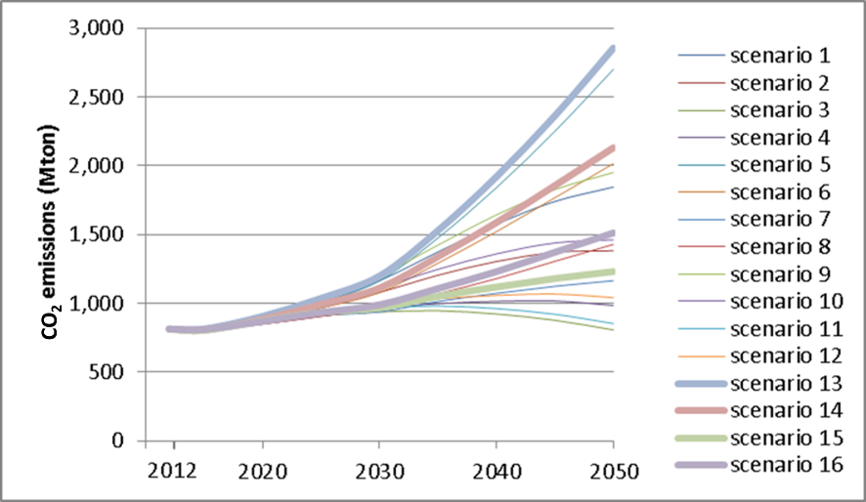
Figure 1: Predicted increase in CO2 emissions from international shipping

Recognizing the potentially significant contribution that the shipping sector would be making to global climate change and ocean acidification under BAU scenarios, IMO Member States moved to strategically act on these projections in a manner that would not impair shipping’s important contribution to continued global prosperity nor the shipping sector’s financial viability. In 2011, IMO Member States adopted a suite of technical and operational measures comprising an energy efficiency framework for ships (Chapter 4 of MARPOL Annex VI) designed to limit GHG emissions from the international maritime sector. Following the adoption of the energy efficiency regulations, a study undertaken for the IMO Secretariat estimated that successful implementation of Chapter 4 of MARPOL Annex VI could reduce shipping GHG emissions by 1 Gt/year CO₂ by 2050 against the then BAU scenario, a sizeable contribution to reducing the projected emissions gap in current emission projection models for a 2ºC outcome. These estimates of CO₂ emission reductions were undertaken by Lloyd’s Register and Det Norske Veritas (DNV) using scenario modelling to forecast possible world fleet CO₂ emission growth trajectories to 2050. The scenarios included options for fleet growth, uptake of technical and operational measures under the Chapter 4 of MARPOL Annex VI, and fuel price and fuel type change from residuals to distillates in view of 2020 more stringent fuel sulphur regulatory limits.

Biofouling on ships' hulls increases hull surface roughness, which in turn increases frictional resistance and ultimately increases fuel consumption and total GHG emissions. The penalty in fuel consumption can vary significantly due to a wide range of technical and operational parameters, but it may be in the order of 2% to 12% for a ship with a modestly fouled hull (see Table 2 and Figure 2).

Table 2: Range of representative coating and fouling conditions (adapted from Schultz, 2007)
Description of condition | Average coating roughness (microns)
Hydraulically smooth surface | 0
Typical as applied AF coating | 150
Deteriorated coating or light slime | 300
Heavy slime | 600
Small calcareous fouling or weed | 1,000
Medium calcareous fouling | 3,000
Heavy calcareous fouling | 10,000

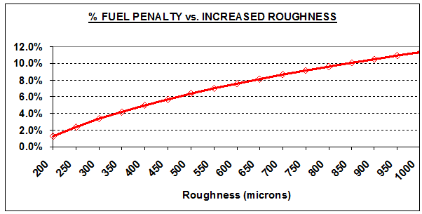
Figure 2: Increase in fuel consumption due to hull roughness (Townsin et al, 1986)

Measures related to the management of ships’ biofouling such as improved hull coating system and hull cleaning are among the most important tools for the reduction of shipping GHG emissions. Some of these are practical measures that may be relatively easily implemented to new and existing ships, and they do not rely on aspirational, emerging or future technologies. A very important aspect of such measures is their 'win-win' nature, as they lead to reductions in fuel consumption, thereby achieving consequential reductions in both GHG emissions and operational costs at the same time (see Figure 3). Combined with their increased practicability compared to other 'tools', this can make these measures more readily acceptable to the shipping industry giving them a realistic potential for more immediate tangible results. However, due to lack of capacity and awareness, the development and uptake of such tools and measures is low in developing countries. Additionally, another barrier for effective uptake of these measures is the perceived impact of such measures on accelerated IAS transfer to local ports. The uncertainty associated with the environmental impact of such practices is real and justified under current circumstances when there is little knowledge or policies on how to deal with relevant issues. It is this latter barrier that this project will seek to address. The project will act as a catalyst for environmentally safe uptake of these energy efficiency measures and will therefore contribute to activities that are underway by the maritime industry in fighting climate change.

The economic and cost-effectiveness aspects of hull and propeller biofouling management with regard to GHG emissions reductions are addressed by a number of researchers. As indicated in Figure 3, propeller polishing and hull cleaning are amongst measures with significant negative marginal abatement cost levels (for propeller polishing about US $225 per tonne CO₂ negative cost, i.e. denoting actual economic saving; and for hull cleaning about US $170 per tonne CO₂ negative cost).

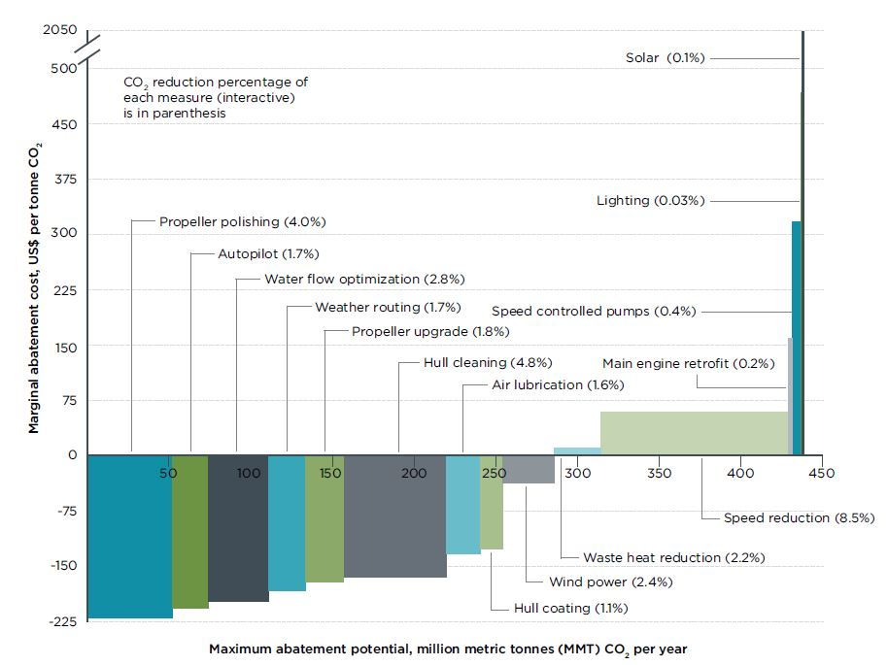
Figure 3: Abatement potential and cost of CO₂ reduction tools including related to biofouling management

Root causes and barriers that need to be addressed

The environmental threats and socioeconomic impacts discussed in detail above can be summarised in the table below. This provides a useful starting point from which to identify and discuss the overall root causes of these threats and impacts.

ENVIRONMENTAL THREATS | SOCIOECONOMIC IMPACTS
Predation on and competition with native species | - Removal of traditional food and recreational species  - Collapse in biodiversity toward a monoculture habitat  - Over-exploitation of primary productivity collapsing native food chains
Alteration of overall habitat dynamics and fundamental changes in ecosystems | - Reduction in amenity values  - Loss of tourist attractions (beach deterioration/change)  - Restricted access for coastal recreation  - Bioturbation and erosion from burrowing fauna
Modification of physical structures | - Damage to coastal infrastructure (tourism, water cooling intakes and heat exchangers for power plants, desalination plant intakes etc.)  - Reduced value of waterfront properties  - Biofouling of commercial craft and standing/fixed structures (shipping, fishing, oil and gas, tourism) reducing cost-efficiency, blocking physical inspection and threatening operations  - Increased fuel consumption levels leading to increased GHG emissions with consequent global effects
Damage to commercial and recreational fishery and aquaculture | - Removal of native species from recreational fishing areas (e.g. parasite or viral infections)  - Threat to aquaculture operations by fouling structures, equipment and the shellfish themselves, requiring cleaning and increasing operational costs  - Reduced establishment and growth of farmed species through predation and competition (for example, tunicates) as well as parasitism with IAS as vectors  - Biofouling of fishing gear

Despite the general awareness and the international momentum generated by the previous GEF interventions via the GloBallast programme, the knowledge base, legal/policy framework and technical, financial and institutional capacities required for developing countries to establish robust programmes for the control and management of marine biofouling as a separate vector to ballast water remain challenging. Efforts to date have tended to be fragmented and under-funded. This lack of attention and coordination has been replicated at the regional level. The absence of an integrated approach means that efforts to address the biofouling problem will prove difficult without focused international assistance.

Because of the technical, scientific, environmental and economic implications, the biofouling issue is more complex than most other ship-based pollution threats faced by countries and the global marine ecosystem. Under the baseline scenario, rapid and effective implementation of any international guidelines could be severely restricted by a lack of capacity in developing countries. It is anticipated that, without further technical cooperation and proper mobilization of existing resources, unilateral management efforts will go through an unnecessarily long process of implementation, leading to the proliferation of detrimental, and sometimes devastating, impacts on coastal and inland populations, the marine environment and aquatic biodiversity. Such a scenario would also diminish the momentum generated by the GEF intervention to address other vectors for alien species transfer (GloBallast).

A root cause of the difficulty in fully and effectively stemming the spread of invasive species by biofouling is the complex, multi-sectoral nature of biofouling sources, which makes it essential to tackle biofouling across the full range of anthropogenic structures in the marine environment. In addition to the problem of biofouling on ships resulting in the introduction of IAS, there are a growing number and variety of fixed surfaces in marine waters (e.g. oil and gas platforms, aquaculture nets, wave energy equipment, etc.) that can provide the substrate for potentially invasive species to settle and grow in proximity to ships. These anthropogenic structures thus can serve as a source for biofouling organisms which can attach to a previously “clean” ship, with the biofouling organisms then transported to a location where they can become invasive. Furthermore, such structures are also capable of translocation between regions, with structures like Mobile Offshore Drilling Units (MODUs) regularly being moved across ocean basins and LMEs, and structures like aquaculture nets or cages being regularly being moved domestically and regionally, resulting in the potential for transboundary introductions of IAS.

A major barrier to effectively tackling biofouling on the global scale and achieving the necessary multi-sectoral scope has been the lack of an institutional structure and process to bring together the diverse range of sectors and actors affected by biofouling. The absence of support, and the lack of coordination and standardized approaches at regional and global level, will discourage emerging biofouling management initiatives and bring additional difficulties to the implementation of an international regime for the marine biofouling issue, which means that the transfer of unwanted species with its significant impacts on the environment, economy and human health will continue.

The root causes associated with these issues can be summarised as follows:
- International and transboundary character of shipping, fishing and other relevant maritime industries.
- Lack of institutional structure and process to develop information exchange and coordinated action among the diverse private sector entities affecting, and affected by, biofouling.
- Broad lack of awareness regarding aquatic biofouling and IAS in general.
- Limitations in the efficacy of existing anti-fouling systems to prevent biofouling on ships, including fishing vessels and leisure craft.
- National and/or regional level institutional, policy and legal arrangements are insufficient or inadequate to address the biofouling problem.
- Conflict between regulations - in-water cleaning may be necessary to keep some niche areas free from biofouling during the in-service life of a vessel, but often water quality regulations prohibit cleaning that may release toxic residues from anti-fouling coatings.
- Poor and inconsistent regional cooperation.
- Limited to non-existent financial resources allocated to address biofouling issues.
- Lack of capacity and cost-effective tools to address biofouling issues for smaller boats and among local communities (especially in SIDS and developing countries).
- Lack of incentives (e.g. commercial or arising from legislative requirements) for the private sector to develop innovative biofouling reduction and remediation technologies.

Biofouling: The Baseline Scenario

Biofouling and IAS
The baseline scenario for the global management of IAS in association with international shipping includes two key instruments administered by the International Maritime Organization (IMO): the International Convention for the Control and Management of Ships' Ballast Water and Sediments, 2004 (BWM Convention, which entered into force on 8 September 2017), and the 2011 Guidelines for the control and management of ships’ biofouling to minimize the transfer of invasive aquatic species (IMO Biofouling Guidelines). For other sectors, there are at present no such centralized or global guidelines or regulations although there are some best-practice or similar guidelines of specific geographic (e.g. Australia) or sectoral scope (e.g. oil and gas).

In the development of the BWM Convention, IMO made a clear commitment to minimizing the translocation of IAS by shipping. The BWM Convention establishes the measures required to meet this commitment and considerable effort is being invested internationally to implement the Convention, including the investment of the GEF into the GloBallast programme. Undoubtedly, GEF, UNDP and IMO’s investment in the GloBallast programme has made a significant contribution to raising the baseline from a “do nothing” standpoint and has mobilized industry both through awareness and action. However, as described earlier, evidence has shown that biofouling is equally important to ballast water as a vector of IAS and pathogens. In fact, in some areas it has contributed to more IAS and pathogen introductions than ballast water. The results of various studies examining the proportions of IAS attributable to either ballast water or biofouling as a transport vector have been provided in Table 1 in Section 1.1.

Concerns about biofouling introductions have been raised through other international fora, including the Convention on Biological Diversity (CBD), UNCLOS (article 196), several UNEP Regional Seas Conventions (e.g. Barcelona Convention for the Mediterranean), the Asia Pacific Economic Cooperation (APEC), the Secretariat of the Pacific Region Environmental Program (SPREP) and the World Ocean Council’s Sustainable Ocean Summit (WOC SOS). Specifically, the Conference of the Parties to the CBD at its Eighth Meeting, inter alia, encouraged Parties to ratify and implement the International Convention on the Control of Harmful Anti-Fouling Systems on Ships, 2001 (AFS Convention) and to implement controls at national level, for example through appropriate measures (e.g., regulations and standards), on marine biofouling as a pathway for introduction and spread of invasive alien species, including for recreational vessels. In addition, the CBD reiterated its call to the IMO regarding the need to also address the issue of hull fouling as a vector for IAS (initially stated in decision VI/23, paragraph 7). There are also numerous commitments at CBD, and other intergovernmental and GEF commitments, on engaging the private sector and creating public-private partnerships.

In response to these concerns, the IMO developed the 2011 Biofouling Guidelines. The Biofouling Guidelines are intended to provide a globally consistent approach to the management of biofouling. They were adopted by IMO’s Marine Environment Protection Committee (MEPC) at its sixty-second session in July 2011 and were the result of three years of consultation between IMO Member States. The IMO Biofouling Guidelines represent a decisive step towards reducing the transfer of IAS by ships. In 2012, IMO also published the Guidance for minimizing the transfer of invasive aquatic species as biofouling (hull fouling) for recreational craft (circular MEPC.1/Circ.792). Since then, the MEPC agreed to keep the Biofouling Guidelines under review based on experience gained in their implementation and published in 2013 the Guidance for evaluating the 2011 Guidelines for the control and management of ships’ biofouling to minimize the transfer of invasive aquatic species (circular MEPC.1/Circ.811), which is an ongoing process further enhanced by the recent decision during MEPC 72 to include a new output on the review of the Biofouling Guidelines, based on a proposal put forward by Australia, the Netherlands and New Zealand (document MEPC 72/15/1).

This evaluation process is supported by a recent IMO study on Global Assessment of Awareness on Biofouling (2015) that revealed that 42 participating National Administrations had not implemented either mandatory or voluntary measures to manage biofouling, with only 15 respondents indicating that mandatory measures were in place and 13 respondents indicating that voluntary measures were in place. Further assessment of responses suggests a significant lack of awareness regarding the contribution of biofouling to the introduction of IAS (see Figure 4) and the relationship of biofouling management to international measures aimed at managing ballast water (BWM Convention) and the control of harmful anti-fouling systems (AFS Convention), as well as insufficient awareness of the IMO Biofouling Guidelines (see Figure 5). It should also be acknowledged that the IMO Biofouling Guidelines, as all guidelines, are voluntary only and do not have a mandatory nature like conventions or similar treaties. For other sectors, the situation is even more challenging given that there are only guidelines at national or regional level and/or developed by industry bodies, rather than governmental or intergovernmental agencies.

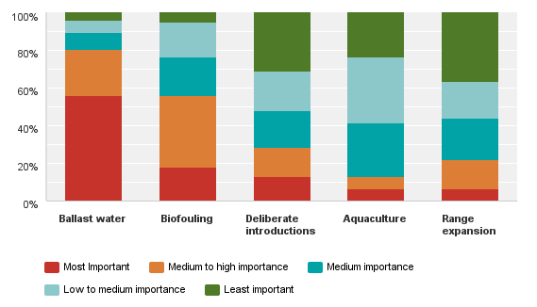
Figure 4: Perceived significance of IAS transport pathways

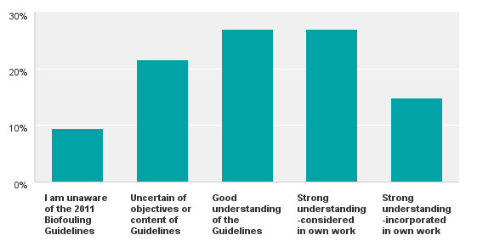
Figure 5: Level of awareness of the IMO Biofouling Guidelines among stakeholders

Current research and development into the management of biofouling is typically focused on a range of areas including the development of improved anti-fouling coating systems and in-water cleaning tools to reduce biofouling levels. A report by Frost and Sullivan published in 2012, estimated that the marine coatings industry had revenues of US$ 5 billion in 2011 and was forecast to reach over US$ 10 billion by 2018. A more recent report published by Global Market Insights estimated that the size of the marine coatings market will reach US$ 15 billion by the end of 2024 (Global Market Insights, 2018). Some leading companies allocate 3% of their sales value to R&D. Conservatively estimating that one-quarter of R&D is biofouling-related means that an estimated US$ 37.5 million was invested in biofouling R&D by the marine coatings sector in 2011 and this could rise to US$ 75 million by 2018. While significant scientific and technological advances are being made, much of this research is commercial in nature with limited opportunity for knowledge sharing. As such, developing countries frequently do not have access to innovative cost-effective solutions for preventing or managing biofouling. Furthermore, policy constraints may in some instances prevent the use of novel anti-fouling coatings and in-water cleaning technologies due to a lack of understanding, regulatory approval processes and/or inconstancies within national legislation.

The IMO has identified that a global collaborative partnership such as that advocated in the current proposal would substantially increase the capacity of States to implement the IMO Biofouling Guidelines and would provide a platform to further develop the capacity of the maritime sector to address both the threat of IAS and the contribution of biofouling to global GHG emissions. This need is particularly apparent in developing States which, as discussed above, are disproportionately affected by the impacts of IAS and in many instances lack the knowledge, resources, technological capacity and regulatory baselines to effectively implement the IMO Biofouling Guidelines. Moreover, such an intervention would also enable the development and implementation of guidelines related to biofouling management for other marine sectors.

Biofouling and GHG Emissions
The Chapter 4 of MARPOL Annex VI, which came into force on 1 January 2013, calls for substantial improvements in ship energy efficiency including both the design of new ships (Energy Efficiency Design Index – EEDI) and the operation of all ships (Ship Energy Efficiency Management Plan – SEEMP). This represents the first ever mandatory global CO₂ reduction regime for an international industry sector. CO₂ emissions from international shipping in 2012 amounted to 796 million tonnes, corresponding to 2.2% of global CO₂ emissions. To reduce CO₂ emissions from international shipping, a number of studies have identified measures that could significantly increase the energy efficiency of ships. Amongst these measures, the increased hull roughness associated with biofouling is taken as one major aspect that needs to be controlled or managed, as otherwise it will increase the ship’s frictional resistance and, ultimately, fuel consumption and total GHG emissions (see section 1.3 above).

Specific reductions that can be achieved in CO₂ emissions from international shipping through the management of ships’ biofouling is dependent on ship type, size, speed and operational profile, making it problematic to generalize. However, estimated energy reduction potentials for a range of biofouling management approaches include from 3 to 8% for propeller polishing, from 1 to 10% for hull cleaning, and from 1 to 5% for the application of efficient hull coatings. As these measures are not necessarily mutually exclusive, the sum of estimated reductions if all approaches were implemented could range from 5% to over 23%. With annual CO₂ emissions from international shipping such as outlined in section 1.3 above, a decrease of 10% across the entire global fleet could correspond to a reduction of around 80 to 90 million tonnes CO₂ emitted on an annual basis. This corresponds to the total annual CO₂ emissions of a country such as Greece, Nigeria or the Philippines.

In response to the Paris Agreement, various Member States and industry bodies have requested that the IMO take further action to define a determined target GHG emission reduction strategy with a clear work-plan on how to achieve these reductions. This was recently achieved during the 72nd session of IMO's Marine Environment Protection Committee (MEPC 72 – 9 to 13 April 2018) via agreeing to a draft IMO GHG Strategy that sets ambitious future activities in this regard. Technical and operational measures to reduce the contribution of ship’s biofouling to global GHG emissions will contribute directly to the goals of the Chapter 4 of MARPOL Annex VI and IMO GHG Strategy, and also contribute towards the broader goals of GHG emission reduction encapsulated by the UNFCCC.

The Alternative Scenario to be pursued by the GloFouling Partnerships Project
The GloFouling Partnerships Project will address the fact that biofouling represents an important threat to marine biodiversity and as such will build on and optimize benefits from measures implemented for other vectors, such as ships’ ballast water, to ensure that investments in managing one IAS vector are not diluted by failing to address others. The GloFouling Partnerships will develop a global, regional and country-based programmatic framework for the management of aquatic biofouling to minimize the introductions of IAS. The Project will also support the development of solutions to manage biofouling by increasing awareness, catalysing change within the shipping sector and outreaching to other maritime industries. Given the synergistic reduction in fuel use and GHG emissions associated with overall reductions in biofouling, GloFouling will also contribute to the global GHG emissions reduction goals.

The aims and objectives of the GloFouling project are an extension of previous GEF interventions to address the IAS issue, with a focus on national legal, policy and institutional reforms in targeted developing countries and SIDS, and an emphasis on integrated management and cross-sectoral coordination. This intervention will include:
- Building on the achievements and momentum of, and utilizing the capacity and talent generated by the previous GEF investments.
- Developing and replicating best practices and encouraging knowledge-sharing at the global, regional and national levels to minimise the transfer of invasive aquatic species through biofouling.
- Supporting identified beneficiary countries in their efforts to stimulate and enact policy reforms at the national level to implement the IMO Biofouling Guidelines and any other relevant best practices.
- Building the capacity, both human and institutional, to enable the selected countries to push forward the national agenda within the global biofouling management framework.
- Strengthening regional collaboration in relevant areas and working towards advanced integration through other interested structures, mechanisms and programmes, including, where optimal, GEF-International Waters (IW) LME projects and UNEP Regional Seas and the Ecosystem Approach to Fisheries (FAO).
- Promoting collaboration with industry (and among various sectors within industry) to facilitate the successful transfer of new technologies from developed to developing countries.

Support for appropriate national institutional arrangements will be provided and, following the successful model from similar projects, selected regional mechanisms will be used as catalysts for supporting national policy reforms. Standardized protocols and methodologies for conducting any port biological surveys (where required, depending on specific needs of target countries) and risk assessments will be provided with direct assistance from the capacity built and tools developed through strategic partners. The project will also develop means to assess the efficacy and uptake of policy measures aimed at implementing the IMO Biofouling Guidelines and any other relevant guidelines, and will examine the effect of these measures on the level of biofouling in the global shipping fleet and the rate of IAS introductions via biofouling. The project will support innovative solutions and technological developments aimed at reducing biofouling within shipping and other sectors implicated in biofouling and IAS. Specific training on biofouling management and control will be provided with emphasis on various recommendations contained within the IMO Biofouling Guidelines. At the regional level, strategies to integrate the biofouling management programmes with existing marine and coastal management schemes will be developed and implemented.

Sustainable financial and institutional arrangements for the long-term management of biofouling will be established, including the mobilization of public and private sector funding. For example, Multilateral or Regional Development Banks and other International Financial Institutions (IFIs) have objectives aligned to those of the IMO, including to help developing countries to achieve international commitments and sustainably raise living standards. Therefore, the GloFouling project will engage with IFIs to utilize their existing links with both governments and the private sector to help support the implementation of the IMO Biofouling Guidelines.

In parallel, the approach towards setting up a Global Industry Alliance (GIA), a public-private partnership established during previous GEF programmes, will be followed to include and address marine biofouling, thus bringing major industry players to support the project objectives.

In essence, the proposed project will build on the findings, institutional settings and capacity developed during the previous GEF investments on ship ballast water management. This will create a significant and highly catalytic incremental benefit with the minimum resources invested. The results of this GEF intervention will include a measurable reduction in risk of aquatic bio-invasions with a significant mitigation of the detrimental effects of IAS transfers, better protection of the marine and coastal ecosystems and habitats and conservation of biodiversity.

The Project will significantly contribute to specific goals of the CBD and its Aichi Biodiversity Targets, including addressing the underlying causes of biodiversity loss by mainstreaming biodiversity across government and society, reducing the direct pressures on biodiversity and promote sustainable use, improving the status of biodiversity by safeguarding ecosystems, species and genetic diversity, enhancing the benefits to all from biodiversity and ecosystem services and, most importantly, enhancing implementation through participatory planning, knowledge management and capacity building.

By addressing the contribution of biofouling to increased frictional resistance on ship hulls and the resulting increase in fuel consumption, the GloFouling project will catalyse tangible reductions in global GHG emissions. The solutions catalysed by the GloFouling project (e.g. more effective hull maintenance, reduced fouling rates due to use of advanced hull coatings and timely propeller polishing) have the potential to reduce hydrodynamic penalties that could bring a reduction of GHG emissions anything between 5 to 23%. Even if a relatively small proportion of these potential emission reductions is achieved, this contribution to reduced GHG emissions by the shipping sector would still represent a significant environmental benefit that could amount to US$ hundreds of millions per year and is complementary to that obtained from the GEF-UNDP-IMO intervention GloMEEP, which addresses general energy efficiency within the shipping sector.

It is difficult to make precise predictions regarding the fate and ultimate outcome of the implementation of relevant tools and measures in terms of GHG reduction levels, since the complexity of international shipping as a single entity should be taken into account. Despite this, the following methodology is used to estimate the potential impact of this project in catalysing GHG emissions reductions from international shipping. The methodology uses the GHG emissions forecasts based on the Third IMO GHG Study 2014 scenario modelling, as previously depicted in Figure 1.

The Third IMO GHG Study 2014 has modelled 16 scenarios altogether. From these 16 scenarios, 8 are selected as below:

- 4 BAU scenarios representing various demand/socio-economic growth scenarios with “BAU shipping energy efficiency” measures, representing no extra GHG reduction policy intervention.
- A second 4 scenarios representing same demand/socio-economic growth scenarios but with High Energy Efficiency measures, that implicitly includes some kind of future policy intervention.

For the purpose of these projections, the average of the 4 BAU scenarios and the average of the 4 High Energy Efficiency scenarios, as estimated under Third IMO GHG Study 2014, are calculated and the forecast is shown in Figure 6.

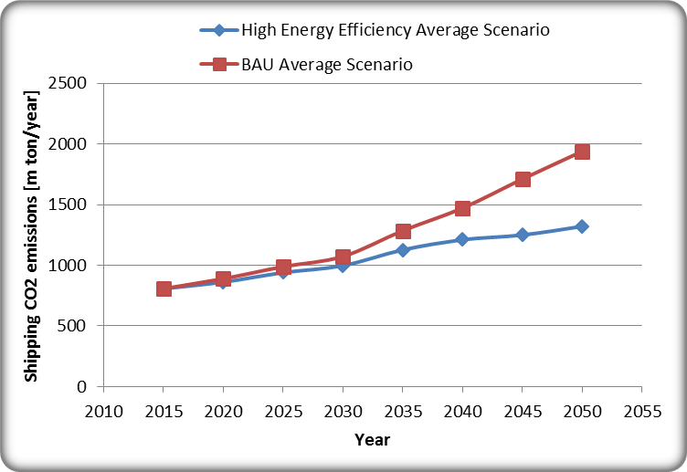
Figure 6: Average of BAU scenarios and alternative High Energy Efficiency scenarios for CO₂ emissions growth
based on Third IMO GHG Study 2014

The difference between the two average scenarios (i.e. difference between the two curves in Figure 6) is considered as the contribution of the High Energy Efficiency intervention elements. Based on this procedure, the potential reduction in GHG emissions from international shipping is estimated as shown in Table 3. For this calculation, it is assumed that an average 10% of the High Energy Efficiency gains will be due to the three measures related to biofouling management (i.e. advanced hull coating to reduce fouling, propeller polishing to reduce propeller roughness and hull cleaning to reduce hull roughness). The percentage used for this calculation is based both on the discussion provided in Section 1.5.2 (the estimated reduction of 5 to 23% presented in the ICCT White Paper) and also using the estimates documented in the IMO-commissioned LR and DNV Study (according to this report, out of the total SEEMP related measures, the hull conditions could account for 8.66% to 13.06% of total CO₂ reductions, depending on various ship types and sizes).

Table 3: Reduction in GHG emissions based on 3rd IMO GHG Study 2014 and estimated potential reduction due to biofouling measures
CO₂ Level for International Shipping [million tonnes / year)
Year | Int. Shipping  Average of BAU Scenarios | Int. Shipping  Average of High Energy Efficiency Scenarios | Reductions due to High Energy Efficiency Scenarios  (High Energy Efficiency -BAU) | Reduction due to biofouling management measures per year
2015 | 808 | 808 | 0 | 0
2020 | 890 | 862 | 28 | 2.8
2025 | 989 | 940 | 49 | 4.9
2030 | 1073 | 998 | 76 | 7.6
2035 | 1286 | 1127 | 159 | 15.9
2040 | 1472 | 1211 | 261 | 26.1
2045 | 1711 | 1250 | 462 | 46.2
2050 | 1940 | 1321 | 619 | 61.9

Using data in Table 3, it is estimated that the total potential reduction in GHG emissions due to biofouling measures between 2020 and 2030 is 50.38 Mt of CO₂ (interpolated from a linear increase between these years for each year, and then added for the period).

As described in Section 1.5.2 and Figure 3, the three biofouling management measures that underlay this calculation are very cost effective and removing the barriers for their implementation will help with their wider practice. In this manner, the GloFouling Project is expected to act as a catalyst for such developments in the future.

Strategy

2.1 Project Rationale and Policy Conformity
As outlined in the previous sections, the transfer of IAS through biofouling on ships and other industry vessels and structures is a global environmental problem which requires intervention at multiple levels. This is an issue intrinsically linked to international shipping, which is truly global in nature, and any benefits accrued at the national level will fully contribute to the global benefits. The discussion below forms the global context and rationale under which the GloFouling Partnerships project is advocated.

2.1.1 GEF focal areas supported
The GloFouling Partnership Project will directly support the International Waters (IW) focal area of the GEF-6 Results Framework. In particular, the GloFouling project addresses International Waters Objective 1, which seeks to catalyse sustainable management of transboundary water systems by (Component 1) supporting multi-State cooperation through foundational capacity building, targeted research and portfolio learning, as well as Objective 3, which aims to enhance multi-state cooperation and catalyse investments to foster sustainable fisheries, restore and protect coastal habitats, and reduce pollution of coasts and Large Marine Ecosystems, particularly Component 6, Prevent the Loss and Degradation of Coastal Habitat. In the context of the IW Objective 1, the GEF-6 IW Strategy makes specific reference to GEF's commitment to continue to engage in addressing global IAS issues in paragraph 37, "Building on IW's success in support of implementation of the Ballast Water Management Convention (through the 'GloBallast' project) and the strong partnership with the IMO, the GEF will pursue additional activities in support of the International Guidelines on Ships' Biofouling".

Due to the dual impact of biofouling on the transfer of IAS and on global GHG emissions, the GloFouling Project would also specifically address the GEF Climate Change Mitigation focal area. Objective 1 of the GEF-6 Climate Change Mitigation Focal Area Strategy aims to promote innovation, technology transfer and supportive policies and strategies. Within this objective, Program 2 calls for projects that develop and demonstrate innovative policy packages and market initiatives to foster a new range of mitigation actions, while Program 1 aims to promote the timely development, demonstration, and financing of low carbon technologies and mitigation options. Furthermore, GEF-6 Climate Change Mitigation Focal Area Strategy calls for projects catalysing systematic impacts through synergistic multi-focal area initiatives. By addressing the role of biofouling in both the transfer of IAS and GHG emissions from the shipping sector, the GloFouling Project will address multiple focal areas by developing a systematic global approach for managing biofouling and will incorporate a novel mitigation strategy to reduce the overall GHG emissions associated with the global shipping sector. Outcomes associated with the GloFouling project will demonstrate a political commitment and shared vision in keeping with the GEF-6 Results Framework and will lead to improved governance within IMO Member States for the ecosystem-based management of transboundary water bodies.

2.1.2 IMO
From the perspective of international shipping, the project builds its base from the 2011 Guidelines for the control and management of ships' biofouling to minimize the transfer of invasive aquatic species (IMO Biofouling Guidelines, IMO resolution MEPC.207(62)), which are intended to provide a globally consistent approach to the management of biofouling. Although these Guidelines are largely focussed on large ships, they can also apply to other marine vessels. In the Biofouling Guidelines, ships are defined as "…vessel of any type whatsoever operating in the aquatic environment and includes hydrofoil boats, air cushion vehicles, submersibles, floating craft, fixed or floating platforms, floating storage units (FSUs) and floating production storage and off-loading units (FPSOs)". The Guidelines have been further supplemented by the Guidance for minimizing the transfer of invasive aquatic species as biofouling (hull fouling) for recreational craft, approved by MEPC at its sixty-fourth session in October 2012 and published as MEPC.1/Circ.792. This Guidance is for use by all owners and operators of recreational craft less than 24 metres in length, which may constitute an important pathway for the transfer of invasive aquatic species due to their large numbers and their operating profile that may make them particularly susceptible to biofouling.

The Biofouling Guidelines are voluntary and represent a decisive step towards reducing the transfer of invasive aquatic species by ships. The aims of the Guidelines are to:
- Provide a globally consistent approach to managing biofouling by providing useful recommendations on general measures to minimize the risks associated with biofouling for all types of vessels.
- Provide practical guidance to States, ship masters, operators and owners, ship builders, vessel repair, dry-docking and recycling facilities, vessel cleaning and maintenance operators, ship designers, classification societies, anti-fouling paint manufacturers and suppliers and any other interested parties, on measures to minimize the risk of transferring invasive aquatic species from ships' biofouling.
- Minimize the transfer of invasive aquatic species: a vessel should implement biofouling management practices, including the use of anti-fouling systems and other operational management practices to reduce the development of biofouling.

The Guidelines provide guidance and best practices for biofouling management, including:
- The use of Biofouling Management Plans and Record Books. The purpose of these Plans is to outline measures for the control and management of biofouling to minimize the transfer of Invasive Aquatic Species. It is recommended that every vessel should have a Biofouling Management Plan to provide effective procedures for biofouling management. The Biofouling Record Book should include anti-fouling details such as coatings used, locations, cleaning, surface preparation and application details, AFS (Anti-fouling) Certificate, dates and location of dry-dockings/slippings, inspections and coating renewals;
- The correct application and maintenance of anti-fouling systems;
- In-water inspection, cleaning and maintenance, including the use of divers or remotely operated vehicles (ROVs);
- Design and construction of vessels, with special attention to minimising niche areas and square edges;
- Dissemination of information, where States are encouraged to provide IMO with the information related to the management of biofouling, such as providing ships with timely, clear and concise information on biofouling management measures and treatment requirements; providing any available information on IAS that may be present in an area or port; ensuring that shipping agents are familiar with biofouling management requirements, treatment procedures, information, etc., needed to obtain entry clearance; and providing the Organization feedback as to why vessels could not apply the Guidelines;
- Training and education; and
- Research.

As scientific and technological advances are made, the Biofouling Guidelines may be refined to enable the risk to be more adequately addressed. Port States, flag States, coastal States and other parties that can assist in mitigating the problems associated with biofouling should exercise due diligence to implement the Guidelines to the maximum extent possible, which can play a significant role in reducing the risk of the transfer of invasive aquatic species.

In support of this review process, IMO has prepared the Guidance for evaluating the 2011 Guidelines for the control and management of ships' biofouling to minimize the transfer of invasive aquatic species, approved by MEPC at its sixty-fifth session in May 2013 and published as MEPC.1/Circ.811. This Guidance is provided to assist Member States and observers who wish to collect information needed to undertake future reviews of the Biofouling Guidelines and to do this in a more consistent way. The Guidance identifies the types of performance measures that could help to assist in evaluating the different recommendations in the Guidelines. This review process is further enhanced by the recent decision during MEPC 72 to include a new output on the review of the Biofouling Guidelines, based on a proposal put forward by Australia, the Netherlands and New Zealand (document MEPC 72/15/1).

The International Convention on the Control of Harmful Anti-Fouling Systems on Ships, 2001 (AFS Convention) addresses anti-fouling systems on ships, although its focus is on the prevention of adverse impacts from the use of anti-fouling systems and the biocides they may contain, rather than the prevention of the transfer of invasive aquatic species through hull fouling. The AFS Convention has legal requirements banning organotin compounds used in anti-fouling systems, i.e. tributyltin or TBT. It also highlights considerations for choosing a suitable anti-fouling coating system such as if a coating is registered for use in the country where it is intended to be used (e.g. some countries such as the UK have banned the use of coatings containing Irgarol 1051 and Diuron).

Biofouling management can be an effective tool in enhancing energy efficiency and reducing air emissions from ships through improved hull maintenance translating into improved hydrodynamic performance. The GloFouling project will also contribute to fostering cooperation that will result in improved environmental outcomes within the shipping and other maritime industry sectors and will also result in cost savings through improved energy efficiency and reduced fuel consumption. This has been recognized by the IMO and is reflected in the 2016 Guidelines for the development of a Ship Energy Efficiency Management Plan (SEEMP) (resolution MEPC.282(70)), where it is stated that:
- Docking intervals should be integrated with ship operator's ongoing assessment of ship performance. Hull resistance can be optimized by new technology-coating systems, possibly in combination with cleaning intervals. Regular in-water inspection of the condition of the hull is recommended.
- Propeller cleaning and polishing or even appropriate coating may significantly increase fuel efficiency. The need for ships to maintain efficiency through in-water hull cleaning should be recognized and facilitated by port States.
- Consideration may be given to the possibility of timely full removal and replacement of underwater paint systems to avoid the increased hull roughness caused by repeated spot blasting and repairs over multiple dockings.

2.1.3 Convention on Biological Diversity
The GloFouling project will also contribute to specific goals of the CBD, specifically, Strategic Goal B: Reduce the direct pressures on biodiversity and promote sustainable use, and its associated Target 9: By 2020, invasive alien species and pathways are identified and prioritized, priority species are controlled or eradicated, and measures are in place to manage pathways to prevent their introduction and establishment. Through its Outcome 1.1, the GloFouling Partnerships will contribute to the following generic and specific indicators of Target 9:
- Generic indicator: Trends in implementation of policy responses preventing the introduction and establishment of invasive alien species.
- Specific indicator: Proportion of countries adopting relevant national legislation and adequately resourcing the prevention or control of invasive alien species.

2.1.4 UN Sustainable Development Goals
Finally, the Project will address the UN Sustainable Development Goals 14 (Conserve and sustainably use the oceans, seas and marine resources for sustainable development), 13 (Take urgent action to combat climate change and its impacts) and 15 (Protect, restore and promote sustainable use of terrestrial ecosystems, sustainably manage forests, combat desertification, and halt and reverse land degradation and halt biodiversity loss). GloFouling will also address SDG 17 – Partnerships for the Goals, SDG 9 – Industry, Innovation and Infrastructure and SDG 5 – Gender Equality. Annex I includes a detailed list of the contributions from the Project to the objectives of the SDGs, including targets and indicators to monitor and evaluate success.

2.2 GloFouling Partnerships Strategy

2.2.1 The LPIR process, the 4-tiered approach and the Glo-X implementation model
The aims and objectives of the GloFouling project will focus on national Legal, Policy and Institutional Reform (LPIR) in targeted LDCs and SIDS, with an emphasis on integrated management and cross-sectoral coordination.

The GloFouling Project is formed as a truly global partnership that spurs government action and industry innovation and know-how in order to reduce the transfer of IAS from international shipping, while also reaching out to other marine sectors in a holistic approach. While the reach is global, all the intended outcomes, outputs and activities are directly geared towards the national level with a view to improving maritime institutions, technologies and operations as well as achieving improved monitoring and impact mitigation in the participating developing countries.

The strategy employed for the GloFouling Partnerships will be based upon the sustainable replication of the Glo-X pyramid model of implementation, developed by IMO from best experiences and previous interventions. This strategy has already been successfully replicated in other projects in the GEF-UNDP-IMO portfolio, such as the GloBallast Partnerships and the GloMEEP Project. The Glo-X model takes its basis from LPIR roadmap developed during the implementation of similar projects and has been adapted towards the need to support developing countries in achieving biofouling management practices as set out in the IMO Biofouling Guidelines. The strategy includes at its core the LPIR that needs to be implemented in order to pave the way for the effective use of resources. This LPIR and implementation process is conceptualised in Figure 7 where the requirement for capacity building, knowledge sharing and technology solutions are also highlighted as a central theme.

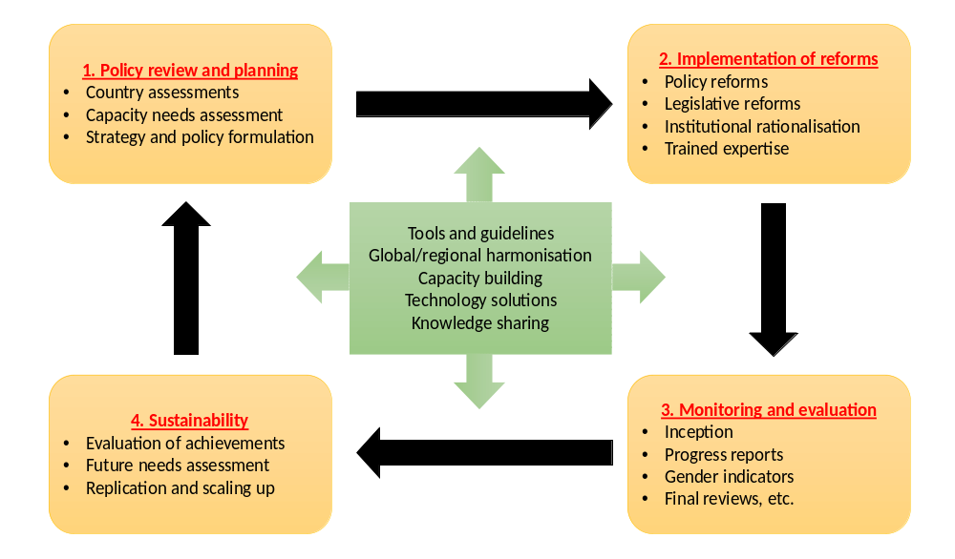
Figure 7: LPIR process

In previous experiences of the Glo-X model, the LPIR process is applied in a 3-tiered approach at the global, regional and national level. For the GloFouling Partnerships, the Glo-X model has been adapted to integrate the local dimension using a 4-tiered implementation approach (see Figure 8):

- A global tier, providing international coordination and information dissemination, developing toolkits, guidelines and training materials, providing capacity building to developing countries and establishing a strong cooperation with industry representatives and NGOs.
- A regional tier, providing regional coordination and harmonization, and promoting information sharing.
- A significant country tier that establishes a fast track (Lead Partnering Country - LPC) and partner track (Partnering Country - PC) process for GEF-eligible countries in the priority regions. LPCs commit to develop and implement a National Biofouling Management Strategy and Action Plan (NBMS), with a view to guide the adoption of LPIR.
- A local tier in each LPC to provide practical experiences in the implementation of the tools developed by the Project through targeted demonstration sites that should facilitate engagement of stakeholders at the national level and provide opportunities for technology demonstration for the private sector, and with particular attention to best management practices for recreational craft.

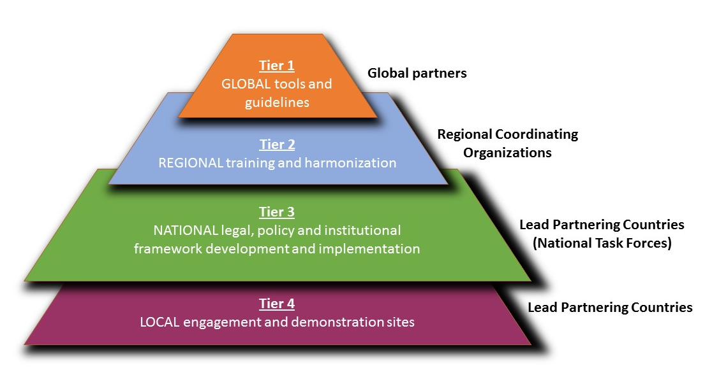
Figure 8: The GloFouling model showing four tiers of engagement

The adapted version of the full Glo-X pyramid model pictured in Figure 9, illustrates how the LPIR roadmap integrates with the engagement of private sector industries through their participation in a public-private partnership created by the GloFouling Project to catalyse technology development, cooperation, transfer and demonstration, which is implemented in parallel to the LPIR process also at the global, regional, national and local level.

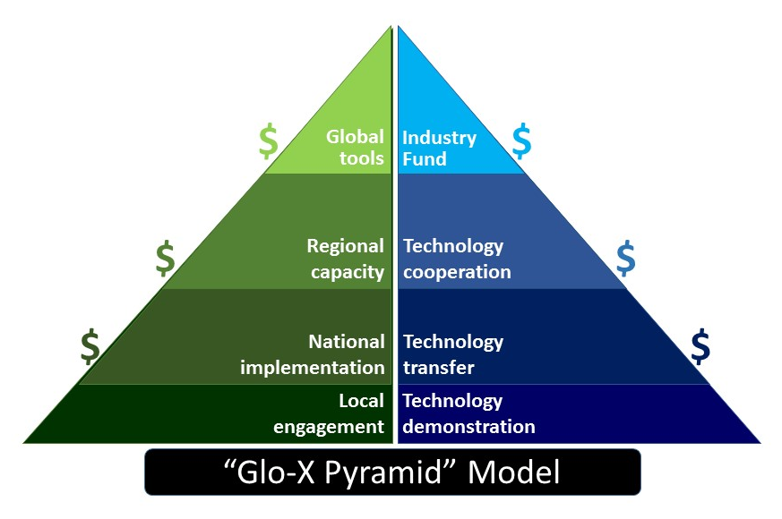
Figure 9: The Glo-X Pyramid model

2.2.2 Global tier
The project will be managed globally through the Project Coordination Unit (PCU), based at the IMO headquarters in London, UK. Given the frequency of IMO Member State participation in regular IMO meetings, in particular during the MEPC, the PCU is in an ideal position to stay in contact with Member State representatives and to ensure that the momentum for addressing biofouling management issues within the priority regions (and in other regions) continues to increase. This particular aspect gives a strong comparative advantage to IMO to be the implementing agency.
The global tier includes the Global Project Task Force (GPTF), comprised by representatives from, UNDP, IMO, LPCs, RCOs, Strategic Partners and Industry, to provide overall management and advisory support for the project. There are also global outputs and activities focused on developing guidance and best practices that will form the baseline for providing training to country officials and experts on strategic planning and LPIR, and the carrying out of applied biofouling management measures. In addition, global level activities include public awareness raising and the development of knowledge management systems that are expected to function as an information clearing house in support of a uniform global approach, as well as an R&D Forum and exhibition.

Of special note, the global tier will also include three instruments to channel the integration of the private sector:

- establishing two industry funds to address marine biofouling, bringing major private sector players (from both shipping and non-shipping industries) to support the project objectives by providing a channel to address industry concerns and contribute to the review process;
- utilizing the WOC Ocean Investment Platform to catalyse funding for biofouling solutions and new technologies; and
- creating forums to foster dialogue between regulators, the scientific community and the private sector.

Further information on the Public Private Partnerships (PPPs) is provided in section 2.2.6.

2.2.3 Regional tier
While the selection of LPCs (see section 2.2.4) was conducted based mainly on national considerations, the regional dimension was also taken into account. The GloFouling Partnerships will indeed use regional mechanisms to deliver outputs more broadly within target regions and to deliver sustainable biofouling management measures beyond the life of the GloFouling Partnerships Project. Seven regions are involved in the GloFouling Partnership effort: South America, South Asia, Red Sea and Gulf of Aden, Pacific, Eastern Africa, Southeast Asia, and the Wider Caribbean (see Table 4).

The regional tier is first and foremost a mechanism to ensure that all countries in the strategic and outreach regions have an opportunity to participate and learn from the activities undertaken by the LPCs. To that end, the regions will play a coordinating role for developing strategies, policies and programmes at the regional level. In addition, it is expected that the regional component brings significant added value to the long-term sustainability efforts by bringing the biofouling management agenda to the regional convention discussions and developing regional action plans to be integrated into existing marine and coastal management schemes. The Regional Coordinating Organizations (RCOs) identified within the existing regional structures have a close access to the key policy makers of the LPCs and offer significant advantage in terms of achieving the most cost-effective coordination and outreach among the other countries in the region to achieve the objectives of the project. See Annex K-5 for the letter of endorsement from the RCOs who already agreed to provide support to the project in their respective regions.

Table 4: List of Strategic Regions and Regional Coordinating Organizations (RCOs)
Region | Organization | Background
South America | CPPS – Comisión Permanente del Pacifico Sur | The South East Pacific coast of South America encompasses the Humboldt Current LME and represents a valuable area for fisheries, and also includes several highly protected and vulnerable marine areas. Local industry and people are highly dependent on the maritime environment throughout this region. Ecuador presents a good opportunity to expand marine biosecurity elements of the existing Action Plan to minimize risks of introduction of marine invasive species to the Galapagos Islands Reserve as a GloFouling demonstration site. The importance of fishing to the economies in the region are also important factors that need to be taken into account. South-East Pacific Action Plan and Convention for the Protection of the Marine Environment and Coastal Zones of the South-East Pacific (Lima Convention).
South Asia | SACEP – South Asia Cooperative Environment Programme | South Asia represents a highly significant shipping region. Sri Lanka lies within the Bay of Bengal LME and lies in the path of one of the most important global shipping corridors. The important role of Sri Lanka as a ship maintenance and repair hub, and the substantial importance of shipping to the region, provide a strong justification for the selection of Sri Lanka as an LPC. It is expected that will also encourage further engagement within the region and may assist other countries to engage with GloFouling in the framework of the South Asian Seas Action Plan.
Red Sea and Gulf of Aden | PERSGA – Regional Organization for the Conservation of the Environment of the Red Sea and Gulf of Aden | The Arabian Peninsula and surrounding seas, including the Red Sea and Gulf of Aden, is a significant region encompassing two key LMEs: the Red Sea and the Arabian Sea. This area is critical to world shipping and encompasses the Suez Canal with is a major shipping route as well as significant ship repair and maintenance facilities within the region. The region also encompasses a significant offshore oil and gas industry, offshore desalinisation facilities and includes important fisheries resources. Local industry and peoples are highly dependent on the maritime environment throughout this region. The Regional Organization for the Conservation of the Environment of the Red Sea and Gulf of Aden (PERGSA) is actively engaged in this region and has previously hosted awareness raising exercises focused on biofouling.  The Action Plan for the Red Sea and Gulf of Aden and the Regional Convention for the Conservation of the Red Sea and Gulf of Aden Environment (Jeddah Convention) provides the regional legal framework.
Pacific | SPREP – Secretariat of the Pacific Regional Environment Programme | The prevalence of SIDS in this region, the reliance of local communities and industries on the marine environment, the enormous traffic through the region by commercial fishing vessel and the potential role of the recreational boating and yachting sector in transferring IAS between Pacific Islands make the Pacific a very important strategic region for the GloFouling Partnership Project. All applicants from the Pacific are considered SIDS and are already engaged with IAS issues through SPREP. Due to the importance of New Zealand as a trading partner for the Pacific Nations, a reasonable goal for GloFouling Partnership Project would be to examine options for LPIR to align Pacific policies with New Zealand’s Craft Risk Management Standard (entering into force in May 2018). Regional harmonization could be achieved through the Noumea Convention.
East Africa | IMO’s Regional Coordinator for Eastern and Southern Africa (based in Kenya) | East Africa encompasses two Large Marine Ecosystems: the Somali Coastal Current and the Agulhas Current LMEs, as well as offshore waters extending to Mauritius. This area represents a significant shipping region, a valuable area for fisheries and an important shipping corridor. Furthermore, local industry and peoples are highly dependent on the maritime environment throughout this region. Within this region Mauritius serves as a maritime hub for ship maintenance and repair and is frequently used for in-water cleaning and in-water repair, while a Class A ship repair facility is located here. In this same region, Madagascar has also been selected as an LPC in consideration of the role the nation could play in the implementation elements of the GloFouling Partnerships such as regional workshops and twinning activities under the Nairobi Convention.
Southeast Asia | PEMSEA – Partnerships in Environmental Management for the Seas of East Asia | Southeast Asia represents a highly significant shipping region both in terms of ship building and repair and also as a significant shipping corridor. Furthermore, local industry and people are highly dependent on the maritime environment throughout this region with mariculture being of growing importance to the region with Indonesia and the Philippines falling within the top 15 global aquaculture producers. The area encompasses a number of Large Marine Ecosystems including the Yellow Sea, South China Sea, Sulu-Celeb Sea, Gulf of Thailand and the Bay of Bengal. Due to the importance of Australia as a trading partner for the Southeast Asian Nations in particular, a reasonable goal for the GloFouling Partnership Project would be to examine options for LPIR to align regional policies with Australia’s developing suite of biofouling management measures at both national and state levels. In this region, Indonesia and the Philippines are presented as very strong candidates with substantial interests in ship repair and maintenance. Considering the need to select limited countries for LPC the ranking reflects the key role of Indonesia in ship repair and the role of the Philippines as the major maritime crewing nation in the world, and also the role these nations could play in the implementation elements of the GloFouling Partnerships such as regional workshops and twinning activities is very important. A Regional Action Plan is currently under development by ASEAN countries under its Maritime Transport Working Group (MTWG).
Wider Caribbean | RAC/REMPEITC-Caribe | The Wider Caribbean area encompasses a number of Small Island Developing States as well as developing countries in Central America and includes several LMEs – Gulf of Mexico LME, Caribbean Sea LME, and Pacific Central America LME. This area represents a significant shipping region, a valuable area for fisheries and is a focal area for recreational boating. Furthermore, ongoing development of oil and gas interests in the broader Gulf of Mexico have resulted in significant offshore infrastructure transiting through this region and being anchored to the sea floor for long periods. Local industry and peoples are highly dependent on the maritime environment throughout this region. Mexico has been selected as an LPC due to broader influence in the Latin American region and coastlines in both the Caribbean and the Pacific and its close proximity to California. A goal to be considered in the Caribbean region is investigating biofouling management measures to align with the mandatory measures recently introduced in California.

2.2.4 National tier
The process of selecting regions and countries to participate in GloFouling Partnership has been deliberate and participatory. In August 2017, the IMO issued its Circular Letter No.3768 (available in annex J) with a Call for Expressions of Interest to become LPCs and PCs of the GloFouling Partnerships Project, which also included a country questionnaire to gather information for assessing the status of biofouling management at the national level. All candidates were reviewed and assessed based on the information provided in the questionnaire and other criteria such as:

- level of exposure to, and risk from, invasive aquatic species through biofouling;
- existence of national institutions, of formal or informal nature, dealing with invasive aquatic species;
- geographical distribution; and
- level of commitment by the country to prioritize biofouling issues and to implement the IMO Biofouling Guidelines.

Based on this information, a ranking of regions was carried out, taking into consideration the regional importance of shipping (particularly in respect to shipbuilding and repair facilities), regional progress towards biofouling management and the existence of regional biofouling management policies that could be leveraged to build broader capacity in the region through the GloFouling Partnerships.

The pre-eminent focus of GloFouling Partnerships is at the national level. It is recognized that international measures can set the stage, and regional organizations can help to convene countries, but it is at the national level where the real actions are taken to reduce the risks from IAS from ships and other sources. In particular, the national level activities are designed to provide the tools and techniques to enable LPCs to reform their legal, policy and institutional structures in order to establish a risk-based and cost-effective approach to improved biofouling management that will reduce the risks of marine bio-invasions. GloFouling Partnerships will help participating countries by providing a “roadmap” on how to achieve LPIR, and then by assisting them to steer the course.

Within the strategic regions detailed in section 2.2.3 above (Table 4), a series of national level actions will be carried out based on two tracks:

- The fast track involves Lead Partnering Countries (LPCs), which have committed themselves to developing national biofouling management strategies and policy reforms. In order to be an LPC, each country had to provide a letter of endorsement and commitment to the project, and to commit co-financing support. At the time of submission, 12 countries have been selected as LPCs. This designation was based upon the confirmed interest of these 12 States to play a leading role in GloFouling Partnerships. To ensure regional representativeness, a decision was made to have no more than two countries from any given region serving as LPCs. Each of the LPCs will appoint a National Focal Point (NFP) and National Project Coordinator (NPC).
It is expected that LPCs will play a catalytic role in their regions. The LPCs will pioneer legal, policy and institutional developments at the national level, the lessons learned and experiences gained will be shared with other Partnering Countries (PC) in the same priority regions. The LPCs will coordinate and host specific training and regional harmonization activities and invite the other countries in the region to participate in these activities, thus extending the benefits to all the other countries in the region.
- The partner track involves countries (Partnering Countries – PCs) in each priority region who are invited to participate in the regional task forces and in regional training and workshop activities. PCs are required to officially endorse the project.

Table 5 below presents the countries that have officially endorsed the project and have been selected as GloFouling LPCs or PCs. The LPCs have signalled their interest to play a lead role through project endorsement and also through their co-financing agreements. See Annex K for letters of endorsement of LPCs and PCs and co-financing commitments from LPCs.

Table 5: List of Lead Partnering Countries (LPCs) and Partnering Countries (PCs)
Region | LPC | PC
Red Sea and Gulf of Aden | Jordan | Djibouti, Somalia, Sudan
South America | Brazil, Ecuador, Peru | Argentina
Wider Caribbean | Mexico | Jamaica, Suriname
Pacific | Fiji, Tonga | Tuvalu
East Africa | Mauritius, Madagascar | Comoros
South Asia | Sri Lanka
Southeast Asia | Philippines, Indonesia | Malaysia
East Asia |  | China

The designation of LPCs and PCs is not static. It may be that over the course of the project some LPCs could be moved to the partner track due to less than satisfactory progress, and be replaced by some PCs that may be elevated into the fast track based on their demonstrated eagerness to play a key role and the progress achieved in implementing the IMO Biofouling Guidelines. Criteria, procedures and responsibilities with respect to revising the partnering status will be developed by the PCU during the initial months of project inception, subject to Executive Committee (IMO/UNDP) approval, and then included in Memorandums of Understanding with the lead agencies of each LPC and also the RCOs. The agreements will be tabled for endorsement at the Project Inception meeting of the GPTF.

The 12 selected GloFouling Lead Partnering Countries (LPCs) are (by alphabetical order):

- Brazil
Brazil has 22,037 km of waterways, with 37 organized public ports and 183 terminals for private use. The country sees a high container port throughput of 9,289,501 TEU annually. Brazil hosts a significant ship repair and maintenance industry with six Class A ship repair yards, and also has a large and growing offshore sector. Given recent biofouling mediated introductions to Brazil’s coastline the country has significant developing experience in IAS and is strongly engaged in developing legal, policy and institutional reforms to better manage the issue.

- Ecuador
90% of Ecuador’s trade is dependent on maritime transport with a fleet comprising oil tankers, general cargo and other vessel types. In Ecuador there are 48 ports nationwide: four commercial ports, 41 Private Enabled Port Terminals, and three Special Ports or Oil Tanker Terminals. There are four shipyards in Ecuador and one Class A ship repair and maintenance yard capable of servicing larger vessels. Ecuador encompasses vulnerable island ecosystems with a focus on invasive species and biofouling management in high value areas (e.g. Galapagos Islands). Ecuador has also a tuna industrial fleet with around 100 vessels that fish in international waters of the eastern tropical Pacific.

- Fiji
Fiji is a SIDS and is considered a hub in the Pacific region. Fiji has numerous international ports of call and a domestic fleet comprising 2,162 ships of which 28 are greater than 400 gross tons. Invasive Aquatic Species are a high priority issue for Fiji and the country has previously engaged on a number of ballast water and biofouling related projects in coordination with SPREP. In-water cleaning to remove IAS is presently only approved following environmental approval and proof of a low risk for IAS transfer. Fiji has a large tourism and fishing industry and the population is highly dependent on the maritime environment. Recreational boating is particularly important to the nation. Fiji is also an important hub in the cruising yacht circuit that transits its waters between America en route to or from New Zealand and Australia.

- Indonesia
Indonesia is positioned on a major shipping route and maritime activities are an important element of the country’s economy. It has a total of 2,289 ports with container port throughput totalling 12,431,700 t annually. Indonesia also has a significant ship repair and maintenance industry with four Class A ship repair yards. Non-shipping interests relevant to biofouling include a mariculture industry which produces 14.4 million metric tons annually, a rapidly developing offshore sector and a coastal population with a strong dependence on the maritime environment.

- Jordan
Jordan is a strong regional voice for environmental management in the Red Sea and the Gulf of Aden where some of the most unique and important coastal and marine environments in the world can be found and it is one of the key repositories of marine biodiversity. The coral reef ecosystem of Jordanian coast is one of the most sensitive areas and have been identified as one of the most threatened in the Red Sea because they are shallow, easily accessible, and adjacent to a major population and industrial centre. Furthermore, there is a strong dependence on the maritime environment by local industries and people in this country. Jordan has previously engaged with the IMO on biofouling management measures in coordination with PERSGA.

- Madagascar
Madagascar currently has 17 seaports, six of which are open to international maritime traffic. Maritime transport activities are focused on transport of goods (including hydrocarbons), passengers, and mineral products. The largest commercial port is the port of Toamasina which has a container terminal, a bulk goods terminal, an oil terminal, and a mineral terminal. Export of raw materials is of major significance to the economy and the ongoing development of mariculture and the offshore industry will see an increased importance on the management of biofouling. There is an intention to develop further management measures for biofouling through the development of the “Nouveau Code Maritime de Madagascar”.

- Mauritius
Mauritius is a SIDS. Port Louis and Port Mathurin are the only commercial ports in Mauritius with Port Louis handling about 99% of the nation’s external trade. Given its strategic location in the Indian Ocean, Mauritius serves as an important ship repair and maintenance hub with two Class A ship repair yards. The 3,500 vessels visiting Port Louis annually result in a container port through-put of 551,000 t annually, and Mauritius is also an important port of call for cruise ships and a base port for passenger/cargo ships plying on inter-island routes. Invasive aquatic species are recognised as a high priority issue for Mauritius and a number of projects including the development of in-water cleaning guidelines, port biological baseline surveys and a current project examining biofouling in Port Louis harbour have focused on reducing IAS transfer. Furthermore, local industry and peoples are highly dependent on the maritime environment.

- Mexico
Shipping and the maritime environment are very important to Mexico’s economy and the nation has two coastlines servicing fleets operating in the Wider Caribbean and the Pacific Ocean. Numerous ports facilitate trade and see a container port through-put of 5,682,322 t annually. Fisheries and a strong reliance on marine resources result in a growing attention on the management of IAS in Mexican waters.

- Peru
Peru is highly reliant upon shipping, with a strong export industry. Container port through-put amounts to 2,319,012 t annually. There is one Class A ship repair and maintenance yard based in Callao. A high reliance on mariculture and fisheries results in a strong importance of managing IAS within Peru’s coastal waters.

- The Philippines
The Philippines is considered the major maritime crewing nation in the world. The five port district offices recognised in the Philippines see an annual container throughput of 7,421,441 t. The Philippines is also a significant centre for ship repair and maintenance with seven Class A ship repair yards. Furthermore, local industry and peoples are highly dependent on the maritime environment with a strong reliance on mariculture which produces 0.52 million metric tons annually.

- Sri Lanka
Sri Lanka lies in a strategically important location of the Indian Ocean in terms of shipping and sits within the major shipping route between the eastern and western hemispheres. The country plays a significant role as a regional hub for ship maintenance and repair, particularly in-water cleaning, and a Class A ship repair and maintenance shipyard is located in Colombo. The five commercial ports in Sri Lanka are visited by more than 5,000 ships annually. The mariculture industry of the country is developing rapidly due to new government policies. Offshore oil and gas exploration activities are underway and there is a potential in the near future for offshore structures. In parallel, as an island nation with 1,620 km of coastline, Sri Lanka has a rich marine and coastal biodiversity, notably including 208 species of hard coral and 756 species of marine molluscs. In addition, more than 1,300 species of marine fish have been reported in Sri Lankan waters, supported by important ecosystems such as coral reefs, mangroves, sea grass beds, salt marsh vegetation, sand dunes and beaches. Research on invasive aquatic species is underway and a new national database is in development.

- Tonga
Tonga is a SIDS. Shipping is of vital importance to the nation with imports totalling 246,148 t and exports totalling 18,867 t. Whale watching and tourism are important elements of Tonga’s economy and the nation is an important centre for recreational boating. Invasive Aquatic Species are a high priority issue for Tonga and the country has previously engaged on a number of IAS related projects in coordination with the SPREP.

2.2.5 Local tier
Biofouling affects a range of scales of operation and effective management requires engagement across multiple levels. In consideration of local needs in LPCs, the GloFouling Strategy extends the model developed in previous Glo-X interventions to include a fourth tier which will engage with local stakeholders and the public sector to raise awareness and implement biofouling management measures (see Figures 9 and 10). This focus reflects the fact that many elements of biofouling management require input from local stakeholders such as recreational boaters and maritime industry sectors including non-shipping industries such as aquaculture.

National Task Forces (NTFs) will play a catalytic role within LPCs to engage with local stakeholders and increase awareness about the needs for implementing sound biofouling mitigation measures to prevent the transfer of IAS within the same region. Local stakeholders will also be engaged in Project activities through focused awareness-raising campaigns and one of the options available for demonstration sites, which will focus on showcasing best practices for biofouling management for recreational craft.

2.2.6 Public Private Partnerships (PPPs) and the cross-sectoral approach

Technology development represents an aspect of the biofouling issue that is ideally suited to industry involvement and leadership. As presented in figure 9, further above, the Glo-X pyramid replicates the LPIR process with a similar intervention focused on the industry and private sector representatives, also at the global, regional and national levels. To implement this concept, and based on similar initiatives implemented by the Glo-X Projects (see GIA for marine biosafety of GloBallast and GIA to support low carbon shipping of the GloMEEP Project), GloFouling will work with leading shipping industry representatives and organizations to establish its own GIA to stimulate continued R&D research, publicize advances in technology development and consider harmonised standards and requirements. Below, figure 10 presents the concept of the GIA.

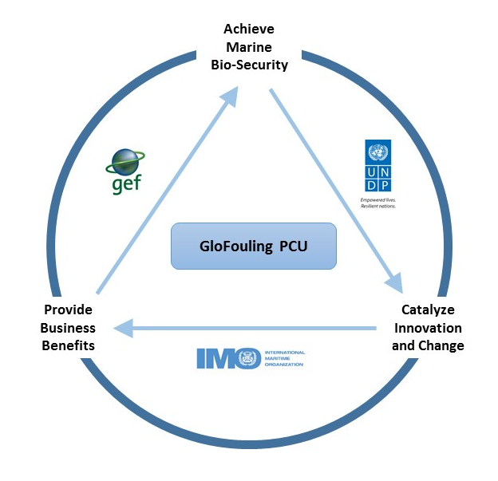
Figure 10: GIA concept

The strategic partnership between GloFouling Partnerships and industry will be mainly funded through the GIA Fund, built up through annual subscriptions from private sector companies that have a stake in any aspect of biofouling management. The GIA Task Force will be created with representatives from private sector partners that have contributed to the Fund, and the PCU will act as Secretary. So far, five companies have stated their support to the GIA through letters of endorsement (see Annex K-8). The GIA funds will be utilized over the course of the Project duration for the implementation of activities devised by the GIA Task Force and will also be used to leverage substantial co-financing from other co-sponsors, such as International Financial Institutions. An organogram for the management of the GIA Fund is given in figure 11 below:

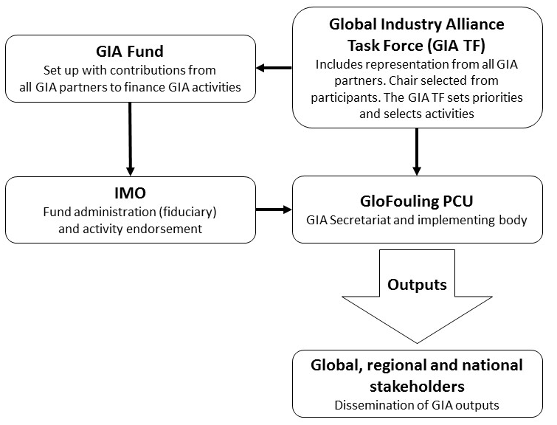
Figure 11: GIA Structure

As established in Section 1, the pathways for the transfer of IAS through biofouling are not restricted to the shipping industry, but also to other ocean industries such as mariculture, ocean energy, oil/offshore, ocean instrumentation, etc. To be effective, any efforts made towards preventing the transfer of IAS through biofouling should therefore include these other industries. To achieve this holistic and harmonised approach, the IMO will partner with the Intergovernmental Oceanographic Commission (IOC-UNESCO), a body with functional autonomy within UNESCO that is the only competent organization for marine science within the UN system.

IOC-UNESCO will take the lead in delivering activities on the non-shipping aspects. Preliminary discussions between IMO and IOC-UNESCO have also considered the possibility of establishing of a new working group of the Joint Group of Experts on the Scientific Aspects of Marine Environmental Protection (GESAMP). It is expected that FAO, WMO, ISA and other relevant international organisations would play a supporting role in the review of biofouling management practices in non-shipping pathways such as aquaculture, fisheries or deep-sea mining, through their participation in this newly created GESAMP working group.

In parallel, and to coordinate contributions and participation from private sector companies outside the shipping industry (non-shipping pathways), the World Ocean Council (WOC) has been identified as an international, multi-sectoral institution that is in the best position to approach the leading industries related to non-shipping pathways and to focus on long-term private sector engagement for improved biofouling management. The WOC will include the project and its private-sector components in its regular agenda, taking responsibility for the sectors that are not regulated by IMO. This will include creating an industry task force similar to the GIA and an investment platform for financing technology development, and holding a series of forums for private sector engagement to channel private sector contributions for the development of best practices.

2.3 Project objective and expected outcomes
The overall objective of the GloFouling Partnership Project is to build capacity in developing countries for implementing the IMO Biofouling and other relevant guidelines for biofouling management and to catalyse overall reductions in the transboundary introduction of biofouling-mediated IAS with additional benefits in the reduction of GHG emissions from global shipping.

In the achievement of this objective, five project components have been identified, each with corresponding outcomes, outputs and activities, (see the project logical framework, Section 5). The five components of the project are as follows:

- Assessing relevant national and regional policies, legislation and institutions to identify gaps, inconsistencies and conflicts, and, as appropriate, adopt LPIR measures to minimise the risk of IAS transferred through biofouling.

- Developing capacity for the implementation of the IMO Biofouling Guidelines through national capacity building, training and technical support, undertaking focused and sustained communications and awareness-raising and executing Pilot/Demonstration Projects in selected ports and marine protected areas.

- Building on the existing partnership concepts and mechanisms, established through GEF’s GloBallast partnerships, and expanding the existing GIA framework to bring active private sector participation at global, regional, national and local levels, to ensure the development of innovative technological and other solutions and financial sustainability for the control and management of biofouling and for the effective involvement of the relevant stakeholders.

- Knowledge management and developing an institutional and procedural approach for monitoring and evaluation of biofouling management and control measures.

- Adaptive project management and coordination for implementation, monitoring and evaluation.

The project will demonstrate practical ways of overcoming barriers to the adoption of best practices, creating an enabling environment for technology development and transfer, and will harness the involvement of IMO as the UN agency specialized in regulating the transfer of IAS through maritime transport and the emission of GHGs from shipping, as well as cross-sectoral leadership and collaboration with the private sector to address biofouling over the long-term via the IOC-UNESCO and the WOC. Clearly associated with and supporting the GEF-6 International Waters and Climate Change Mitigation focal area strategies, the project will help to develop strategic links across operational programmes across focal areas, and will contribute to an integrated, cross-sectoral approach to marine ecosystems management.

It is expected that by the end of the project, all LPCs will be able to demonstrate significant improvement in their legal, policy and institutional structures, with corresponding reduced risks from biofouling mediated IAS. Such improvements in biofouling management will require that each of the 12 LPCs will establish institutional mechanisms for carrying out the project. This will include identifying a lead agency and establishing a national task force (NTF), and that each NTF will take responsibility to develop a National Biofouling Management Strategy and Action Plan (NBMS), which lays out the mechanisms to be used by national Administrations, including funding, to establish an effective and sustainable biofouling management program.

In addition to catalysing LPIR in LPCs, the GloFouling project will focus on increased capacity building in LPCs and strategic regions. The Project will create new platforms for the collation of existing biofouling management knowledge and will instigate new reviews and studies to present information in accessible and applied form to assist LPCs in developing tools and effective approaches to implementing NBMS. A further indication of project success will be that member states of the Regional Seas conventions and Large Marine Ecosystem programmes will indicate their collective support, by approving regional strategies and protocols on biofouling management.

The Project recognizes that technology solutions must go hand in hand with LPIR in order to substantially reduce the risks of biofouling mediated IAS. As a consequence, the project includes a series of activities (see Component 3), designed to join with industry in pursuit of cost-effective technology solutions for biofouling management. It is important to note that a successful conclusion of the project assumes that, during the 5 years of project implementation, research and development by industry will escalate, and effective technology solutions for biofouling management will be made available to companies in shipping and other sectors relevant to biofouling.

The following diagram (figure 12) graphically depicts the project objective, components, outcomes, outputs and activities (at global, regional, national and local levels) to be carried out. These are then further discussed as a narrative in section 2.4, and then provided in Section 5 using a Logical Project Results Framework approach.

Figure 12: Overview of the GloFouling Project’s Outcomes, Outputs and Activities
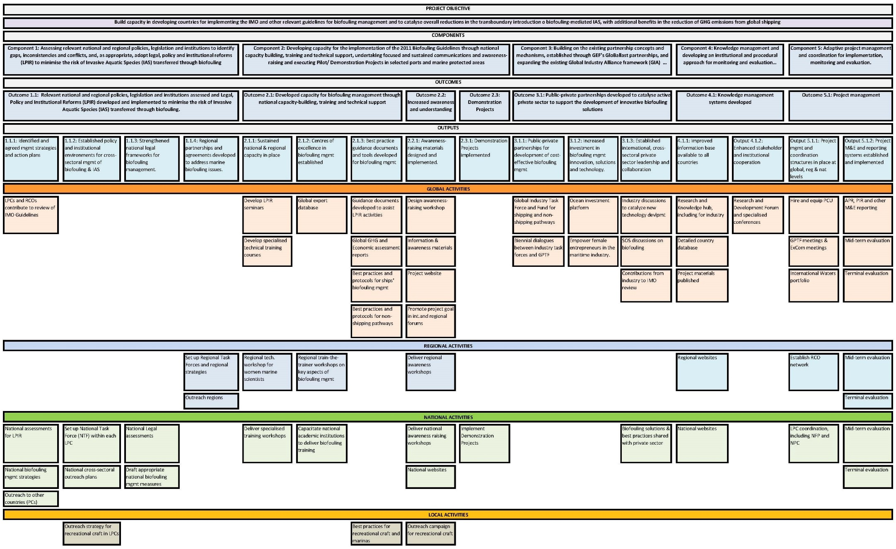

2.4 Project Components, Outcomes, Outputs and Activities

The full description of the Project Components, Outcomes, Outputs and Activities is given below and should be read in conjunction with the Logical Framework provided in Section 5 and in the context of Figure 11 above.

The project Logical Framework also provides all the baseline scenarios, mid-term and end of project targets, indicators, sources of verification and risks, assumptions & mitigation strategies associated with each activity described below.

Component 1
Assessing relevant national and regional policies, legislation and institutions to identify gaps, inconsistencies and conflicts, and, as appropriate, adopt legal, policy and institutional reforms (LPIR) to minimise the risk of Invasive Aquatic Species (IAS) transferred through biofouling.

Component 1 of the GloFouling Partnerships Project will assess relevant national and regional policies, legislation and institutions to identify gaps, inconsistencies and conflicts, and will assist in the development and adoption of LPIR to minimise the risk of IAS transferred through biofouling. The end of project target for this Component is to ensure that appropriate and sustainable LPIR to prevent the transfer of IAS through ships’ biofouling is in place at national and regional levels. This component will be achieved through a single Outcome:

Outcome 1.1: Relevant national and regional policies, legislation and institutions assessed and Legal, Policy and Institutional Reforms (LPIR) developed and implemented to minimise the risk of Invasive Aquatic Species (IAS) transferred through biofouling.

The project is designed to assist the participating countries and regions to develop, implement and enforce LPIR in order to improve biofouling management practices and thereby mitigate the risk of transferring IAS. At the conclusion of the GloFouling Partnerships Project it is expected that LPCs will have reviewed their current Legal, Policy and Institutional arrangements, defined biofouling management strategies and drafted appropriate national biofouling management measures on both national and regional scales. To achieve this, all LPCs are expected to develop reports to assess the current national status with regards to biofouling management and the economic impacts of IAS and the cost of implementation of biofouling management best practices. These reports will be developed using the tools and methodologies prepared and published by the Project through activities in Output 2.1.3. In parallel, regional organizations are expected to encourage the harmonisation of biofouling management and mitigation measures at the regional level by supporting outreach activities to PCs in the region and incorporating the biofouling agenda into current regional action plans. This Outcome 1.1 will be achieved via four Outputs and associated activities:

Output 1.1.1: Identified and agreed management strategies and action plans to address the threats posed by biofouling for ships and other transportable marine infrastructure.
Activities falling under Output 1.1.1 will examine current legal, policy and institutional arrangements in LPCs to identify appropriate strategies for LPIR to implement the IMO Biofouling Guidelines (and other relevant guidelines). Specific activities falling under this output will include the creation of a NTF in each LPC to oversee LPIR components of GloFouling, conducting National Assessments to establish baseline LPI arrangements relating to biofouling, conducting Economic Assessments to examine costs and risks associated to biofouling, and the development of a National Biofouling Management Strategy and Action Plan detailing how to implement National LPIR to improve biofouling management within specified timeframes. Five Activities are identified within this Output:

Activity 1.1.1.1: Conduct National Status Assessments for biofouling management and national economic assessments of the impacts of biofouling and the cost of appropriate control and management in LPCs.
It is expected that all 12 LPCs will develop a report to identify their key national issues for biofouling management, their top priorities and plans for reforms. The reports will be developed using the guidance published by the Project through activity 2.1.3.1. It is important to note that the assessments are not designed to be at the level of detail provided for in GEF transboundary diagnostic analyses (TDAs). The emphasis is not to move through an extensive set of stakeholder discussions in order to arrive at an understanding of root causes, but rather to set the stage for the strategic planning exercise by determining key issues and current status.
In addition to being perceived as a major ecological problem, IAS cause significant economic impacts through, inter alia, disruption to fisheries, fouling of coastal industry and infra-structure, interference with human amenity and the costs of research, monitoring and control and mitigation measures. Globally, such economic impacts are poorly quantified, but are likely to be considerable. The 2004 GloBallast initial scoping study provided some broad estimates of economic costs encompassing both direct economic costs (e.g. reductions in fisheries production, reduced output in aquaculture, impacts on infrastructure and amenity-based impacts) and management costs of IAS (e.g. prevention, eradication, control, education, regulation, etc.). This broad baseline has been supplemented by the National Economic Assessments of participating countries in the GloBallast Project.
Notwithstanding the baseline information provided through GloBallast, LPCs engaged in the GloFouling Partnerships have a limited understanding of the contribution of IAS to economic impacts and the specific costs of introducing specific LPIR measures to better manage biofouling. In order to provide a more informed basis for governments and industry to respond more effectively to this problem, an international consultant will be engaged to provide a consistent approach to conducting Economic Assessments in each LPC, and to subsequently compile an overview document providing an international economic assessment encompassing the outputs of the national assessments. The approach will encompass a cost-benefit analysis that compares known impacts from biofouling species to projected costs for management measures. In addition to calculating response costs for biofouling management, each of the LPCs will be tasked with identifying mechanisms to finance their programmes in light of these costs.

Activity 1.1.1.2: Develop National Biofouling Management Strategies and Action Plans in LPCs and PCs.
Each LPC will develop and adopt a National Biofouling Management Strategy and Action Plan (NBMS) and implement it during the course of the project. The NBMS will cover all major facets of biofouling management, including legal and policy issues, institutional strengthening, regional cooperation, biofouling monitoring and management, port State control enforcement, and flag State requirements. The NBMSs should specifically address how elements of the IMO Biofouling Guidelines will be integrated into LPIR and how capacity for biofouling management will be developed and maintained. Furthermore, the NBMS will identify appropriate timeframes for the development and delivery of appropriate biofouling management measures and highlight how such initiatives will be sustained. Consideration should also be given to the existing National Biodiversity Strategies and Action Plans to incorporate reference to NBMS.
It is assumed that the Strategies will need to be approved at cabinet or ministers level, and/or by national legislative bodies, and/or by the National Task Forces (see Activity 1.1.2.1). This outcome will be achieved through a step-wise process that starts from the development of guidelines, then a series of national stakeholder meetings and regional harmonization workshops, leading to the development of the national strategies. In addition, the achievement of other Outputs within Outcome 1.1 all link directly into strategy development, providing inputs to the Strategy and in turn being directed by the Strategy (e.g. Activity 1.1.1.1: Status Assessment, Activity 1.1.1.3: Economic Assessment, Activity 1.1.3.1: Legal assessment, Activity 1.1.3.2: National biofouling management measures). This inter-linkage of inputs and outputs suggests that drafts of the economic reports, legislative reports and financing options will need to be on hand for the development of the NBMS, and the final reports will then need to be completed once political direction is achieved by approval of the strategy.
As an adjunct to the achievements in LPCs, it is expected that the RCOs will spearhead an effort in their respective regions to draft NBMS in PCs through South-South cooperation and using expertise developed by the Project in LPCs in the region. The development of NBMS in PCs will also be conducted using the methodology and recommendations created by the Project in Activity 2.1.3.2. It is also expected that the development of NBMS in PCs will contribute to the harmonisation of measures at the regional level and contribute to the establishment of biofouling management strategies at the regional level (Output 1.1.4).

Activity 1.1.1.3: LPCs and RCOs contribute to the evaluation of the IMO Biofouling Guidelines.
Throughout the GloFouling Project LPCs and RCOs will incorporate lessons learned and strategic assessment outcomes into ongoing contributions to the evaluation of the IMO Biofouling Guidelines, initiated by MEPC 72 with the inclusion of a new output on the review of the Biofouling Guidelines, based on a proposal put forward by Australia, the Netherlands and New Zealand (document MEPC 72/15/1). The review will be further supported by the Guidance for evaluating the 2011 Guidelines for the control and management of ships’ biofouling to minimize the transfer of invasive aquatic species (MEPC.1/Circ.811), published by IMO in 2013.

Output 1.1.2: Established policy and institutional environments in all participating countries, conductive to cross-sectoral management of IAS transferred through biofouling.
Activities falling under Output 1.1.2 will be directed towards establishing an effective institutional setup and dialogue between the key national stakeholders, including industry associations and the private sector, raising awareness of biofouling issues within the LPCs and seeking community input into the National Biofouling Management Strategy and Action Plan. Specific Activities will include the development of an Outreach Strategy and establishment of cross-sectoral coordination mechanisms to facilitate broad stakeholder input into GloFouling Partnership Projects and opportunities to share lessons learned between stakeholders and industry sectors. Three Activities are identified within this Output:

Activity 1.1.2.1: Set up a National Task Force (NTF) in LPCs.
GloFouling Partnerships includes an additional governing task force at the national level. All the LPCs will either develop new task forces or utilize appropriate existing task forces to ensure that:
- Other pertinent government agencies (e.g. port State control, ports management, transportation, environment and health) participate in the development of a national strategy and in the implementation of the Action Plan and the activities of the GloFouling Partnerships, and can be called upon to support legal, policy and institutional reforms.
- Interested stakeholders from industry and Civil Society Organizations (CSOs) have an opportunity to stay abreast of the strategies and actions being devised under GloFouling Partnerships.
The NTF meetings are expected to occur every year, and especially prior to the Regional Task Forces (RTF) and Global Project Task Force (GPTF) meetings. In this way, the LPCs have an opportunity to formulate their positions and recommendations prior to regional and then global decision-making meetings of the Project.

Activity 1.1.2.2: Develop a national cross-sectoral outreach plan in LPCs.
Although inclusion of interested stakeholders in the GloFouling Partnerships project activities is a key role of the NTF, a dedicated cross-sectoral outreach plan is required to ensure that all relevant stakeholders are adequately consulted and have an opportunity to provide input into the NBMS and the development and implementation of biofouling management measures. To this effect, each NTF will devise an outreach plan to identify key national maritime industry stakeholders, both from the public and private sector, and set up mechanisms for ensuring that stakeholders have an opportunity to contribute to the NBMS and participate in GloFouling Partnership activities.
The outreach plan should give particular attention to the recreational craft. Marinas constructed in the Indian Ocean and Southeast Asia highlight the growth of long-distance travel and new travel routes. Transoceanic shipment of yachts involves thousands of vessels annually (Frank 2013). In 2014, 64,000 fishing vessels of 24 m or longer, were in operation (FAO 2016). Therefore, a dedicated section of the outreach plan for the recreational boating sector is required to ensure that local activities are effectively delivered and that risks from biofouling associated with recreational boating are effectively managed. Each LPC will identify key focal points for the recreational boating sector for their nation and set up mechanisms for ensuring that stakeholders have an opportunity to contribute to the NBMS and participate in local GloFouling Partnership activities. The outreach plan should make use of awareness-raising materials created by the Project to this effect (refer to Outcome 2.2).

Output 1.1.3: Strengthened national frameworks for biofouling management.
The implementation of effective biofouling management strategies will in most cases entail the need to enhance national legal structures. The GloFouling project includes development of a generic legal framework for biofouling management, supported by legal training on maritime and biofouling management legal issues. The legal instruments will enable countries to implement the IMO Biofouling Guidelines. The intention is to develop effective regulatory frameworks in each of the LPCs. Given the voluntary nature of the Guidelines, no ratification is required, but LPCs can still enhance their legal systems and develop strategies that enable a risk-based approach and reduced threat of bio-invasions. Two Activities are identified within this Output:

Activity 1.1.3.1: Conduct national legal assessments and draft appropriate national biofouling management measures in LPCs.
This effort to develop a national legal assessment constitutes the starting point from which the current status of national legal frameworks relevant to the management of biofouling is examined, lead agencies identified and mechanisms for LPIR are assessed. This process will be informed through the production and dissemination of a guidance document for assessing national legal frameworks related to biofouling management (Activity 2.1.3.3).
Based on the outcomes of the national status, legal and economic assessments, and the priorities identified in the endorsed NBMS, LPCs will draft appropriate national biofouling management measures. Such measures should be developed in the context of the IMO Biofouling Guidelines and considering mechanisms of regional harmonization. Management measures could include a range of mechanisms appropriate to the LPC and may encompass guidelines, guidance documents, legislation, regulations or other appropriate measures. To facilitate the outcome, this activity may also include, where necessary, the provision of support by the PCU in the form of a seminar on drafting national maritime regulations.

Output 1.1.4: Regional partnerships and cooperation agreements developed to address marine biofouling issues.
Activities falling under Output 1.1.4 will be directed towards ensuring that measures adopted by LPCs are developed in coordination with broader regional biofouling management policies and agreements overseen by Regional Coordinating Organizations (RCOs). In particular, RCOs will aspire towards the introduction of consistent biofouling management measures across broader Large Marine Ecosystems (LMEs). Activities will work towards regionally harmonized biofouling management arrangements and establishing sustainable governance and support mechanisms to maintain effective management beyond the life of the GloFouling Partnerships Project. Two Activities are identified within this Output:

Activity 1.1.4.1: Set up Regional Task Forces (RTFs) in strategic regions.
The RCOs will each establish a new RTF or utilize appropriate existing task forces with representation from all countries in the region. The aims of creating RTFs are:
- To serve as a mechanism to expand Partnering Countries’ interest and involvement in GloFouling Partnerships.
- To raise issues and concerns, and generate regional status reports, for consideration at the GPTF meetings.
- To provide an opportunity for PCs to gather knowledge on the status of the IMO Biofouling Guidelines, including guidance on implementing the Guidelines.
- To develop recommendations for regional coordination on biofouling management issues and develop a Regional strategy for biofouling management (Activity 1.1.4.2).
- To identify mechanisms for national and regional sustainability on biofouling management issues after the conclusion of GloFouling Partnerships.

Activity 1.1.4.2: Draft regional strategies in strategic and outreach regions.
RTFs in each strategic region will examine options for regional cooperation and the coordination of biofouling management measures and develop a strategy to develop regional harmonization of biofouling management in each strategic region. Regional strategies should consider NBMS developed under the GloFouling Partnerships Project as well as biofouling management practices and approaches implemented by other nations both regionally and globally.
Based on the work conducted in strategic regions, the GloFouling Project will also engage other regions (outreach regions) to examine options for regional cooperation and the coordination of biofouling management measures and develop a strategy to encourage regional harmonization of biofouling management in each outreach region. Regional strategies should consider NBMS developed under the GloFouling Partnerships Project as well as biofouling management practices and approaches implemented by other nations both regionally and globally.

Component 2
Developing capacity for the implementation of the 2011 Biofouling Guidelines through national capacity building, training and technical support, undertaking focused and sustained communications and awareness-raising and executing Pilot/Demonstration Projects in selected ports and marine protected areas.

This component will aim to develop the capacity within LPCs and strategic regions to effectively assess the current status of biofouling management, develop appropriate management strategies and maintain effective and sustainable processes to reduce the transfer of IAS in association with biofouling on ships’ hulls. The capacity building will be developed through three Outcomes specifically addressing training and technical support (Outcome 2.1), awareness raising (Outcome 2.2) and the development of demonstration projects to showcase effective biofouling management (Outcome 2.3):

Outcome 2.1: Developed capacity for biofouling management through national capacity-building, training and technical support.
At the conclusion of the GloFouling Partnerships it is expected that the Project will have facilitated the training of appropriate personnel in LPCs to deliver the LPIR identified in Component 1 of the Project. The project also aims to provide training on the practical implementation of biofouling management practices to ensure that LPCs are well equipped to translate LPIR into effective on the ground management with a tangible impact of the rate of IAS transferred in association with ships’ biofouling. Outcome 2.1 is divided into 3 Outputs.

Output 2.1.1: Sustained national and regional capacity in place for reducing the introduction of IAS through biofouling.
Activities falling under Output 2.1.1 will be directed towards developing and delivering training materials to National Agencies and Management Authorities. Training material will be designed to increase awareness of biofouling issues, to provide the capacity to manage biofouling effectively within LPCs and to establish sustained capacity to effectively manage biofouling issues. Activities will include the development of technical training material by international subject matter experts, the delivery of National Training Workshops and the adaption of training material to meet the identified requirements of LPCs. Seven Activities are identified within this Output:

Activity 2.1.1.1: Design and deliver national training in LPCs on the transfer of IAS through biofouling and biofouling management for shipping and non-shipping pathways.
This activity delivers an overview of biofouling issues and is primarily intended to raise awareness of biofouling and provide context for the delivery of other technical training activities. The PCU will engage appropriate technical experts and/or consultants to develop training materials and seminars. Material will incorporate existing biofouling awareness material previously developed by IMO and include additional material focused on considerations for the implementation of biofouling management. This training could be delivered back-to-back with Activity 2.1.1.2 and/or 2.2.1.2.
In parallel, this activity will also deliver an overview of biofouling issues and is primarily intended to raise awareness of biofouling amongst stakeholders of non-shipping industries. This activity intends to summarise the best practices published through activity 2.1.3.7 into a training module to be delivered back-to-back with activity 2.1.1.1 and/or 2.2.1.2. PCU will engage appropriate technical experts and/or consultants to develop the training materials.

Activity 2.1.1.2: Design and deliver national training on inspection methodologies in LPCs.
This activity is designed to prepare and train national authorities and quarantine officers in approaches and tools to screen incoming vessels to determine the presence or absence of problematic biofouling. The PCU will engage appropriate technical experts and/or consultants to develop training materials and seminars. Approaches considered will examine cost effective methodologies appropriate for the needs of LPCs and provide training in a range of tools targeted towards various accepted thresholds for biofouling management. The training course should be based on the overview published through Activity 2.1.3.9.

Activity 2.1.1.3: Design and deliver national training on Biofouling Management Plans and Biofouling Record Books in LPCs.
This activity is designed to prepare and train national authorities and quarantine officers in the design and application of Biofouling Management Plans (BMPs) and Biofouling Record Books (BRBs) in accordance with the IMO Biofouling Guidelines. The PCU will engage appropriate technical experts and/or consultants to develop training materials and seminars. Training will focus on the reception and analysis of BMPs and BRBs from a port State control (PSC) context to ensure that LPCs are equipped to appropriately assess documentation provided by vessel operators, and to assist vessel operators in designing and maintaining BMP and BRBs. Training material will incorporate the outputs of Activity 2.1.3.13.

Activity 2.1.1.4: Design and deliver national training on in-water cleaning in LPCs.
This activity is designed to prepare and train national authorities on the issues involved in in-water cleaning, and practical management tools to mitigate risks associated with in-water cleaning. The PCU will engage appropriate technical experts and/or consultants to develop training materials and seminars. Training will showcase current in-water cleaning technologies, examine impacts to the environment associated with in-water cleaning (e.g. introduction of IAS and leaching of anti-fouling biocides) examine technological solutions (e.g. containment technologies) and also examine the effect of in-water cleaning on biofouling accumulation and the differences between cleaning to remove biofouling versus in-water grooming techniques. Training material will incorporate the outputs of Activity 2.1.3.10.

Activity 2.1.1.5: Design and deliver national training on dry dock operations and application of anti-fouling coatings in LPCs.
This activity is designed to prepare and train national authorities on best practice standards for dry-dock cleaning and the application of anti-fouling coatings and other biofouling mitigation considerations developed to minimize the transfer of IAS. The PCU will engage appropriate technical experts and/or consultants to develop training materials and seminars. Training material will incorporate the outputs of Activity 2.1.3.8.

Activity 2.1.1.6: Design and deliver technical workshop for female marine scientists in strategic regions.
This activity is designed to empower women marine scientists in LPCs to take a leading role in managing biofouling and to equip participants with the technical tools and background knowledge to support activities in delivered by the GloFouling Partnership. The PCU will engage appropriate technical experts and/or consultants to develop training materials and seminars. Partnering with national and regional Women In Maritime Associations (WIMAs) and organizations such as Women’s International Shipping and Trading Association (WISTA) will ensure this activity is implemented in line with SDG 5 – see also Annex G for the Project Gender Analysis and Action Plan.

Output 2.1.2: Centres of excellence in biofouling management established through training of selected experts.
Output 2.1.2 is designed to foster Centres of Excellence to play an ongoing role in the dissemination of sound biofouling management advice and support beyond the life of the GloFouling Partnerships Project. Hosting institutions will be identified at national or regional level with a view to develop capacity to support biofouling management initiatives by incorporating into their curricula seminars on key aspects of biofouling management. Three Activities are identified within this Output:

Activity 2.1.2.1: Design and deliver regional train-the-trainer workshops on key aspects of biofouling management.
The GloFouling Partnerships will prepare and deliver a train-the-trainer workshop designed to capacitate two participants from each academic institution designated to deliver training on biofouling management, based on the GloFouling trainings (see Output 2.1.1). Participants should be part of the staff of the academic institution and will be made familiar with the subject, the training materials and the method of delivery.

Activity 2.1.2.2: Capacitate training institutes or academies for delivery of courses on biofouling management.
Following the activity 2.1.2.1, the training institution selected to deliver biofouling management training will conduct a pilot training course, organised and delivered by the participants trained in the train-the-trainer workshop and using the materials from the GloFouling training courses on biofouling management prepared by the PCU under Output 2.1.1. It is expected that after the delivery of the pilot training course, the academic institutions will incorporate biofouling training into their curricula of studies and deliver the course on a regular basis without further support from the project, thus sustaining the intervention’s efforts.

Output 2.1.3: Best practice guidance documents and tools developed to showcase the practical implementation of biofouling management.
Activities falling under Output 2.1.3 will be directed towards developing supporting tools and monographs to assist LPCs in the development and delivery of GloFouling Project Outputs (Activities 2.1.3.1 to 2.1.3.5) and to provide best practice guidance on the implementation of effective on the ground biofouling management practices (Activities 2.1.3.6 to 2.1.3.13). The materials produced under this Output will form a key component of knowledge management and will provide a unique resource to assist LPCs, strategic regions and the broader maritime community in better managing the transfer of IAS in association with biofouling. Thirteen Activities are identified within this Output:

Activity 2.1.3.1: Develop and publish guidance documents on the main aspects informing a Legal, Policy and Institutional Reform (LPIR) process in LPCs and PCs.
This activity will produce a series of monographs to assist LPCs to develop the different aspects of LPIR, including:
- Guidance for conducting National Status Assessments (Activity 1.1.1.1),
- Guidance for developing a National Biofouling Management Strategy (Activity 1.1.1.2).
- Guidance to assist LPCs in contributing to national economic assessments, to be conducted by an international consultant who will ensure consistency of approaches and comparability between the reports drafted by all LPCs (Activity 1.1.1.3). The guidance will also allow for PCs and RCOs to conduct subsequent economic assessments relative to their needs. The international consultant engaged by the PCU to conduct the national economic assessment will be required to produce this guidance.
The PCU will engage appropriate technical experts and/or consultants to develop the monograph.

Activity 2.1.3.2: Develop and publish a global summary based on the outcome of the national economic impact assessments conducted in LPCs.
This activity will present a global summary of the national economic assessments conducted under Activity 1.1.1.3 and will provide a global cost benefit analysis of the economic impacts associated with the transfer of IAS in association with biofouling and the cost of implementing management measures. The international consultant engaged by the PCU to conduct the national economic assessments will be required to ensure harmonization of methodologies to facilitate the production of this summary report.

Activity 2.1.3.3: Develop and publish review of existing biofouling management practices across all maritime sectors, the impacts of biofouling for specific industries and how it contributes to the transfer of IAS.
With the support of the PCU, IOC-UNESCO will identify appropriate subject matter experts that will contribute to an overarching review of biofouling management across all maritime sectors. It is important to note that some sectors aim at maintaining functional efficiency or are motivated by cost efficiencies, and do not take into account the transfer and impacts of IAS. This review should therefore give special attention to the transfer of IAS and how it is related to the different activities undertaken in all maritime sectors.

Activity 2.1.3.4: Develop and publish best practices for the implementation of biofouling management for non-shipping pathways.
With the support of the PCU, IOC-UNESCO will identify appropriate subject matter experts to produce a report of best practices for biofouling management for non-shipping pathways such as aquaculture, the offshore energy industry and coastal infrastructure, including the views and experience from the private sector. It is expected that WOC will coordinate the contributions from the private sector by identifying suitable experts and representatives from the private sector. The report will assess current practices and seek to identify where examples of best practice can be shared between sectors, and also where biofouling management approaches can be shared between shipping and non-shipping sectors.

Activity 2.1.3.5: Develop and publish best practices for cleaning vessels in dry-dock and the selection and application of anti-fouling coatings to enhance immunity to biofouling.
This activity will produce a technical monograph identifying best practice approaches for managing a vessel in dry-dock to remove all high-risk accumulations of biofouling, to increase immunity to subsequent contamination and to select appropriate anti-fouling coatings based on the vessels operating parameters. The report should give special attention to niche areas, identified as an important risk in relation to harbouring IAS, with a focus on new technologies for keeping niche areas free of biofouling - proactive measures - and for removing biofouling from these area - reactive measures. The PCU will engage appropriate technical experts and/or consultants to develop the monograph.

Activity 2.1.3.6: Develop and publish best practices for inspection methodologies.
This activity will produce a technical monograph identifying best practice approaches for the inspection of ships. The monograph will include attention to niche areas, identified as a particular risk in relation to harbouring IAS, and how to assess coating condition in a practical and cost-effective manner. The publication will also examine the use of robots and any other technologies that may facilitate in-water inspection. The PCU will engage appropriate technical experts and/or consultants to develop the monograph.

Activity 2.1.3.7: Develop and publish best practices for in-water cleaning and maintenance.
This activity will produce a technical monograph identifying best practice approaches for in-water cleaning. The monograph will showcase current in-water cleaning technologies, as well as examine impacts to the environment associated with in-water cleaning (i.e. introduction of IAS and leaching of anti-fouling biocides) technological solutions (e.g. containment technologies) and the effect of in-water cleaning on biofouling accumulation, including the differences between cleaning to remove biofouling versus in-water grooming techniques. The PCU will engage appropriate technical experts and/or consultants to develop the monograph.

Activity 2.1.3.8: Development of biofouling management approaches and best practices for recreational craft and marinas.
This activity will produce a monograph identifying best practice approaches for managing biofouling of recreational craft. The monograph will utilize the IMO guidance for minimizing the transfer of invasive aquatic species as biofouling (hull fouling) for recreational craft and will focus on practical advice on how to achieve bests standards as well as a discussion of IAS transfer in the context of recreational craft and marinas. The PCU will engage appropriate technical experts and/or consultants to develop the monograph.

Activity 2.1.3.9: Develop and publish a report on the impact of biofouling management on GHG emissions.
To ensure that GloFouling project’s activities do not lose sight of potential GHG reductions due to biofouling control or dos not impede the shipping GHG related activities, this activity will aim to gather more robust information on the GHG reduction potential of biofouling management measures in particular future scenarios and forecasts. This Activity will not only provide a better picture of potential benefits of biofouling management measures but also will make sure that project activities are in tandem with GHG reduction activities at LPCs’ and international levels.
To fulfil this objective, the following specific activities will be carried out and published in a monograph:
- A full literature survey of the studies carried out on propeller and hull fouling and hull coatings, current industry practices with the aim of establishing quantified numbers on the potential level of fuel consumption reductions.
- Cost data related to propeller and hull inspections and underwater cleaning or dry-docking associated to improving the propeller and hull surface conditions.
- Estimation of cost-effectiveness of the biofouling management measures using the gathered data.
Based on this activity, a closer understanding of the relationship between GHG reduction efforts and biofouling management will be achieved.
The main deliverable of this activity will be a technical report that would contain the findings with regard to biofouling management versus energy management, cost-benefit analysis with regard to GHG reductions and conformity of GloFouling findings against the GHG reduction strategies.
The study should also include a suitable methodology for calculating and monitoring the impact of biofouling management measures on GHG emissions.

Activity 2.1.3.10: Develop and publish an overview of the application and use of Biofouling Management Plans (BMPs) and Biofouling Record Books (BRBs).
This activity will deliver an overview of the role BMPs and BRBs play in reducing the transfer of IAS in association with biofouling and will examine elements of the IMO Biofouling Guidelines to showcase how to maximize the benefit of BMPs and BRBs over the entire cycle of a vessel’s operation between scheduled dry dockings. The overview will also use available data to assess the influence of biofouling management measures over time to inform managers when reviewing BMPs and BRBs. The PCU will engage appropriate technical experts and/or consultants to develop the monograph.

Outcome 2.2: Increased awareness and understanding of the impacts of IAS introduced through biofouling, the impact of biofouling on GHG emissions, and existing management and control options.
At the conclusion of the GloFouling Partnerships Project it is expected that the project will have facilitated an increased awareness of the role biofouling plays in the transfer of IAS, the contribution of biofouling to GHG emissions, and the various options available to manage this risk. This increased awareness will be achieved through a significant multimedia awareness raising campaign in LPCs and strategic regions.

Output 2.2.1: Awareness-raising and outreach materials designed and implemented in LPCs, strategic regions and ocean industries using traditional and new media platforms.
Activities falling under Output 2.2.1 will be directed towards communication activities at the global, regional and national levels using awareness material and technical resources developed by the GloFouling Partnerships Project to ensure that interested stakeholders, the private sector and the general public in all partner regions and countries are informed of the issues and project status. Thus, the output serves to capture all project activities designed to create and disseminate printed and visual media, including posters and videos. Awareness material and information resources will include outreach campaigns using social media and a GloFouling website as well as a range of other targeted material and face-to-face events. Eleven activities are identified within this Output:

Activity 2.2.1.1: Design Project branding and visual identity, maintain a project website and publish news items and other outreach materials to showcase project activities and achievements.
Through this activity, the PCU will channel the definition of its communication strategy. It will also include selecting the Project’s logo and an appropriate style and branding to guide the design of its publications, website and general awareness-raising materials. Selection of the branding should be conducted through an appropriate tender, following standard IMO procedures for procurement.
Within this activity, the PCU will develop and launch a dedicated website, which will represent the major portal to provide materials and resources and up to date information regarding the GloFouling Partnership Project. The PCU will maintain and coordinate the delivery of appropriate materials for the website. To ensure sustainability, hosting will be provided either by the IMO Secretariat or through the GEF IW:LEARN Project. The website is expected to serve as the main point of entry for information about the Project and a vehicle for the outputs from activities 4.1.1.1 (Knowledge hub), 4.1.1.2 (Project outputs database) and 4.1.1.3 (Countries’ Profile database).
News items and other outreach materials to showcase project activities and achievements will ensure that interested stakeholders and the general public in all partner regions and countries stay informed of the issues and project status. Actions included here will serve to capture all project activities designed to create and disseminate printed and visual media, including news items, pamphlets and posters. The PCU shall also contribute to external publications such as case-studies or best practices for project implementation, developed under the aegis of UNDP, GEF, IW:LEARN or other relevant stakeholders. This activity also includes the publication of a monograph at the end of the project reviewing and presenting its achievements.

Activity 2.2.1.2: Design and deliver national and regional awareness-raising workshops on biofouling management.
Awareness raising workshops will be delivered at the national level to increase awareness of biofouling issues and engender support and engagement with the GloFouling Partnerships Project. Awareness material already developed by IMO will be adapted and presented in addition to new material produced specifically to support GloFouling outputs. Awareness raising workshops will evolve throughout the course of the project to reflect the shift from awareness of the problem towards awareness of available solutions. The workshops will also present the impact of IAS transferred through non-shipping pathways.

Activity 2.2.1.3: Design and distribute information materials for awareness-raising on biofouling issues and the impact of IAS.
A broad range of awareness raising material and policy briefs will be produced and available through the GloFouling website, social media and other communication channels, as well as in printed form within the LPCs and strategic regions. There are four key aspects to be delivered by this activity:
- Awareness raising material reflecting the entire breadth of activities encompassed by the GloFouling Partnerships Project and utilising a range of print and visual media strategies.
- Following the successful model of GloBallast, the GloFouling Partnerships project will produce and broadcast at least two awareness raising audiovisual products focused on IAS impacts and the management of biofouling. The goal will be to produce at least one longer feature documentary accompanied by a shorter one suitable for dissemination on social media. Given the costly nature of audiovisual productions, the PCU may seek formulas for financing the production costs, through contributions from either GIA members, developed countries and/or strategic partners. The selection of the production company shall also include exploring suitable channels for distribution of the final product through global content providers. Audiovisual products shall also be available on the Project website.
- As part of the local engagement strategy for the GloFouling Partnerships, LPCs will conduct a targeted outreach campaign to deliver awareness material and inform local recreational boaters on the problems associated with biofouling and effective approaches to managing biofouling. This outreach campaign will incorporate the delivery of targeted material produced through Activity 2.1.3.11 as well as providing an opportunity for recreational craft operators to contribute to the development of the NBMS.
- As part of the national engagement strategy for the GloFouling Partnerships, LPCs will conduct a targeted outreach campaign to design and distribute biofouling awareness material to the non-shipping sector. This outreach campaign will incorporate the delivery of targeted material produced through Activity 2.1.3.7 as well as providing an opportunity for broader consultation and input in the development of the NBMS.

Activity 2.2.1.4: Translate appropriate project publications and outreach materials into key languages.
The activity will ensure that project outputs and monographs are translated into at least four key languages to ensure broad dissemination and engagement. While other languages may be considered, key languages for the GloFouling Partnerships Project will include English, Spanish, French and Arabic.

Activity 2.2.1.5: Represent and promote the project in international and regional conventions and forums.
This activity will ensure that a public presence will be maintained by the GloFouling Partnerships Project at major international and regional conventions and forums (such as the meetings of the Conference of the Parties of the CBD, technical conferences on different aspects of biofouling management (such as ICMCF, ANZPAC workshops or others) and at meetings with other international projects that may contribute to the overall goal of GloFouling Partnerships. This representation effort will be shared between the PCU and experts within its regional and national partners.

Outcome 2.3: Effective approaches to biofouling management and the mitigation of risks associated with the transfer of IAS through biofouling are showcased through demonstration projects in each Lead Partnering Country.
At the conclusion of the GloFouling Partnerships Project it is expected that LPCs will have showcased effective approaches to biofouling management through a series of demonstration projects in selected ports and/or marine protected areas. The end of project target for this Outcome is to deliver demonstration projects that have engaged local and national stakeholders in the development of sound biofouling management practices.

Output 2.3.1: Demonstration Projects undertaken to showcase the implementation of improved biofouling management practices.
Demonstration Project activities will be designed to highlight sound approaches to biofouling management and to involve a broad range of stakeholders in GloFouling Partnerships Project. LPCs will select and design an appropriate demonstration project from the four available options and based on their recognized strategic priorities. Demonstration Projects in LPCs will encompass a number of identified priorities that showcase approaches to biofouling management and also engage local communities in the application of best practice approaches to managing biofouling.

Activity 2.3.1.1: Implement demonstration sites.
Each LPC will identify the scope of demonstration projects to be implemented and define the project goals and approach within the identified priority areas. Four options will be available:
- Demonstration site on in-water cleaning. Site visits to witness the demonstration of existing and novel in-water cleaning technologies, as well as projects to showcase the operation of in-water cleaning technologies used in commercial applications. Demonstration Projects may encompass both shipping and non-shipping in-water cleaning and biofouling management tools.
- Demonstration site on in-water biofouling inspection tools and procedures for recreational craft. Application of in-water biofouling inspection tools such as ROVs, hand-held cameras, divers and molecular approaches. Such demonstration projects are likely to be most feasible by focusing on trials in recreational marinas where a wide range of vessels with differing biofouling statuses should be available. Projects should focus on practical tools for use by national authorities to assess risk.
- Demonstration site to showcase biofouling inspection and cleaning methodologies in shipyards and dry docks. Site visits to shipyards and dry-docks to introduce participants to the reality and scale of biofouling and to showcase the diversity and complexity of the issue. Visits should be timed to encompass the inspection of vessels immediately after drying to examine biofouling communities as well as ensuring that cleaned vessels are available to demonstrate the complexity of niche areas on vessels.
- Demonstration site to showcase biofouling management in high value marine ecosystems (such as Marine Protected Areas - MPAs). Theoretical and/or practical exercises to examine current approaches to managing biofouling on vessels visiting high value areas with a view to developing appropriate measures that can be applied in LPCs. This demonstration project should refer to existing local management strategies such as those employed in the Galapagos Islands (Ecuador), the Hawaiian National Monument (US) and the New Zealand Sub-Antarctic Islands and Kermadec Islands.

Component 3
Building on the existing partnership concepts and mechanisms, established through GEF’s GloBallast partnerships, and expanding the existing Global Industry Alliance framework (GIA) to bring active private sector participation at global, regional, national and local levels, to ensure the development of innovative technological and other solutions and financial sustainability for the control and management of biofouling and for the effective involvement of the relevant stakeholders.
A crucial part of the effort to reduce the threat of IAS transferred through biofouling is in the area of research and development into cost effective solutions and technologies. The effective implementation of the IMO Biofouling Guidelines and other best practices will require that the current technology hurdles are overcome, and effective solutions are available for testing and approving the use of new technologies.
Pending the development of proper research on the economic impact studies to be prepared by the Project, the estimated savings related to reduced levels of energy consumption seem to indicate there is ample room for market forces to drive innovation, and it strongly suggests that a close partnership with industry is crucial if solutions are to be achieved in the near term. Although several R&D efforts are currently underway, one of the difficulties faced by this diverse global R&D effort is the lack of effective lines of communication between these groups and with governments and the shipping industry. There is also a general lack of involvement of developing countries and an increasing need to facilitate technology transfer towards developing countries and ensure global sustainability through North-South collaboration, and international harmonization of best practices.
Component 3 of the GloFouling Partnerships Project will replicate and develop the experience gained through the GloBallast Project to develop a Global Industry Alliance on marine biosafety that will foster private-public partnerships and play a key role to support the development of innovative technological and other solutions for the control and management of biofouling. The outputs and activities under Component 3 will be funded mostly by private sector partners.

Outcome 3.1: Public-private partnerships developed to bring active private sector participation at global, regional, national and local levels, to support the development of innovative technological and other solutions and financial sustainability for the control and management of biofouling and for the effective involvement of relevant stakeholders.
Through the outputs resulting from the implementation of activities included in this outcome, it is expected that Public-Private Partnerships (PPPs) will incentivise the development of technologies, clarify the difficulties for testing and implementing new approaches, facilitate financial instruments for R&D and encourage cross-sectoral public-private dialogues to help the definition and establishment of best biofouling management practices.

Output 3.1.1: Public-private partnerships developed to incentivize the development of cost-effective management and technological solutions to prevent the transfer of IAS through biofouling.
The strategic partnership between the GloFouling Project and the industry will be funded through:
- The Global Industry Alliance (GIA) Fund, built up through annual subscriptions from private sector companies that have a stake in any aspect of biofouling management.
- In-kind support through independent technology development efforts by GIA members who have agreed to share the results of these developments with GloFouling Partnerships and to support technology diffusion and North-South technology transfer. Based on the support letters provided by the GIA members, it is expected that significant co-financing/parallel financing resources from industry will be leveraged during the implementation of the project.
- Activity-specific partnership arrangements will also be established which will be negotiated and concluded during the course of the Project. Such partnerships could be at the global, regional or even national levels depending on the activity and geographic locations. Contributions from the industry in the form of expertise, direct financial support and other in-kind contributions can form the basis of such partnerships.

Activity 3.1.1.1: Set up a Global task forces for shipping and non-shipping industries with private sector financial contributions.
The GIA Task Force will be created with representatives from the industry partners, and the PCU will act as Secretary. The PCU will develop the final terms of reference that will govern the GIA Task Force and the GIA Fund (see section 2.2.6). So far, five companies have stated their support to the GIA through letters of endorsement (see Annex K-8).
Once the GIA is in operation, its members can decide how frequently they intend to meet. At a minimum, it is expected that the industry members will meet at least three times during the course of the project (inception, mid-term and closing meetings). The Chair of the GIA will be from one of the industry members on a rotational basis. The industry will also have representation on the Global Project Task Force (GPTF).
The GIA funds will be utilized over the course of the Project duration for the implementation of activities devised by the GIA Task Force and will also be used to leverage substantial co-financing from other co-sponsors, such as International Financial Institutions.
With regards to non-shipping industries, the WOC has been identified during the development of the PIF as the best candidate to approach the leading industries related to non-shipping pathways of biofouling. Through this activity, WOC (with the support of IOC-UNESCO) will set up a Global Industry Task Force similar to the one created by the PCU for the shipping industry.

Activity 3.1.1.2: Hold biennial industry dialogues between industry task forces and the GloFouling GPTF.
The Project will facilitate dialogue between the Industry Task forces for shipping and non-shipping pathways and the main project stakeholders during the biennial GPTF meetings. To this effect, the Industry Task Forces will develop a biennial report to be submitted to the GPTF, and representatives from both Industry Task Forces will participate in the meeting, with a view to increase communication between the global industry, developing countries and strategic regions, and provide input to the regulatory and capacity-building process.

Output 3.1.2: Increased investment catalysed for biofouling management innovation, solutions and technologies.
A crucial part of the effort to reduce the threat of IAS carried through biofouling is in the transformation of research and development into cost effective technologies and solutions. It is expected that the activities included in this Output will contribute to raising awareness among the investment community and create suitable environments for catalysing investment in new technologies.

Activity 3.1.2.1: Hold WOC Ocean Investment Platform sessions to catalyse investment in biofouling solutions and technologies.
Investors and financial advisers use investment platforms to access information and tools to inform their investment choices, to execute, review and potentially change their investments. The WOC has been raising awareness on the opportunities for investors to invest in responsible ocean economic development through its Ocean Investment Platform, which is intended to bring together the investment community with major ocean use companies and companies providing technology and solutions for ocean sustainable development challenges. For the implementation of this activity, the WOC will include a session on biofouling management during the meetings of its Ocean Investment Platform. The overall objective will be to present the latest technologies and investment opportunities; catalyse interaction among solution developers and investors; and provide financial incentives for the development of new or improved biofouling management solutions. The sessions will be organized by the WOC, with support and feedback from IOC-UNESCO and the GloFouling PCU when and where appropriate.

Activity 3.1.2.2: Hold global conference for female entrepreneurs in the maritime industry.
As part of the efforts of strengthening the role of women in the maritime sector, promoting gender equality and empowering women, the PCU will organise at least one conference for women entrepreneurs in the shipping and other ocean industries considered as pathways for IAS through biofouling. The overall objective of the conference will be to increase awareness amongst entrepreneurs of the business opportunities related to biofouling and invasive aquatic species. The conference will include an introduction to the biofouling issue and its role as a pathway for IAS; a review of the current international regulatory framework; new technologies and solutions; required services and potential areas for investment and development, etc. It is expected that this conference will be conductive to increased opportunities for women in the maritime and other sectors to play a leading role in the implementation of solutions to biofouling and IAS.

Output 3.1.3: Established international, cross-sectoral private sector leadership and collaboration to address IAS and biofouling management.
With the exception of coatings manufacturers, there is currently limited participation from the private sector in R&D discussions, particularly from non-shipping industries. This Output will address this issue and also foster knowledge-sharing to identify common shortfalls being confronted by the industry and technology developers, particularly for testing and deploying new technologies and tools. Moreover, it is expected that these discussions will feed into industry associations with observer status at IMO and contribute the views from the private sector into the regulatory process during IMO meetings.

Activity 3.1.3.1: Hold industry forums to identify research and development priorities relevant to biofouling management in all industries.
This activity aims to address the limited availability of forums for discussion at the global level of research and development priorities with industry associations and private sector stakeholders. The PCU will establish a biennial conference aimed at bringing together leading industry associations and the private sector, to discuss priorities relevant to research and development and technology commercialization. For each event, the PCU will set the agenda and identify speakers and organise the logistics. It is expected that the implementing partners (IOC-UNESCO and WOC) will help chair the discussions and will also lead the inclusion of non-shipping sector participants.

Activity 3.1.3.2: Hold annual meetings to discuss biofouling management issues and the impact of marine invasive species transferred through non-shipping pathways.
The WOC, through its Sustainable Ocean Summit (SOS), has been holding annual global conferences to bring together leadership companies from the diverse ocean business community. With this activity, it is expected that the WOC will use its SOS platform to include an annual parallel session on biofouling and IAS to raise awareness of the problems caused by biofouling and its impact on the transfer of IAS. The GloFouling PCU will help identify potential speakers and will help coordinate the agenda for the parallel session.

Activity 3.1.3.3: Contribute to the evaluation of IMO’s Biofouling Guidelines with input from the private sector.
Throughout the GloFouling Project it is expected that the private sector will provide its experience and feedback to contribute to the ongoing evaluation of the IMO Biofouling Guidelines, as initiated by MEPC 72 with the inclusion of a new output on the review of the Biofouling Guidelines, based on a proposal put forward by Australia, the Netherlands and New Zealand (document MEPC 72/15/1). The review will be further supported by the Guidance for evaluating the 2011 Guidelines for the control and management of ships’ biofouling to minimize the transfer of invasive aquatic species (MEPC.1/Circ.811), published by IMO in 2013. The feedback could be based on the lessons learned during Project-related activities and be part of a document submitted to MEPC or PPR through the IMO Secretariat or the strategic partners who have observer status at the IMO.

Component 4
Knowledge management and developing an institutional and procedural approach for monitoring and evaluation of biofouling management and control measures.
Through the outputs included in Component 4 of the GloFouling Partnerships Project, it is expected that knowledge management systems will be developed and stakeholder and institutional cooperation will be enhanced to contribute to monitoring and evaluation of biofouling management and control measures.

Outcome 4.1: Knowledge management systems developed and stakeholder and institutional cooperation enhanced for monitoring and evaluation of biofouling management and control measures.
Information and knowledge on biofouling management related to IAS is globally disjunct and difficult to access, with limited forums for discussion of biofouling issues at the global level with the inclusion of developing countries. The key aspect of this outcome is the sustainability of the project efforts, namely identifying how to keep updated the knowledge tools after project closure.

Output 4.1.1: Improved information base available to countries to develop appropriate national strategies and advocacy.
This Output is designed to ensure that interested stakeholders, the industrial players and general public in all LPCs stay informed of the biofouling issues, regulatory developments, Project progress, activities and status. This Output will serve to capture all Project activities, create and disseminate related printed and visual media, including research, pamphlets and posters.

Activity 4.1.1.1: Create global knowledge hub on biofouling management.
The preparation phase of the GloFouling Partnerships identified the need for a unified knowledge hub that would provide information on all aspects related to IAS and biofouling management. While the PCU will define the main items to be included, it is expected that the knowledge hub will be a gateway to providing access and/or links to IAS databases, the latest research, reports and legislation related to biofouling management. The PCU may liaise with existing IAS databases such as the GIASIPartnership Gateway, the World Register of Introduced Marine Species (WRiMS), the IUCN Global Invasive Species Database (GISD), the CABI Invasive Species Compendium, etc., to avoid duplication of efforts and use content of existing knowledge platforms.
Based on the training and other capacitating activities conducted under Outputs 2.1.1 and 2.1.2, the PCU will create and maintain a global pool of experts and trainers on all aspects of biofouling management. The database will include a consolidated list of consultants and participants in Project trainings, with special emphasis on including female experts and parameters such as regional and language-based capacity. This list will serve as a database of profiles and CVs that LPCs and RCOs can utilize to identify potential resources. The sustainability plan of the Project will include solutions for maintaining the database after Project closure.
All outputs, publications and awareness-raising materials developed by the GloFouling Partnerships will be available online and downloadable free of charge for all stakeholders and the general public. It is expected that the PCU will embed the database into the existing Project website created in Activity 2.2.1.5, although other suitable formulas may be explored. To ensure sustainability of achievements, the PCU shall ensure that all content will continue to be available freely to the public after Project closure. Content should also include materials translated into other languages (i.e. not only English), based on the output from activity 2.2.1.10.
The PCU is expected to develop a database using internal or outsourced local data service providers. The database shall provide information about each LPC relevant to biofouling management, including regulations and procedures for vessels planning to navigate their waters. Cooperation will be sought from the administrator of IMO’s Global Integrated Shipping Information System (GISIS) and the GEF IW:LEARN project to facilitate hosting solutions where necessary. LPCs are expected to provide updated information using the standard format devised by the PCU and all content will be approved by the national lead agencies allowing for information sharing. The Project website (Activity 2.2.1.5) could also host such a database.

Activity 4.1.1.2: Create national and regional websites for dissemination of information in LPCs.
LPCs and RCOs are expected to create a website or add a new section to an existing website to serve as a vehicle for national and regional participants, including national and regional task force members, key stakeholders, experts, and the general public to gain access to up-to-date information on project progress, IAS, biofouling issues and management aspects. It is expected that websites will be launched in the national or regional language(s). The LPCs and RCOs are expected to provide their own financial and human resources to establish the websites, although the PCU may provide project and biofouling-related materials and images, which the LPCs and RCOs may modify for their own use while respecting relevant authorship rights. All the national and regional websites will be cross-linked with the global GloFouling website to facilitate information exchange. Cooperation will also be sought from the GEF IW:LEARN project to facilitate hosting solutions where necessary.

Output 4.1.2: Enhanced stakeholder and institutional cooperation.
A biennial R&D forum and global technology exhibition will be held to showcase technologies under development and to disseminate results from work of the scientific community.

Action 4.1.2.1: Hold biennial Research and Development Forums or specialised conferences.
The PCU is set to establish a series of R&D conferences aimed at bringing together leading scientific experts, the maritime industry, academia and technology development leaders in the field of biofouling management and IAS for a comprehensive overview of this rapidly expanding area of research and development and technology commercialization. For each event, the PCU will publish a call for papers and set up an international scientific panel to select the best submissions, and publish the conference proceedings. The PCU will also decide the theme of each conference, prepare the agenda and organise the logistics. The Project will cover travel expenses for LPC and RCO representatives to attend the conferences. The PCU will also seek additional funding and sponsorship to finance the overall cost of the R&D conferences. In parallel to the conference, an exhibition of the latest technologies available will be presented to the participants, with support from the private sector stakeholders.

Component 5
Adaptive project management and coordination for implementation, monitoring and evaluation.
Component 5 of the GloFouling Partnerships Project will provide adaptive project management and coordination for implementation, and establish the right mechanisms for monitoring and evaluation of the Project.

Outcome 5.1: Adaptive project management and coordination for implementation, monitoring and evaluation in place throughout project lifetime.
By Project closure, it is expected that learning, evaluation and adaptive management will be increased for all PCs. Within this outcome, the coordination and management aspects of the project are established, and mechanisms are established for reporting and external evaluation.

Output 5.1.1: Project management and coordination structures in place at global, regional and national levels.
For project coordination and monitoring, a lean management and coordination structure is defined at global, regional and national levels. The management and coordination structure will ensure that the activities to be conducted by the Project are smoothly delivered and the roles and responsibilities of various parties are defined, monitoring by stakeholders is in place and reporting and evaluation are carried out in a systematic basis. Seven activities are included in this Output:

Activity 5.1.1.1: Hire and equip the Project Coordination Unit (PCU) staff at IMO headquarters.
The GloFouling Partnerships will be managed globally through the PCU, based at IMO headquarters in London, UK. The decision to house the Project PCU headquarters in London is based on the synergistic effect of having the PCU in close proximity to the Marine Environment Division within IMO, to follow up and be involved in the regulatory process and discussions at MEPC and PPR meetings on biosafety related matters and receive the technical backstopping from IMO technical officers in the Biosafety Section. Given the frequency of IMO Member State participation in the regular IMO meetings, in particular the MEPC and its working groups, the PCU is in an ideal position to stay in contact with member state representatives and to ensure that the momentum for addressing biofouling management issues within the strategic regions (and in other regions) continues to build.
The PCU will be staffed by a Chief Technical Adviser, a Technical Adviser, a Principal Administrative Assistant and an Administrative Assistant. This four-person PCU constitutes a lean organizational structure for a global project of this scale. It is possible to operate effectively with such a small coordination unit because of the national and regional management structures that the project will establish and also because of the administrative and technical backstopping of IMO. The expectation is that the PCU can be quickly established and will be fully functional to ensure a smooth transition between the PPG and the full-size project implementation phase.
The PCU will be responsible for the day-to-day management of the Project, including developing and supervising technical outputs, outreaching and coordinating to strategic partners and other stakeholders, ensuring that deadlines are met, financial and reporting requirements are adhered to, consultants are effectively utilized, and the LPCs are well supported with their activities. They will also be responsible for the project monitoring and evaluation and external evaluation by the donor.
For the effective implementation of the Project activities, all PCU staff will be provided with a personal development plan related to their annual performance appraisal, giving special attention to technical knowledge aspects and specialised skills, ensuring they remain updated according to the Project needs. Objectives will be clearly outlined during the planning phase of the performance appraisal and carried out throughout the year.
Refer to section 4, Project Governance and Management, for further details and Annex D for the Terms of Reference for Key Project Staff.

Activity 5.1.1.2: Establish and support the governing bodies of the Project: Global Project Task Force (GPTF) and Executive Committee (ExCom).
The Global Project Task Force (GPTF) will meet every two years to provide an overall management advisory support for the Project and will also act like a steering group.
The GPTF membership includes participants from IMO, UNDP, IOC-UNESCO, WOC and at least one delegate from each LPC and RCO. It would also include representatives from global strategic partners, and other international organizations and NGOs as per requirements on an ad hoc basis. One member from the Global Industry Task Forces will also take part in GPTF meetings. ‘Sister’ projects identified during the implementation phase will also be invited to attend GPTF meetings to facilitate coordination between closely related initiatives which share objectives of industry transformation in the context of biofouling management.
There are significant financial implications in establishing a large GPTF, yet it is imperative that the key project participants have an opportunity to periodically come together to consider project status and operational aspects. There are three key periods when the GPTF will meet related to the following key operational events:
- Inception meeting: This will take place at the beginning of the project. It will ensure that various project activities are started based on detailed annual work plans. The work plans and various activities of the project will be subject to review and endorsement by the GPTF at this meeting.
- Mid-term meeting: providing implementation status and input to the mid-term review.
- Final meeting: This meeting will take place at the end of the project. It will concentrate on review of project results against work plan, the terminal evaluation, discussing achievements, lessons learned, next steps and sustainability aspects of the GloFouling Partnerships achievements.
During the interim years of GPTF meetings, an Executive Committee, composed of UNDP-GEF, IMO and the PCU will convene to discuss project implementation, focusing on feedback from any issues raised in the Annual Project Report and Project Implementation Review (APR/PIR). See also section 4, Project Governance and Management, for further details.
Refer to section 4, Project Governance and Management, for further details.

Activity 5.1.1.3: Facilitate project coordination at the regional and national levels.
The GloFouling Partnerships includes a close partnership with Regional Coordinating Organizations (RCOs) from the strategic regions. These organizations have been identified based upon their involvement in the UNEP-Regional Seas and Large Marine Ecosystems Programmes. It is important to note that the linkage to regional organizations is in order to expand the number of countries that can directly participate in the Project. In addition to the 12 Lead Partnering Countries (LPCs), it is anticipated that an additional 10 or more countries can participate in and benefit from GloFouling Partnerships by utilizing the assistance of these regional organizations.
During the beginning of the Project implementation, formal arrangements, including, as necessary, the development of Memorandums of Understanding (MoUs) will be established between IMO and each RCO.
These RCOs will each identify a coordinator responsible for Project activities during the five- year project cycle. See section 2.2.5 on the regional tier of implementation for more details.
The LPCs each will appoint a National Focal Point (NFP) representing the Government’s Lead Agency for biofouling management. It is assumed that, in most cases, the Lead Agency will most likely be from the Government Maritime Authority. The NFP is expected to be a senior government official who can speak on behalf of the lead agency, and who will serve on the GPTF. It is further expected that each LPC will identify a National Project Coordinator (NPC), who will provide day-to-day management for GloFouling Partnerships, on behalf of the NFP. NPCs can be current government officials, providing their time to coordinate activities to be implemented at the national level for the Project.
The project plan envisions frequent contact between the NPCs, NFPs, RCOs and the PCU, in addition to the opportunities afforded by workshops and task force meetings, for instance through videoconferencing.

Activity 5.1.1.4: Coordinate project implementation with the GEF-UNDP International Waters (IW) portfolio.
Based upon the experience from the GloBallast Partnerships, the recommendations from the terminal evaluation report, and the escalating requests to IMO from international and regional organizations to know more about biofouling management and IAS, a specific budget has been included to present the GloFouling Partnerships at GEF International Waters project biennial meetings (IW Conference – IWC) and annual meetings of the Large Marine Ecosystems (LMEs) and UN Environment Regional Seas Programme. It is expected that this activity will allow for stronger coordination with ‘sister’ projects and integration in the overall objectives of the LMEs and Regional Seas Programme of UN Environment.

Output 5.1.2: Project monitoring, evaluation and reporting systems established and implemented.
The second Output and related activities within Outcome 5.1 involve monitoring and reporting procedures during the project. Project monitoring, evaluation and reporting systems will be established and implemented, to include mid-term review and terminal evaluation and the submission of Annual Project Reports and Project Implementation Reviews (APRs/PIRs) and other GEF/UNDP project monitoring reports as required. Full details on monitoring and evaluation can be found in the M&E Plan included in Section 6.

Activity 5.1.2.1: Develop and submit APR/PIR and other required project monitoring reports as per the M&E plan.
The PCU will be responsible for the submission of Annual Project Reports and Project Implementation Reviews (APRs/PIRs) and other progress reports defined in the M&E plan (available in Section 6), such as the Quarterly Progress Reports (QPRs).

Activity 5.1.2.2: Conduct mid-term review and terminal evaluation.
The main focus of the mid-term review will be on the progress made to date, and whether changing circumstances merit revisions in the work plans. The mid-term review report will be submitted to UNDP/GEF in the same year as the mid-term GPTF. The report findings and responses outlined in the management response will be incorporated as recommendations for enhanced implementation during the final half of the project’s duration. The terms of reference, the review process and the mid-term report will follow the standard templates and guidance prepared by the UNDP Independent Evaluation Office (IEO) for GEF-financed projects. The consultant(s) that will be hired to undertake the assignment will be independent from organizations that were involved in designing, executing or advising on the project. The GEF Operational Focal Point and other stakeholders will be involved and consulted during the mid-term review process.
An independent Terminal Evaluation (TE) will take place upon completion of all major project outputs and activities to address project successes, shortcomings, lessons learned and recommended next steps. The terminal evaluation process will begin at least three months before operational closure of the project allowing the evaluation mission to proceed while the PCU is still in place, yet ensuring the project is close enough to completion for the evaluation team to reach conclusions on key aspects such as project sustainability. The PCU will remain on contract until the TE report and management response have been finalized. The terms of reference, the evaluation process and the final TE report will follow the standard templates and guidance prepared by the UNDP IEO for GEF-financed projects. The evaluation will be independent, impartial and rigorous. The consultant(s) that will be hired to undertake the assignment will be independent from organizations that were involved in designing, executing or advising on the project to be evaluated. The GEF Operational Focal Point and other stakeholders will be involved and consulted during the terminal evaluation process. The final TE report will be cleared by IMO and the UNDP-GEF Technical Adviser, and will be approved by the GPTF. The TE report will be publicly available in English.

Risks and Sustainability

Risks and mitigation measures
_____________________________________________________________________________________________
Risk 1: The project is not primarily associated with a mandatory international regulatory framework, as the IMO Biofouling Guidelines are voluntary and there are no similar global guidelines for other sectors. Thus, the GloFouling Project may not have the same investment or commitment as demonstrated by States and industry stakeholders participating in GloBallast and GloMEEP, where actions were taken in the context of mandatory instruments administered by the IMO. As such, there may be a lower level of political commitment to the project itself and to sustained action beyond the project.

Mitigation: This risk, in relation to the shipping industry, is mitigated by the fact that the management of biofouling provides a substantial benefit with regard to fuel consumption and GHG emissions. On the one hand, therefore, there are benefits to ship operators through reduced fuel consumption (and thus cost) and it is envisioned that the “win-win” nature of the project will facilitate the support of the maritime industry sector in light of cost reductions, which will provide positive momentum. On the other hand, a similar rationale can also be applied to non-shipping sectors, where the project outputs will deliver commercial benefit, i.e. reduction in biofouling and, thereby, in direct costs associated with removing and disposing of biofouling. Moreover, the global political pressure to address climate change, including the contribution of shipping, is expected to boost political commitment to the project, despite that lack of mandatory international instruments to manage biofouling. The risk is also mitigated by the raising of awareness of the importance and complexity of biofouling.
_____________________________________________________________________________________________
Risk 2: The two distinct environmental benefits achievable through the management of biofouling, namely the reduction of the transfer of IAS and the reduction of GHG emissions, require different goals (levels) for biofouling management. For example, a ship that has 90% of its external hull free of biofouling may have very low hull resistance and thus may be operating at high fuel efficiency with low relative emission of GHGs. However, the remaining 10% of the hull may have biofouling, e.g. restricted to niche areas such as sea chests, which, while not contributing to drag (and fuel consumption), can still harbour IAS that represent a risk to coastal biodiversity.

Mitigation: Notwithstanding the different levels of hygiene required to address hull resistance versus IAS transfer, the goal of the GloFouling project is to provide overall better management. It is broadly accepted that, by moving towards better biofouling management practices in general, the overall risk of IAS introductions will be diminished.
_____________________________________________________________________________________________
Risk 3: The ultimate contribution of biofouling management to reducing the transfer of IAS will be difficult to quantify, due to the high level of complexity of the relevant processes, entailing a host of biological and environmental variables. Some limitations, though to a much lesser extent, may also exist in the quantification of contribution to reducing GHG emissions.

Mitigation: The implementation of the IMO Biofouling Guidelines will undoubtedly result in some risk reduction. While it may not be possible to accurately quantify the risk reduction, a measure of the actual implementation of the IMO Biofouling Guidelines across the various ship types/sectors will provide some basis for evaluation. In addition, reductions in hull resistance, which equate to reductions in GHG emissions, are expected to be possible to quantify with significant confidence.

3.2 Gender equality and empowering women
The IMO's Strategic Plan for the six-year period 2018 to 2023 specifically mentions that IMO, in all aspects of its work, will always attach the utmost importance to education and training, as well as the promotion of gender equality and the empowerment of women. At the operational level, the Programme for the Integration of Women in the Maritime Sector (IWMS) remains the primary vehicle for supporting the UN SDG 5 to “Promote gender equality and empower women”. The project will operate in accordance with the above-mentioned SDG and IMO’s Strategic Plan.

Following the consultation process during the preparation phase, the GloFouling Project includes targeted initiatives focusing specifically on women aimed at creating an empowering space for reducing existing disparities in maritime administrations, the scientific community and the private sector (e.g. activities 2.1.1.7, 2.1.2.3 and 3.1.2.2). In this regard, the participation of women associations in the maritime sector has also been secured to facilitate their contributions in the planning and roll-out of regional and national programmes. Gender equality principles have also been included into all other project activities to ensure women’s full and effective participation and equal opportunities at all levels.

Finally, all reports commissioned by the project will include gender perspectives, where relevant, to make them more central to policy development, research, advocacy, development, implementation and monitoring of norms and standards related to biofouling management and the impact of IAS.

Gender mainstreaming targets will be monitored throughout the implementation of the GloFouling project at the national, regional and global levels, using a specific gender marker and gender-sensitive indicators that have been included in the M&E plan to review how outputs and outcomes promote equal benefits for men and women and that gender inequality is not reinforced in project implementation. Annex G presents more information on the project’s gender action plan.

3.3 South-South and Triangular Cooperation (SSTrC)
The project will catalyse South-South and Triangular Cooperation (SSTrC) as a broad framework for collaboration between countries for the establishment of biofouling management best practices. This important concept of solidarity breaks the traditional dichotomy between donors and recipients and it will be a key aspect of the GloFouling Partnerships for implementing all project activities in LPCs, including for the outreach strategy and for securing intra-regional harmonization of biofouling management regulations and practices.

At the LPC level, all NFPs and NPCs will be encouraged to participate in a communication network that will facilitate knowledge-sharing with a view to increase capacity to tackle common issues and challenges related to the implementation of project activities at the national level (activity 5.1.1.6).

Another essential aspect of SSTrC will be the development of national strategies in Partnering Countries (PCs) using the experiences and technical know-how nurtured by the project in neighbouring LPCs (activity 1.1.1.4). The use of experts from LPCs trained by the GloFouling project will help disseminate the tools and practices created by the project and ensure that the lessons learned in LPCs are replicated efficiently in PCs, providing a baseline for the harmonisation of biofouling management measures in the region. Language-based partnerships will be another vehicle for establishing further South-South cooperation between countries in different regions that share a common language to facilitate knowledge-sharing.

Efforts at the national level will be reinforced through the work developed at the regional level by RCOs to increase outreach to other countries in the region and support the establishment of further Southern-driven partnerships between a LPCs, PCs and other countries, with a view to coordinate efforts and to develop regional strategies to be incorporated into existing regional instruments or action plans (activity 1.1.4.3).

3.4 Sustainability of Resources
GloFouling Partnerships aims to ensure the sustainability of relevant GloFouling products and structures to effectively support the ongoing implementation of the IMO Biofouling Guidelines and to promote sound management of the risks associated with biofouling in developing countries beyond the life of the GloFouling Project. The GPTF of GloFouling will be comprised of representatives of UNDP, IMO, IOC-UNESCO, WOC, participating countries, the private sector, NGOs and strategic partners. The Executive Committee (UNDP and IMO representatives) is the governing body of the Project. While these two official groups will cease their functions following the termination of the Project, much of the broad partnership-based governance structure may be maintained. The commitments made in support of biofouling management by regional bodies and international organizations are thus envisioned to extend beyond their direct involvement in the GloFouling Project. By continuing to work through the global network of partnering organizations, the role of the GloFouling Project is intended to be assimilated into the ongoing partnership framework. Key partners in this capacity include both Regional Coordinating Organizations (RCOs, listed in table 4) and Strategic Partners (see Annex F). All the letters of endorsement from Strategic Partners and RCOs have been attached to the project document as Annex K.
Sustainability will also be achieved through pre-existing mechanisms to strengthen knowledge management capacity such as the GEF International Waters Learning Exchange and Resources Network (IW-LEARN). Specific strategies to ensure the sustainability of GloFouling products and structures include:
    - An established global framework will help to continuously drive adoption, implementation and enforcement of national biofouling management policies and regulations by flag and port States.
    - Use of existing regional frameworks and institutions (such as Regional Seas programmes, Regional Fisheries Bodies, GEF LME programmes, etc.) as project partners who will include the project and its components in their regular agenda.
    - Use of the IMO Integrated Technical Cooperation Programme (ITCP) to sustain the technical cooperation and capacity building efforts by sustaining the delivery of the GloFouling training packages.
    - Formation of national task forces that will act as seeds for longer-term, cross-sectoral institutional mechanisms at national level.
    - The Project will facilitate increased awareness of the commercial benefits from biofouling measures, and their relation to energy efficiency, leading to increased uptake of new measures due to the highly competitive nature of the sector (at the level of ships, shore-based installations and actors, and in ports).
    - Engagement with International Financial Institutions (IFIs) as and when relevant capacity and infrastructure investment becomes necessary or opportune. Regional and multilateral IFIs will be involved in the regional stakeholder discussions that would identify capacity or infrastructure gaps in the private and public sectors to implement biofouling management practices and measures, and related investment opportunities.
    - Key project partners (executing partners), the IOC-UNESCO and WOC, will include the project and its components in their regular agenda, taking on responsibility for the sectors that are not regulated by the IMO. This will include giving continuity to the formation of an international, multi-stakeholder platform on biofouling, which is expected to serve as a longer-term institutional mechanism to address the issue.
    - The Global Maritime Technologies Cooperation Centres (MTCC) Network (GMN), an initiative funded by the European Union and implemented by IMO, promotes technologies and operations in five world regions to improve energy efficiency in the maritime sector and help navigate shipping into a low-carbon future. The Project will explore support from the GMN as potential vehicles for disseminating and/or delivering capacity-building tools once the GloFouling Project comes to completion.
    - Further linkages to other relevant interventions and projects such as the ICES-IMO-IOC Working Group on Ballast and Other Ship Vectors (WGBOSV) or the Baltic Marine Environment Protection Commission (HELCOM) COMPLETE Project (Completing management options in the Baltic Sea Region to reduce risk of invasive species introduction by shipping), have also been initiated during PPG (see Annex F).

3.5 Sustaining National and Regional Capacity
One of the key objectives of the GloFouling Partnerships is to develop capacity to assist IMO Member States to implement the IMO Biofouling Guidelines and increase capacity to manage the threat posed by aquatic biofouling. Significant contributions such as the development of tools, training courses and guidance documents, to provide contemporary, practical and best-practice-based assistance, will provide immediate benefits to LPCs. However, the long-term sustainability of such measures requires the establishment of the capacity to maintain and develop such tools and ensure that LPCs have the internal resources to train subsequent managers in the effective management of biofouling. The institutional and technical ability to disseminate, deliver and update the tools and their content is essential to ensure their value is maintained and replicated. GloFouling Partnerships has adopted a “train-the-trainers” approach to sustainable capacity building. This approach provides for sustained national and regional capacity and facilities for reducing the introduction of IAS through biofouling including established national training capabilities focused on effective biofouling management. National Maritime training institutes will also be capacitated with the GloFouling training packages which will eventually be included in their regular curriculum before Project’s closure (see Output 2.1.2). In addition, and as described in section 3.4 above, the Project will explore potential support from the GMN to maintain the availability of capacity-building tools after Project termination.

3.6 Scaling up and Replication
The country participation model, used very effectively in the GloBallast programme for developing successful models and lessons through piloting the various tools and methodologies developed, supports scaling up to include a larger number of countries as momentum builds on developing country implementation of the international guidelines. As such, LPCs participating in the GloFouling project will be expected to pass on knowledge and experience gained through the project to other countries in their regions through bilateral or multilateral agreements facilitating information exchange and knowledge sharing, especially through replicating the Project’s efforts in the Partnering Countries (PCs). Such twinning arrangements are part of the South-South cooperation and have proven a successful model in other GEF interventions and have resulted in broad regional benefits despite an initial investment in only a small number of LPCs.

New knowledge and experience gained by LPCs and regional partners through their participation in the GloFouling project will feed back to the ongoing evaluation of the IMO Biofouling Guidelines. This new knowledge will contribute to the further development, refinement and improvement of the IMO Biofouling Guidelines and thus contribute to overall improved biofouling management practices on a global scale. At the same time this may also lead to the development or improvement of guidelines for other sectors (non-shipping pathways).

Regional Coordinating Organizations (including Regional Seas Agreements, other regional marine environment organizations, Regional IMO Offices and regional WOC business leadership groups) will facilitate further scaling-up of the outputs of GloFouling and will enable knowledge-sharing across a broad geographic scale.

There is also the potential for scaling-up through the WOC international, multi-stakeholder platform on biofouling and the WOC Ocean Investment Platform. The latter brings companies developing innovation, technology and service solutions to the attention of investors, thus sustaining, replicating and accelerating investment in solutions over the long-term through this ongoing structure and process that engages the full range of industries and ocean users affected by biofouling.

The project will directly contribute to the UN SDGs (see section 2.1.4 and Annex L), in particular SDG 14. With a strong focus on LDCs and SIDS, GloFouling is at the heart of the Blue Economy approach to increase economic benefits from sustainable management of marine resources, including fisheries, aquaculture and tourism. The project will also take part in the United Nations Decade of Ocean Science for Sustainable Development (2021-2030), coordinated by IOC-UNESCO, to gather ocean stakeholders worldwide behind a common framework that will ensure ocean science can fully support countries in the achievement of SDG14. In this logic, IMO has registered the GloFouling Partnerships as an SDG 14 voluntary commitment (#OceanAction16601) and, in this way, the Project will directly contribute towards the UN Agenda 2030 (see letter from Mr Thomson, Special Envoy for the Ocean, in Annex I).

Project Governance and Management

4.1 Global Management Arrangements

4.1.1 Governing bodies
The GloFouling Partnerships will be funded by the GEF, under UN Agency Implementation, and the Implementing Partner is IMO. The project also includes stakeholder and process engagement at global, regional and national levels, including the role of IOC-UNESCO as an Executing Partner (IMO Responsible Party).

GloFouling will use the successful implementation and coordination strategy adopted and applied in previous GEF-UNDP-IMO joint collaborations, such as GloBallast and GloMEEP, which have been very successful in addressing, respectively, another significant environmental threat from IAS (transfer via ships' ballast water) and the reduction of GHG emissions, respectively. This Glo-X multi-tiered implementation strategy, which translates the global interventions to regional, national and local levels actions and engages stakeholders and strategic partners at all levels, has proven highly effective and would significantly support the results-based management approach to be used for the GloFouling project. The application and delivery of this tiered approach to GloFouling is described in Section 2.2.

The governance structure of GloFouling Partnerships is summarised in Figure 13. UNDP is the implementing agency for GEF and IMO is the Implementing Partner for UNDP; thus a Project Executive Committee (ExCom) representing UNDP and IMO will provide high-level coordination and support for its implementation. The main governance and oversight body will be the Global Project Task Force (GPTF) with representatives from GEF, UNDP, IMO, IOC-UNESCO, WOC, LPCs, RCOs, the private sector, NGOs and strategic partners. The GPTF will meet at the inception, mid-point and conclusion of the project to review progress, provide strategic advice and guidance, and support adaptive project management. The GPTF will also approve the Project Implementation Plan, LPC National Biofouling Mitigation Strategy and Action Plans and major project outputs. Further description of the roles of the GPTF and the Ex-Com are included in the M&E Plan (section 6) and in Annex D (Terms of Reference).

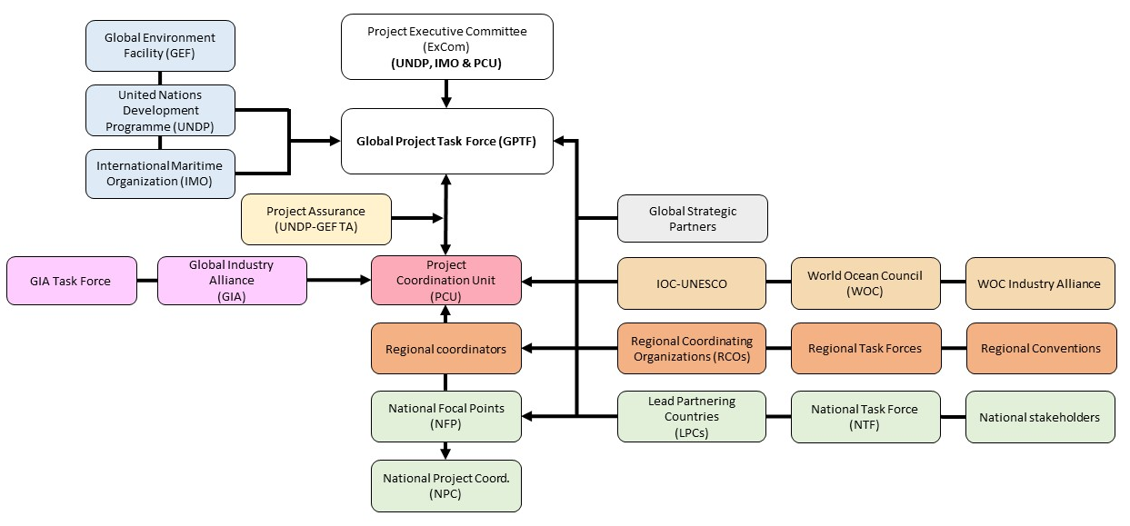
Figure 13: The GloFouling governance structure

4.1.2 Project Coordination Unit (PCU)
Day-to-day project management will be through a dedicated Project Coordination Unit (PCU) established within the Marine Environment Division (MED) of IMO under the Deputy Director, Subdivision for Major Projects. The PCU will be housed at IMO headquarters and consist of a Chief Technical Adviser (CTA), a Technical Adviser (TA), a Principal Administrative Asistant (PAA) and an Administrative Assistant (AA). The major responsibility of this personnel will be to deliver the technical outcomes of the project including training activities. Extensive use of technical expertise existing within the PCU will ensure the much needed cost-efficiency required by the tight budgets. External expertise will be hired only to augment the technical expertise within the PCU. The PCU will also assume day to day operational control of the project, and will directly liaise with counterparts at the regional and country levels (although such coordination/ administration will only take roughly 10 % of the PCU efforts). The PCU organigram is shown in Figure 14, including a brief description of each role. A full description of the duties of each position in the PCU can be found in Annex D.

The PCU will also ensure a proper coordination of the project activities with the IMO ITCP activites, as well as with other technical donor initiatives and IFIs. Furthermore, the GloFouling project will establish links with the existing GEF IW:Learn and LME:Learn in order to facilitate the management and exchange of knowledge and information.
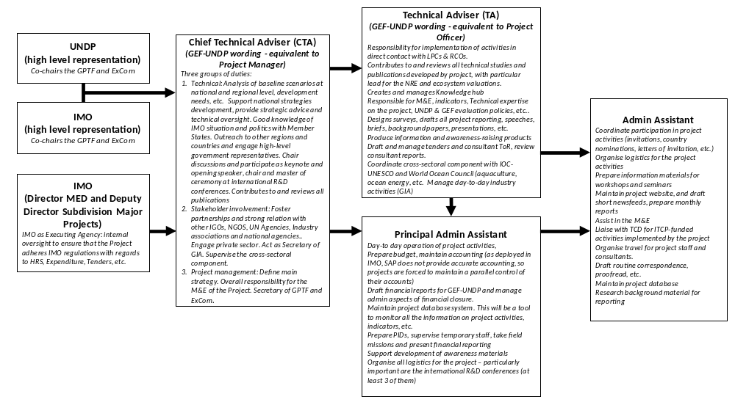Figure 14: PCU organigram

4.1.3 Executing partners
As it has been established in Section 1, the pathways for the transfer of IAS through biofouling are not reduced to the shipping industry, but also to other ocean industries such as mariculture, fisheries, ocean energy, ocean instrumentation, etc. To be effective, any efforts made towards preventing the transfer of IAS through biofouling should therefore include these other industries. To achieve this holistic and harmonised approach, and as described in section 2.2.6, the IMO will engage the Intergovernmental Oceanographic Commission (IOC-UNESCO), a body with functional autonomy within UNESCO that is the only competent organization for marine science within the UN system. IOC-UNESCO will take responsibility for the implementation of activities related to non-shipping pathways (i.e. sectors not regulated by IMO), with coordination from the PCU. The terms of the agreement between IMO and IOC-UNESCO will adhere to the standard UN Agency to UN Agency Contribution Agreement (see letter of support in Annex K-2).

In parallel, and to coordinate contributions and participation from private sector companies outside the shipping industry (non-shipping pathways), the World Ocean Council (WOC) has been identified as an international, multi-sectoral institution, that is placed in a good position to focus on long-term private sector engagement. The WOC has already established a Partnership Agreement with IOC-UNESCO. In this regard, and with oversight from IOC-UNESCO, WOC will include the project and its private-sector components in its regular agenda, taking responsibility for the private sectors that are not regulated by IMO (see letter of support in Annex K-2).

4.2 National and Regional Management Arrangements
National and regional coordination in the LPCs and Strategic Regions will be ensured through the creation and operation of National and Regional Task Forces and by identifying a National and Regional Focal Points seconded to the project by the Governments or RCOs (see paragraphs 2.2.3 to 2.2.5).

4.3 Financial Management
Financial management will be through established procedures between UNDP and IMO, and between IMO and other co-funders who will provide financing to the GIA Fund. In turn, the IMO will enter into contractual arrangements with the Regional Coordinating Organizations (RCOs) for the dispensation of funds for LPC and PC activities, and will enter into contractual arrangements with international and national consultants for the dispensation of funds for global, regional and country-level activities. The direct recruitment of consultants or agencies is the preferred course of action for GloFouling. For all country and regional level activities, the nominated RCOs will be dealing with the arrangements for the attendance of LPC participants, thus reducing the administrative burden on the PCU, although funding will be provided by the PCU. All transactions shall be conducted following the IMO Financial Regulations and Financial Rules and relevant articles included in the terms of reference and MoUs signed with the executing partners and other stakeholders of the Project.

4.4 Project Assurance
UNDP provides supervision, oversight and quality assurance role – funded by the GEF agency fee – involving UNDP staff at headquarters level. Project Assurance must be totally independent of the Project Management function. The quality assurance role supports the Project ExCom and Project Coordination Unit by carrying out objective and independent project oversight and monitoring functions. This role ensures appropriate project management milestones are managed and completed. The Project ExCom cannot delegate any of its quality assurance responsibilities to the Project Manager. This project oversight and quality assurance role is covered by the GEF Agency.

4.5 Intellectual rights and use of logo
Agreement on intellectual property rights and use of logo on the project’s deliverables and disclosure of information: To accord proper acknowledgement to the GEF for providing grant funding, the GEF logo will appear together with the IMO and the UNDP logos on all promotional materials, other written materials like publications developed by the project, and project hardware. Any citation on publications regarding projects funded by the GEF will also accord proper acknowledgement to the GEF. Information will be disclosed in accordance with relevant policies notably the UNDP Disclosure Policy and the GEF policy on public involvement .

Project Results Framework
This project will contribute to the following Sustainable Development Goal (s): SDG5, SDG9, SDG14, SDG15 & SDG17
This project will contribute to the following country outcome included in the UNDAF/Country Programme Document: n/a
This project will be linked to the following output of the UNDP Strategic Plan: 1.4.1. Solutions scaled up for sustainable management of natural resources, including sustainable commodities and green and inclusive value chains

Project Objective
Build capacity in developing countries for implementing the IMO and other relevant guidelines for biofouling management and to catalyse overall reductions in the transboundary introduction of biofouling-mediated invasive aquatic species with additional benefits in the reduction of GHG emissions from global shipping
Component | Outcome | Baseline | Mid-term target | End of project target | Indicators | Sources of verification | Risks, assumptions & mitigation
1. Assessing relevant national and regional policies, legislation and institutions to identify gaps, inconsistencies and conflicts, and, as appropriate, adopt Legal, Policy and Institutional Reforms (LPIR) to minimise the risk of Invasive Aquatic Species (IAS) transferred through biofouling | 1.1 Relevant national and regional policies, legislation and institutions assessed and Legal, Policy and Institutional Reforms (LPIR) developed and implemented to minimise the risk of Invasive Aquatic Species (IAS) transferred through biofouling | Poor understanding in LPCs and strategic regions of biofouling management practices and limited national policies or regulations focused on preventing the transfer of IAS through biofouling | National Task Forces in place in 10 out of 12 LPCs  National biofouling management strategies and action plans developed in 6 out of 12 LPCs | Appropriate and sustainable LPIR to prevent the transfer of IAS through ships’ biofouling in place in at least 10 LPCs, 3 target regions and 2 outreach regions. National strategies drafted in at least 10 PCs | Number of LPIR documents developed by the LPCs, PCs, strategic and outreach regions | Reports from NTF meetings  Reports from GPTF  National assessments conducted by all LPCs  Reports from RCO,  Regional strategies and Action plans | It is assumed that baseline information and strategic planning will be completed by the mid-term of the Project to enable progress towards implementing and achieving the goals of the National Biofouling Management Strategies and Action Plans  Mitigation: Strong support from the IMO Secretariat will be gathered to ensure National Lead Agencies in LPCs receive in-country political support to achieve the Project goals
2. Developing capacity for the implementation of the IMO Biofouling Guidelines through national capacity building, training and technical support, undertaking focused and sustained communications and awareness-raising and executing Pilot/ Demonstration Projects in selected ports and marine protected areas | 2.1 Developed capacity for biofouling management through national capacity-building, training and technical support | LPCs have limited resources to train national stakeholders and authorities. Existence of global knowledge gaps and limited technical resources to assist in the implementation of sound biofouling management. No identified pool of expertise within strategic regions | At least 3 guidance documents and reports developed and published to assist in the technical aspects of biofouling management in all sectors. At least 2 training packages developed and used for training at least 100 (50 male; 50 female) participants | At least 400 (200 female; 200 male) participants trained in different aspects of biofouling management using at least 5 training packages based on at least 8 guidance documents and technical reports published to assist in the technical aspects of biofouling management in all sectors  Centres of excellence established in at least 4 strategic regions | Attendance rates and surveys of national and regional training workshops  Number of training packages developed  Number of Centres of excellence habilitated by the project  Number of applied resources developed and published | Reports and surveys from national and regional training workshops and activities  Training packages and presentations  Reports from pilot courses in Centres of excellence  Applied monograph series | Risk 1: It is assumed that LPCs will require practical tools to assist the implementation of the IMO Biofouling Guidelines and other best practices. The development of these reports will require the support from world leading experts and global institutions  Mitigation 1: Outreach to scientific and research community was initiated during the project preparation phase to secure participation in the development of materials required for this outcome  Risk 2: It is assumed that providing training to appropriate agencies and personnel will result in broad dissemination of learnings. However there is also a risk that newly acquired knowledge and skills may not be sustained  Mitigation 2: Sustainability of learning and new skills relies on continued engagement and knowledge update. NFPs and the PCU will maintain communication with all participants in training activities with a view to guarantee sustainability of efforts
 | 2.2. Increased awareness and understanding of the impacts of IAS introduced through biofouling, the impact of biofouling on GHG emissions, and existing management and control options | Limited awareness of biofouling issues, the impact of IAS and available solutions in LPCs and, more broadly, the international shipping community and other ocean industries | Project website in place and at least 25 communication and awareness-raising materials developed in different formats (e.g. printed, audiovisual, etc.) and distributed effectively to all stakeholders through traditional and new media platforms | Project website in place and hosting guaranteed after project closure  At least 100 communication and awareness raising materials developed in diverse formats, including 2 documentaries | Number of communication and awareness materials developed and disseminated by the project | Awareness measured through project website traffic, distribution of communication resources and via feedback from strategic partners and general public | It is assumed that communication materials developed by the Project will percolate to various stakeholders via the Project website and through targeted communication actions in LPCs and strategic regions. There is a risk that these communication actions do not capture the attention of identified target audiences  Mitigation: To ensure a broad reception, communication materials will target a range of levels from the general public to governance officers, technical experts and ocean industries, and will also make use of well-established channels through IMO, UNDP, IOC-UNESCO and WOC media teams
 | 2.3. Effective approaches to biofouling management and the mitigation of risks associated with the transfer of IAS through biofouling are showcased through demonstration projects in each Lead Partnering Country | LPCs with limited experience in implementing biofouling management measures | LPCs identify demonstration projects to showcase strategic biofouling management strategies | Demonstration projects completed in at least 10 LPCs, and showcasing effective approaches to biofouling management and the mitigation of risks associated with the transfer of IAS through biofouling and contributing to stress reduction from invasive species in 150,000 ha (marine) | Number of implemented demonstration projects  Number of marine hectares under improved management effectiveness | Demonstration Project Reports  Associated outreach and awareness material | Demonstration projects could be costly and drain project resources. Due to the broad aspects of biofouling management and the different priorities in LPCs, there is a risk that participating countries will not agree on a common goal for the demonstration sites  Mitigation: Demonstration projects should be scaled according to available resources and strategic objectives of LPCs. LPCs will be offered a pool of options to guarantee adjustment to national priorities and achieve support  Co-financing from the private sector will be explored
3. Building on the existing partnership concepts and mechanisms, established through GEF’s GloBallast partnerships, and expanding the existing Global Industry Alliance framework (GIA) to bring active private sector participation at global, regional, national and local levels, to ensure the development of innovative technological and other solutions and financial sustainability for the control and management of biofouling and for the effective involvement of the relevant stakeholders | 3.1. Public-private partnerships developed to bring active private sector participation at global, regional, national and local levels, to support the development of innovative technological and other solutions and financial sustainability for the control and management of biofouling and for the effective involvement of relevant stakeholders | Limited public-private cooperation to identify needs and develop technological solutions to better manage biofouling  Limited awareness of business opportunities related to biofouling management solutions and technologies within the investment community | Industry task forces and funds set up, with contributions from at least 5 shipping and non-shipping private sector companies and producing work plans  At least 2 platforms set up to facilitate participation of industry in R&D discussions and to catalyse investment in biofouling management solutions and technologies | Industry task forces playing ongoing role to develop private sector solutions  At least USD 300,000 contributed by private sector partners to fund activities of the Global Industry Alliance  At least 6 international meetings organised through 2 platforms to facilitate participation from shipping and non-shipping private sector companies in R&D discussions and to catalyse investment in biofouling management solutions and technologies | Number industry players joining Industry task forces and total contributions in USD  Number of international R&D conferences  Number of investment discussions/meetings | Reports from meetings; conference proceedings and Industry task forces minutes | Assumes significant buy-in from key industry representatives and the identification of appropriate avenues for private sector participation  Mitigation: Outreach to private sector has already been initiated during the project preparation phase to secure engagement and participation
4. Knowledge management and developing an institutional and procedural approach for monitoring and evaluation of biofouling management and control measures | 4.1. Knowledge management systems developed and stakeholder and institutional cooperation enhanced for monitoring and evaluation of biofouling management and control measures | Biofouling management information and knowledge is globally disjunct and difficult to access, with limited forums for discussion of biofouling issues at the global level with the inclusion of developing countries | Knowledge hub created and one R&D Forum organised, facilitating the participation of voices from developing countries and facilitating North-South technology transfer | Global Knowledge hub achieves at least 500 average sessions per month  3 R&D Forums organised, facilitating the participation of voices from developing countries and facilitating North-South technology transfer | Average number of sessions per month of web-based Global Knowledge hub  Number of R&D Forums organised by the project | Global Knowledge hub website traffic reports  Published proceedings and reports from R&D Forums | Assumes cooperation from LPCs, research community, technology developers, industry and key environmental organizations for participation and information-sharing  Mitigation: The stakeholder review during the project design phase included outreach to key strategic partner to secure participation and support
5. Adaptive project management and coordination for implementation, monitoring and evaluation | 5.1. Adaptive project management and coordination for implementation, monitoring and evaluation in place throughout project lifetime | No existing project staff or structure in place  M&E plan included in Project document | All project management structures in place by end of 1st year and M&E plan fully implemented for first two years of project  Mid-term evaluation | End of project sustainability strategy addresses legacy structure and Project achieves overall Satisfactory ratings from terminal evaluation | Outcome from terminal evaluation and other M&E reports | Mid-term and Terminal evaluation reports; Report from last GPTF; Sustainability strategy | Successful project implementation will require prompt appointment of PCU staff, and national and regional project coordination. M&E will need to provide timely feedback throughout project implementation, contributing to continuous review and adaptive management  Mitigation: Engagement with IMO HR, LPCs and RCOs initiated during project preparation phase.  The design of the M&E plan includes cross-reference roles for all the main stakeholders to ensure the need for any corrective action is identified and implemented in a timely manner

Outputs and Activities | Baseline | Mid-term target | End of project target | Indicators | Sources of verification | Risks, assumptions & mitigation
Component 1: Assessing relevant national and regional policies, legislation and institutions to identify gaps, inconsistencies and conflicts, and, as appropriate, adopt Legal, Policy and Institutional Reforms (LPIR) to minimise the risk of Invasive Aquatic Species (IAS) transferred through biofouling
Outcome 1.1: Relevant national and regional policies, legislation and institutions assessed and Legal, Policy and Institutional Reforms (LPIR) developed and implemented to minimise the risk of Invasive Aquatic Species (IAS) transferred through biofouling
Output 1.1.1: Identified and agreed management strategies and action plans to address the threats posed by biofouling for ships and other transportable marine infrastructure. | LPCs have poor understanding of the baseline status of biofouling management at the national level, including the costs and benefits of managing biofouling and have not developed a strategy to implement the IMO Biofouling Guidelines and other best practices. | Development of National Status Assessments and National Biofouling Management Strategies and Action Plans in at least 6 LPCs | National strategies and action plans endorsed in at least 10 LPCs, with NTFs providing continued oversight of biofouling management issues. National strategies drafted in at least 10 PCs | Number of LPIR documents published by the LPCs and PCs | National Status Assessments.  National Biofouling Management Strategy and Action Plans.  National Economic Assessments.  LPC reports to GPTF. | It is assumed that baseline information and strategic planning will be completed by the mid-term of the GloFouling project to enable progress towards implementing and achieving the goals of the National Biofouling Management Strategies and Action Plans.  Mitigation: Strong support from the IMO Secretariat will be gathered to ensure National administrations in LPCs do receive in-country political support to achieve the Project outcomes.
Activity 1.1.1.1: Conduct national status assessments for biofouling management and national economic assessments of the impacts of biofouling and the cost of appropriate control and management in LPCs. | Biofouling management in the majority of LPCs is limited or poorly understood and inconstantly applied between maritime sectors. The economic cost associated with the impacts of IAS introduced through biofouling and the cost of implementing the IMO Biofouling Guidelines in the LPCs are unknown. | 6/12 Draft national assessments developed. 6/12 Draft national strategies and action plans include need to develop national economic assessments. | 10/12 National Status Assessments and 10/12 National economic assessments published and endorsed by NTF. | Number of national status assessment reports and number of economic assessment reports. | National status assessments.  National economic assessments.  LPC reports to GPTF. | It is assumed NTFs will have the resources to deliver National Baselines within project timeframes. The development of the Guidance document (activity 2.1.3.1) will mitigate this risk by providing appropriate advice to NTFs.  Accurate and appropriate empirical research documenting the economic impacts of biofouling is limited and may be difficult to apply in the context of LPCs. To ensure that the use of a consistent methodology, the development of economic assessments will be based on the Guidance document (activity 2.1.3.1) to ensure comparability of results.
Activity 1.1.1.2: Develop national biofouling management strategies and action plans in LPCs and PCs. | The LPCs and PCs have no formal process in place to implement the IMO Biofouling Guidelines, nor any target timeframe for implementation. | 6/12 Draft national strategies developed.  Outreach and twinning arrangements discussed between LPCs and PCs in 3 regions. | 10/12 National strategies and action plans endorsed by NTF.  National Biofouling Management Strategies and Action Plans drafted in 10 PCs. | Number of endorsed National biofouling strategies and action plans in LPCs.  Number of Biofouling Management Strategies and Action Plans drafted in PCs. | National biofouling strategies and action plans from LPCs.  Draft Biofouling Management Strategies and Action Plans from PCs.  Reports to GPTF. | It is assumed NTFs will have the resources to deliver the Biofouling Management Strategy and Action Plans in a timely manner. The development of the Guidance document (activity 2.1.3.1) will mitigate this risk by providing appropriate advice to NTFs.  It is assumed that PCs will have the resources to follow-up and deliver the Biofouling Management Strategy and Action Plans. The development of the Guidance document (activity 2.1.3.1) and outreach and twinning arrangements will assist this work.
Activity 1.1.1.3: LPCs and RCOs contribute to the evaluation of the IMO Biofouling Guidelines. | No contributions from the LPCs to the evaluation of the IMO Biofouling Guidelines. | At least one document submitted to PPR and/or MEPC reporting on the experience of LPCs in the implementation of the IMO Biofouling Guidelines. | At least three document submitted to PPR and/or MEPC reporting on the experience of LPCs in the implementation of the IMO Biofouling Guidelines. | Number of reports submitted by LPCs to PPR and/or MEPC meetings. | MEPC and PPR documents. | The evaluation of the IMO Biofouling Guidelines may need to consider issues outside of the LPCs and RCOs interests and needs to be cognisant of any other review and/or evaluation processes over the project timeframe.
Output 1.1.2: Established policy and institutional environments in all participating countries, conductive to cross-sectoral management of IAS transferred through biofouling. | Policy and institutional environments are not conductive to cross-sectoral biofouling management. | NTFs established in at least 10 LPCs and met at least once, playing effective role in steering activities listed under Outputs 1.1.1 to 1.1.3. | NTF (or lead agency) appropriately funded to sustain and oversee further development of biofouling in at least 10 LPCs. | Number of NTF meetings in LPCs. | Reports from NTF and GPTF meetings.  Reports from national outreach campaigns. | It is assumed that the private sector and relevant ocean industries are interested in participating in the dialogue and will benefit in the application of better biofouling management.  Mitigation: Awareness-raising materials and leadership from global industry partners are expected to result in the involvement of national industry representatives.
Activity 1.1.2.1: Set up a National Task Force (NTF) in LPCs. | The majority of LPCs have limited coordination of biofouling management issues across sectors. | NTFs established in at least 10 LPCs and met at least once, playing effective role in steering activities listed under outputs 1.1.1 to 1.1.3. | NTF (or lead agency) appropriately funded to sustain and oversee further development of biofouling in at least 10 LPCs. | Number of NTF meetings in LPCs. | Reports from NTF and GPTF meetings. | It is assumed that key ministries and/or lead agencies within each LPC will be engaged with GloFouling processes and appropriately resourced to contribute to NTFs.
Activity 1.1.2.2: Develop a National cross-sectoral outreach plan in LPCs. | Maritime sectors are poorly engaged and informed about the problems of biofouling and approaches to biofouling mitigation are not shared or coordinated between sectors. Biofouling management status for recreational craft in the LPCs is unknown or poorly implemented. | Key focal points for participating sectors identified and participating in ongoing dialogue with NTF.  Outreach strategy drafted in at least 6 LPCs and 6 public outreach campaigns for recreational craft are in development. | Sectoral outreach strategies developed and endorsed by NTFs in 10 LPCs.  Cross sectoral dialogue on biofouling management is facilitated through established and ongoing processes in all LPCs.  Outreach strategies for recreational craft drafted and implemented in at least 10 LPCs. | Number of National cross-sectoral outreach plans.  Number of outreach strategies for recreational craft. | Reports from NTF and GPTF meetings.  Reports from national outreach campaigns. | It is assumed that the private sector will be interested in participating in this process. The development of appropriate outreach materials (outcome 2.2) will assist in engaging with stakeholders and will outline the benefits to participation in the GloFouling process.  It is assumed that outreach activities will provide the basis to facilitate a high level of cooperation and a willingness to engage with this process within the recreational boating community. Due to the international element of recreational boating, engagement at the local or national level may not encompass some high risk recreational vessel operators entering LPC waters. Mitigation: Engagement will be sought within ports of origin of major recreational routes into LPCs.
Output 1.1.3: Strengthened national frameworks for biofouling management. | Limited national policy or regulations focused on preventing the transfer of IAS through ships’ biofouling. | Legal experts in at least 6 LPCs trained to enable effective screening of potential LPIR. | Appropriate and sustainable national biofouling management measures are in place in at least 10 LPCs. | Number of national policies, regulations or guidelines related to biofouling management. | Endorsed Legal Assessment.  Regulations, national policies or legislation, guidelines. | It is assumed that national decision-makers will support the need to define suitable national instruments for the implementation of the IMO Biofouling Guidelines.  Mitigation: Legal Assessments and National Status Assessments conducted in LPCs will help raise awareness of national decision-makers and highlight the positive outcome of developing national measures for effective implementation of the IMO Biofouling Guidelines.
Activity 1.1.3.1: Conduct national legal assessments and draft appropriate national biofouling management measures in LPCs. | The current national legal framework needs to be assessed in all LPCs. Limited national policy or regulations focused on preventing the transfer of IAS through ships’ biofouling. | 6/12 Draft national legal assessments.  Potential LPIR measures are outlined in the national biofouling management strategies in at least 4 LPCs. | 10/12 National legal assessments, leading to appropriate and sustainable national biofouling management measures in at least 10 LPCs. | Number of national legal assessment reports.  Number of drafted national policies, regulations and/or guidelines related to biofouling management. | National legal assessment reports.  Reports from NTF and GPTF meetings. | The requirements for legal assessment will vary between LPCs depending on the LPIR strategies advocated in their respective National Biofouling Management Strategies and Action Plans. Guidance prepared through activity 2.1.3.1 should aid LPCs to undertake appropriate assessments.  It is assumed that the Legal Assessment conducted by each LPC will identify the appropriate regulatory tools to be developed.  Support to lawyers, legal drafters and maritime administrations will be provided where deemed necessary to ensure a successful outcome.
Output 1.1.4: Regional partnerships and cooperation agreements developed to address marine biofouling issues. | Limited consideration of biofouling management within regions. | All Regional Task Forces (RTFs) in strategic regions are aware of the impact of biofouling in the transfer of IAS. | IMO Biofouling Guidelines and biofouling management options are included in strategies of at least 3 strategic regions and 2 outreach regions. | Number of strategic and outreach regions that include biofouling management measures in their strategic plans. | Reports from Regional Coordinating Organizations (RCOs).  Regional strategies and Action plans. | It is assumed that all countries in the region will be open to discuss the need to include biofouling management in the regional strategies and action plans.  Mitigation: the broad regional engagement facilitated by RCOs, with the help of materials developed by the Project, and the lead of LPCs, will present a viable model to engage with countries not presently participating in the project.
Activity 1.1.4.1: Set up Regional Task Forces (RTFs) in strategic regions. | Limited consideration of biofouling management within strategic regions. | All RTFs in strategic regions are aware of the impact of biofouling in the transfer of IAS. | RTFs are working to implement strategic plans in at least 3 strategic regions. | Number of regions with RTF in place. | Reports from RCOs and RTF meetings. | There is a risk that regional efforts at better biofouling management will be hampered by States.  Mitigation through RCOs and LPCs leadership with support from materials developed by project
Activity 1.1.4.2: Draft regional strategies in strategic and outreach regions. | The majority of the strategic and outreach regions lack consideration of biofouling and its role in the transfer of IAS. | All RTFs in strategic regions are aware of the role of biofouling in the transfer of IAS.  2 outreach regions are aware of the role of biofouling in the transfer of IAS. | 3 strategic regions have included biofouling management approaches in their strategies and/or action plans.  2 outreach regions have included biofouling management approaches in their strategies and/or action plans. | Number of strategic and outreach regions that include biofouling management measures in their strategic plans. | Reports from RCOs.  Regional strategic plans. | There is a risk that regional efforts at better biofouling management will be hampered by States.  Mitigation through RCO and LPC leadership with support from materials developed by project.
Component 2: Developing capacity for the implementation of the 2011 Biofouling Guidelines through national capacity building, training and technical support, undertaking focused and sustained communications and awareness-raising and executing Pilot/ Demonstration Projects in selected ports and marine protected areas
Outcome 2.1: Developed capacity for biofouling management through national capacity-building, training and technical support
Output 2.1.1: Sustained national and regional capacity in place for reducing the introduction of IAS through biofouling. | LPCs with limited resources to train national agencies and management authorities in biofouling management. | At least 100 (50 female; 50 male) participants trained in different aspects of biofouling management.  At least 2 training packages developed. | At least 400 (200 female; 200 male) participants trained in different aspects of biofouling management.  At least 5 training packages developed. | Attendance and feedback survey reports of national and regional training workshops.  Number of training packages developed. | Reports and surveys from national and regional training workshops and activities.  Training packages (manuals and presentations). | It is assumed that providing training to appropriate agencies and personnel will result in broad dissemination of learnings (i.e. train-the-trainer model). There is also a risk that newly acquired knowledge and skills may not be sustained.  Mitigation: Sustainability of learning and new skills relies on continued engagement and knowledge update. NFPs and the PCU will maintain communication with all participants in training activities with a view to guarantee sustainability of efforts.
Activity 2.1.1.1: Design and deliver national training in LPCs on the transfer of IAS through biofouling and biofouling management for shipping and non-shipping pathways. | Training needs are presently undefined and LPCs do not have access to training material or subject matter experts for developing such material. | PCU have engaged appropriate technical experts and/or consultants to develop training material.  IOC have engaged appropriate technical experts and/or consultants to develop training material. | At least 200 (100 male, 100 female) participants have received training.  Training material published on the GloFouling website and freely available. | Number of participants. | Training course materials.  Reports from trainings. | It is assumed that appropriate technical experts and/or international consultants can be identified to develop training resources and that this material can be developed within appropriate timeframes and budgets. The modules for non-shipping industries should be based on best practices published through activity 2.1.3.4. Consideration should be given for delivery combined or back-to-back with activity 2.2.1.2.
Activity 2.1.1.2: Design and deliver national training on inspection methodologies in LPCs. | Training needs are presently undefined and LPCs do not have access to training material or subject matter experts for developing such material. | PCU have engaged appropriate technical experts and/or consultants to develop training material. | Training course developed and at least 50 (25 male, 25 female) participants from LPCs trained. | Number of participants.  Training materials. | Training course materials.  Reports from trainings. | It is assumed that appropriate technical experts and/or international consultants can be identified to develop training resources and that this material can be developed within appropriate timeframes and budgets. The training course should be based on the overview published through activity 2.1.3.5.
Activity 2.1.1.3: Design and deliver national training on biofouling management plans and record book in LPCs. | Training needs are presently undefined and LPCs do not have access to training material or subject matter experts for developing such material. | PCU have engaged appropriate technical experts and/or consultants to develop training material. | Training course developed and at least 50 (25 male, 25 female) participants from LPCs trained. | Number of participants.  Training materials. | Training course materials.  Reports from trainings. | It is assumed that appropriate technical experts and/or international consultants can be identified to develop training resources and that this material can be developed within appropriate timeframes and budgets. The training course should be based on the overview published through activity 2.1.3.10.
Activity 2.1.1.4: Design and deliver national training on in-water cleaning in LPCs. | Training needs are presently undefined and LPCs do not have access to training material or subject matter experts for developing such material. | PCU have engaged appropriate technical experts and/or consultants to develop training material. | Training course developed and at least 50 (25 male, 25 female) participants from LPCs trained. | Number of participants.  Training materials. | Training course materials.  Reports from trainings. | It is assumed that appropriate technical experts and/or international consultants can be identified to develop training resources and that this material can be developed within appropriate timeframes and budgets. The training course should be based on best practices published through activity 2.1.3.7.
Activity 2.1.1.5: Design and deliver national training on dry dock operations and application of AF coatings in LPCs. | Training needs are presently undefined and LPCs do not have access to training material or subject matter experts for developing such material. | PCU have engaged appropriate technical experts and/or consultants to develop training material. | Training course developed and at least 50 (25 male, 25 female) participants from LPCs trained. | Number of participants.  Training materials. | Training course materials.  Reports from trainings. | It is assumed that appropriate technical experts and/or international consultants can be identified to develop training resources and that this material can be developed within appropriate timeframes and budgets. The training course should be based on best practices published through activity 2.1.3.5.
Activity 2.1.1.6: Design and deliver technical workshop for female marine scientists in strategic regions. | Training needs are presently undefined and LPCs do not have access to training material or subject matter experts for developing such material. | PCU have engaged appropriate technical experts and/or consultants to develop workshop. | Workshop materials developed and at least 50 participants from all strategic regions. | Number of participants.  Workshop materials. | Workshop materials.  Reports from workshops. | It is assumed that appropriate technical experts and/or international consultants can be identified to develop resources and that this material can be developed within appropriate timeframes and budgets.
Output 2.1.2: Centres of excellence in biofouling management established through training of selected experts. | No identified pool of expertise to play ongoing role in biofouling management. | At least 4 hosting institutions identified. | At least 4 centres of excellence established and playing a key role in the dissemination of sound biofouling management advice and support. | Number of Centres of excellence habilitated by the project. | Reports from pilot courses. | The idea of “centres of excellence” to facilitate training on sound biofouling management relies upon a sustained demand and financing of their services.  Mitigation: Centres of excellence will be placed in existing academic institutions already delivering education and training on marine issues. It is expected that this will facilitate inclusion of new courses into the curricula of the institution and provide regular demand. All teaching materials will be provided free of charge and experts will be selected from a pool of staff from the institution.
Activity 2.1.2.1: Design and deliver regional train-the-trainer workshops on key aspects of biofouling management. | No institutes or academies equipped or identified to deliver biofouling management courses. | At least 4 hosting institutions identified. | Staff from at least 4 academic institutions capacitated to deliver training courses on biofouling management issues. | Number of experts capacitated to deliver training courses on biofouling management issues. | Reports and surveys from workshops. | It is assumed that appropriate institutions can be identified and that resources are available to sustain the role of the Centres of Excellence.
Activity 2.1.2.2: Capacitate training institutes or academies for delivery of courses on biofouling management. | No institutes or academies equipped or identified to deliver biofouling management courses. | At least 4 hosting institutions identified. | At least 4 centres of excellence established. | Number of Centres of excellence habilitated by the project. | Reports from pilot courses. | It is assumed that appropriate agencies can be identified and that personnel within agencies have appropriate backgrounds to deliver biofouling management courses.
Output 2.1.3: Best practice guidance documents and tools developed to showcase the practical implementation of biofouling management. | Global knowledge gaps and limited technical resources to assist in the implementation of sound biofouling management. | At least 3 guidance documents and reports developed and published to assist in the technical aspects of biofouling management in all sectors. | At least 8 guidance documents and reports developed and published to assist in the technical aspects of biofouling management in all sectors. | Number of applied resources developed and published. | Applied monograph series. | It is assumed that LPCs will require practical tools to assist them in implementing elements of the IMO Biofouling Guidelines and other best practices. The development of these reports will require the support from world leading experts and global institutions.  Mitigation: Outreach to scientific and research community was initiated during the project preparation phase to secure participation in the development of materials for this output.
Activity 2.1.3.1: Develop and publish guidance for the main aspects informing a Legal, Policy and Institutional reform process in LPCs and PCs. | No agreed approach to assessing baseline status of biofouling management or developing appropriate LPIR strategies and considerations in developing effective biofouling policy. | At least 3 guidance documents developed and distributed to LPCs. | 4 Guidance documents published and freely available after project closure. | Number of published guidance documents. | Guidance documents; project website. | It is assumed that a consistent approach will be applied by all LPCs in developing the different national LPIR reports. National Focal Points (NFPs) and global experts will be consulted in the development of the guidance documents.
Activity 2.1.3.2: Develop and publish a global summary based on the outcome of the national economic impact assessments conducted in LPCs. | The economic cost associated with the impacts of IAS introduced through biofouling and the cost of implementing the IMO Biofouling Guidelines is unknown at the global level. | 4/12 National economic assessments initiated. | Report published and freely available after project closure. | Report published. | Report; project website. | Global summary requires that standardised approaches are possible between LPCs and that sufficient data is available to accurately identify economic costs of both IAS impacts and the cost of proposed management measures.
Activity 2.1.3.3: Develop and publish a review of existing biofouling management practices across all maritime sectors, the impacts of biofouling for specific industries and how it contributes to the transfer of IAS. | Approaches to managing biofouling are typically developed for specific commercial needs and there is limited synergy of approaches between sectors or transfer between sectors. | IOC has outlined scope of review and identified appropriate subject matter experts for contributing and drafting document. | Report published and freely available after project closure. | Report published. | Report; project website. | The focus of biofouling management in many maritime sectors is maintaining functional efficiency. As such the goal of this review is to focus specifically on IAS transfer and its relation to biofouling.
Activity 2.1.3.4: Develop and publish best practices for the implementation of biofouling management for non-shipping pathways | Biofouling management in the non-shipping sector poorly coordinated with limited advice for management in the context of IAS transfer. | IOC has outlined scope of review and identified appropriate subject matter experts for contributing and drafting document. | Report published and freely available after project closure | Report published | Report; project website | This review requires input from diverse industry sectors often with limited experience in managing IAS, and where biofouling management may be a commercially sensitive issue. Some approaches may be proprietary.
Activity 2.1.3.5: Develop and publish best practices for cleaning vessels in dry-dock and the selection and application of antifouling coatings to enhance immunity to biofouling. | Cleaning and anti-fouling coatings application are typically driven by commercial considerations with no consistent standards applied to ensure best practice in the context of IAS and biofouling management. | Appropriate subject matter experts identified and engaged to develop report. | Report published and freely available after project closure. | Report published. | Report; project website. | There is limited coordination in dry-dock practice around the world and standards are typically driven by competition based on costs. Best practice has cost implications that may not be saleable to a market trying to operate cost-effectively. Best practice standards might be a contractual requirement based on a vessel’s BMP/BRB.
Activity 2.1.3.6: Develop and publish best practices for inspection methodologies. | The continuous development of new technologies is providing new tools for performing inspections. However, there are still challenges to access some commonly overlooked areas of the hull, such as niche areas. | Appropriate subject matter experts identified and engaged to develop report. | Report published and freely available after project closure. | Report published. | Report; project website. | The report should give special attention to niche areas, identified as particular risk in relation to harbouring IAS, and assessing coating condition in practical and cost-effective ways.
Activity 2.1.3.7: Develop and publish best practices for in-water cleaning and maintenance. | In-water cleaning considerations are discussed in the IMO Biofouling Guidelines but only a few nations have developed in-water cleaning guidelines. | Appropriate subject matter experts identified and engaged to develop report. | Report published and freely available after project closure. | Report published. | Report; project website. | In-water cleaning practices require consideration of impacts from both IAS and biocides leaching from paints, as well as the impact of cleaning on AFS performance. Some capture and containment methodologies are available to retain IAS during cleaning.
Activity 2.1.3.8: Development of biofouling management approaches and best practices for recreational craft and marinas. | Limited information available to assist marinas to manage biofouling. | Appropriate subject matter experts identified and engaged to develop report. | Report published and freely available after project closure. | Report published. | Report; project website. | Biofouling management approaches will need to consider management on resident vessels, visiting vessels and submerged and floating marina structures, especially those which are moved between locations.
Activity 2.1.3.9: Develop and publish a report on the impact of biofouling management on GHG emissions. | While the relationship between biofouling and GHG emissions has been assessed, there is limited information available to assist vessel owners and operators in understanding or quantifying the relationship between biofouling management and GHG emissions. | Appropriate subject matter experts identified and engaged to develop report. | Report published and freely available after project closure. | Report published. | Report; project website. | The relationship between GHG emissions and biofouling management is complex and affected by a vessel’s operating parameters, area of operation and a range of environmental considerations. Impacts need to be considered both in general and in the context of increasing emissions over a vessel’s dry-docking interval. In some cases, acceptable management in the context of GHG emissions may still encompass some residual risk of IAS transfer.
Activity 2.1.3.10: Develop and publish an overview of the application and use of Biofouling Management Plans (BMPs) and Biofouling Record Books (BRBs). | The IMO Biofouling Guidelines provide guidance on the content of BMPs and BRBs. The application of these guidelines and the effect on IAS transfer has not been examined in the context of real-world examples. | Outline Terms of Reference for project and contract appropriate technical experts to undertake a scientific study using a large number of vessels and biofouling management approaches. | GloFouling monograph published examining the application of BMPs and BRBs. | Report published. | GloFouling monograph. | This is a necessary step to validating approaches encompassed by the GloFouling Partnerships and is necessary to ensure that investment in these practices is cost-effective and providing the best protection from IAS transfer.
Outcome 2.2: Increased awareness and understanding of the impacts of IAS introduced through biofouling, the impact of biofouling on GHG emissions, and existing management and control options.
Output 2.2.1: Awareness-raising and outreach materials designed and implemented in LPCs, strategic regions and ocean industries using traditional and new media platforms. | Limited awareness of biofouling issues, the impact of IAS and available solutions in LPCs and, more broadly, international shipping and other ocean industries. | Project website in place and at least 25 communication and awareness-raising materials developed in different formats (e.g. printed, audiovisual, etc.) and distributed effectively to all stakeholders through traditional and new media platforms. | Project website in place and hosting guaranteed after project closure. Average number of sessions per month at least 500.  At least 100 communication and awareness raising materials developed in diverse formats, including at least 2 audiovisual productions. | Number of communication and awareness materials developed and disseminated by the project.  Level of engagement for each platform. | Awareness measured through project website traffic, distribution of communication resources and via feedback from strategic partners and general public. | It is assumed that communication materials developed by the Project will percolate to various stakeholders via the GloFouling website and through targeted communication actions in LPCs and strategic regions. There is a risk that these communication actions do not capture the attention of its target audience.  Mitigation: To ensure a broad reception, communication materials will target a range of levels from the general public to governance officers, technical experts and ocean industries, and will also make use of channels already established by IMO, GEF, UNDP, IOC-UNESCO and WOC media teams. M&E plan includes impact measurement to confirm effectiveness of materials
Activity 2.2.1.1: Design Project branding and visual identity, maintain a project website, and publish news items and other outreach materials to showcase project activities and achievements. | Project branding does not exist and concept needs to be developed. No public platform has been nominated to report on Project news items | Project logo selected.  Visual branding for all Project materials developed.  Project website is launched and providing appropriate resources and material to support the GloFouling Partnerships Project.  Social media accounts created and Project website launched.  At least 15 news items published. | Logo and branding used consistently throughout implementation phase in all Project materials.  Combined average number of website sessions per month at least 500.  At least 50 news items published on the Project website and through social media. | Use of Project logo and branding.  Number of website sessions per month.  Number of news items published through Project website and social media. | Project website, publications and other outreach materials.  Statistics from Project website and social media platforms. | Target audience may change throughout the Project cycle and could require review of project branding.  M&E plan includes impact measurement to confirm effectiveness of project branding.  Risks: Project website insufficiently publicised. Website hosting not secured after project termination.  Appropriate resources need to be allocated for the support, upkeep and maintenance of the GloFouling website after project closure.  Social media outreach requires maintained investment of personnel to manage accounts and feedback.
Activity 2.2.1.2: Design and deliver national and regional awareness-raising workshops on biofouling management. | Awareness of biofouling management issues low in the LPCs and selected regions. | Workshop content and materials prepared.  At least 8 national workshops conducted.  At least 1 regional workshop conducted. | At least 12 national workshops conducted. Attendance: at least 150 participants.  At least 3 regional workshops conducted.  Attendance: at least 50 participants. | Number of national and regional workshops and participants. | Workshop reports.  Records of attendance. | The goals of awareness-raising workshops and the content of workshops may evolve over the Project cycle as outputs are developed and there is a transition from awareness of the issues to awareness of solutions.
Activity 2.2.1.3: Design and distribute information materials for awareness-raising on biofouling issues and the impact of IAS. | Biofouling issues and the role of GloFouling Partnerships in addressing this problem poorly understood. There is limited audiovisual material available to assist in developing awareness of biofouling management issues in all marine industries and recreation vessel operators in LPCs are poorly informed on biofouling issues or best practices. | A broad range of information materials for awareness-raising available on the Project website and distributed within LPCs and strategic regions.  Key biofouling issues in non-shipping sector researched to inform the design and focus of awareness raising material. | A broad range of information materials and policy briefs for awareness-raising available on the Project website and distributed within LPCs and strategic regions.  At least 2 audiovisual products completed and distributed through the Project website and other media platforms, with at least 10,000 views.  At least 10 LPCs have conducted awareness campaigns for recreational craft.  At least 4 awareness raising resources developed for non-shipping ocean industries identified as biofouling pathways. | Number of awareness materials, including audiovisuals, developed by the project.  Number of outreach campaigns conducted in LPCs. Outcome of impact surveys conducted in LPCs.  Number of resources developed for non-shipping ocean industries. | Awareness materials available through Project website and in other formats.  Project website and other media platforms.  Impact surveys and reports. | The central approach to communications campaign relies on the development of the Project website and the effective distribution of materials.  It assumed that high impact filmmakers can be engaged to produce high quality audiovisual materials that are engaging and informative.  Selection criteria should include access to effective distribution channels.  While educating local recreational vessel operators is important, ongoing awareness campaigns and outreach for arriving foreign vessels may need to be considered. Identify and distribute outreach materials in main departure points of foreign recreational vessels transiting through LPCs.
Activity 2.2.1.4: Translate appropriate project publications and outreach materials into key languages. | Biofouling management literature is not available in key languages used in the LPCs or strategic regions. | Selected material produced by the Project is translated into 4 key languages | All relevant material produced by the Project is translated into at least 4 key languages. | Number of languages used for translating relevant outreach materials and project publications. | Selected translated materials developed by the Project. | Some strategic regions and LPCs encompass multiple languages. Key languages will be selected to maximise the awareness raising outcomes.
Activity 2.2.1.5: Represent and promote the project in international and regional conventions and forums. | No existence of project prior to implementation. | Project objective, awareness and stature is raised in international and regional forums through participation of PCU, RCO and/or LPCs in at least 3 events. | Project objective, awareness and stature is raised in international and regional forums through participation of PCU, RCO and/or LPCs in at least 6 events | Number of meetings attended. | IMO mission reports | Presence in regional or international conferences and other relevant meetings to be considered during project implementation
Outcome 2.3: Effective approaches to biofouling management and the mitigation of risks associated with the transfer of IAS through biofouling are showcased through demonstration projects in each Lead Partnering Country
Output 2.3.1: Demonstration projects undertaken to showcase the implementation of improved biofouling management practices. | LPCs with limited experience in implementing biofouling management measures and in awareness of new tools, technologies and their applicability to best practices. | At least 5 LPCs have confirmed the scope of in-country demonstration projects and defined the goals and approach. | Demonstration projects completed in at least 10 LPCs, and showcasing effective approaches to biofouling management and the mitigation of risks associated with the transfer of IAS through biofouling and contributing to stress reduction from invasive species in 150,000 ha (marine). | Number of implemented demonstration projects.  Number of marine hectares under improved management effectiveness. | Demonstration Project Reports.  Associated outreach and awareness material. | Demonstration project activities could be costly and drain project resources. Due to the broad aspects of biofouling management and the different priorities in LPCs, there is a risk that participating countries will not agree on a common goal for the demonstration sites.  Mitigation: Demonstration projects should be scaled according to available resources and strategic objectives of LPCs. LPCs will be offered a pool of options to guarantee adjustment to national priorities.  Co-financing from the private sector will be explored to support the activities.
Activity 2.3.1.1: Implement demonstration sites in all LPCs. | LPCs authorities with limited appreciation of the existing and novel technologies and current approaches to managing biofouling on vessels. | LPCs have confirmed with PCU the scope of in-country demonstration projects and defined the goals and approach. | LPCs have delivered intended demonstration projects and documented the outcomes.  Improved management practices in place in ports and/or protected areas in LPCs contributing to stress reduction from invasive species in 150,000 ha (marine). | Number of demonstration projects completed within LPCs.  Number of marine hectares under improved management effectiveness in ports and protected areas. | Demonstration project reports. | There is a risk that demonstration project activities will require significant resources and due to the large scope of potential biofouling issues, could grow in scale. Focal areas have been defined to assist LPCs in developing demonstration projects with clear outcomes and where resources are available to assist in implementation.
Component 3: Building on the existing partnership concepts and mechanisms, established through GEF’s GloBallast partnerships, and expanding the existing Global Industry Alliance framework (GIA) to bring active private sector participation at global, regional, national and local levels, to ensure the development of innovative technological and other solutions and financial sustainability for the control and management of biofouling and for the effective involvement of the relevant stakeholders
Outcome 3.1: Public-private partnerships developed to bring active private sector participation at global, regional, national and local levels, to support the development of innovative technological and other solutions and financial sustainability for the control and management of biofouling and for the effective involvement of relevant stakeholders
Output 3.1.1: Public-private partnerships developed to incentivize the development of cost-effective management and technological solutions to prevent the transfer of IAS through biofouling. | Limited public-private cooperation or collaboration to identify needs and develop technological solutions to better manage biofouling. | Industry task forces and funds set up, with contributions from shipping and non-shipping private sector companies and producing work plans. | Industry task forces participate in at least 2 GPTF and oversee implementation of at least 4 activities devised in their work plans.  Private sector partners contribute at least USD 300,000 to finance activities of the GIA. | Financial contribution from private sector partners.  GIA playing key role to support the development of innovative technological and other solutions and financial sustainability for the control and management of biofouling and for the effective involvement of relevant stakeholders. | GIA task force meetings, work plans and outputs. | Assumes significant buy-in from key industry representatives and the identification of appropriate avenues for private sector participation.  Mitigation: Outreach to private sector has already been initiated during the project preparation phase to secure participation. Further engagement and awareness-raising efforts will be made at IMO, IOC and WOC meetings.
Activity 3.1.1.1: Set up a Global task forces for the shipping and non-shipping industries with private sector financial contributions. | No dedicated industry voices to assist in developing better biofouling management solutions. | Two industry task forces set up with at least 5 companies each and producing work plans of activities. | Both Industry task forces fund and oversee implementation of at least 4 activities (2 each) agreed in their work plans.  Private sector partners contribute USD 300,000 to finance activities of the GIA. | Financial contribution from private sector partners.  Number and outcome of activities funded by industry task forces. | Minutes from task force meetings; activity reports. | Sufficient engagement of industry and financial contributions to fund activities.
Activity 3.1.1.2: Hold biennial industry dialogues between industry task forces and the GloFouling GPTF | Limited communication between global industry representatives, LPCs and RCOs. | Industry task forces participate in at least 1 GPTF to provide advice on biofouling management. | Industry task forces participate in at least 2 GPTF to provide advice on biofouling management. | Number of participations of industry task force representatives in GPTF meetings. | Reports from GPTF meetings. | Industry task force representatives available to participate.
Output 3.1.2: Increased investment catalysed for biofouling management innovation, solutions and technologies. | Limited awareness of business opportunities related to biofouling solutions and technologies within the investment community. | At least 2 platforms set up to catalyse investment in biofouling management solutions and technologies. | At least 4 platforms organised to catalyse investment in biofouling management solutions and technologies, and included in sustainability plan. | Number of investment discussions/meetings. | Reports from meetings; conference proceedings. | Assumes engagement of the investment community, industry associations and R&D community, and the identification of appropriate avenues for investment.  Mitigation: Outreach to private sector and industry associations has already been initiated during the project preparation phase to secure their participation. WOC has already established an Ocean investment platform.
Activity 3.1.2.1: Hold WOC Ocean Investment Platform sessions to catalyse investment in biofouling solutions and technologies. | No dedicated fund to provide financial incentive for the development of better biofouling management tools | Investment platform set up and with at least 1 meeting taking place. | 3 sessions of the Ocean Investment Platform organised at the global level contributing to increased investment in biofouling management and technologies. | Number of investment discussions or conferences. | Reports from meetings; conference proceedings. | Successful launch of the WOC Ocean Investment Platform sessions.
Activity 3.1.2.2: Hold global conference for female entrepreneurs in the maritime industry | Limited awareness of business opportunities related biofouling and IAS issues within female maritime associations. | 1 business conference. | 2 business conferences, with 50% increased awareness from female stakeholders on biofouling issues. | Number of conferences.  Impact on awareness levels (% increase). | Conference proceedings.  Participant surveys. | Assumes proper engagement of proper associations and representatives.  Mitigation: outreach to associations of women entrepreneurs in the maritime sector has already been initiated during the project preparation phase.
Output 3.1.3: Established international, cross-sectoral private sector leadership and collaboration to address IAS and biofouling management | Limited participation from private sector in discussions related to biofouling and IAS, particularly from non-shipping industries | At least 2 platforms set up to facilitate participation from shipping and non-shipping private sector companies in discussions on biofouling management | At least 6 international meetings organised through 2 platforms to facilitate participation from shipping and non-shipping private sector companies in discussions on biofouling management, leading to contribution to the evaluation of the IMO Biofouling Guidelines. Continuity of meetings included in sustainability plan | Number of international and national meetings or conferences | Reports from meetings; conference proceedings | Assumes engagement and participation of the private sector.  Mitigation: Outreach to private sector has already been made during the project preparation phase to secure their participation.
Activity 3.1.3.1: Hold industry forums to identify research and development priorities relevant to biofouling management in all industries. | Limited forums for discussion of biofouling issues at the global level with the inclusion of private sector stakeholders. | One industry forum organised, facilitating the participation of voices from the private sector and facilitating North-South technology transfer. | 3 industry forums organised, facilitating the participation of voices from the private sector and North-South technology transfer. | Number of industry forums organised by the project. | Published proceedings and reports from industry forums. | Assumes participation from the private sector.  Outreach to private sector has already been made during the project preparation phase to secure their participation.
Activity 3.1.3.2: Hold annual meetings to discuss biofouling management issues and the impact of marine invasive species transferred through non-shipping pathways. | Sustainable Ocean Summit (SOS) holds annual parallel session on biofouling, but with limited participation from non-shipping industries. | 2 SOS conferences include session on biofouling, with contributions from developing countries and non-shipping industry representatives. | 4 SOS conferences include session on biofouling, with contributions from developing countries and non-shipping industry representatives. Continuity of biofouling sessions is secured after project closure. | Number of SOS conferences with session on biofouling. | Published proceedings and reports from SOS conference. | Assumes participation from the private sector.  Outreach to private sector has already been made during the project preparation phase to secure their participation.
Activity 3.1.3.3: Contribute to the evaluation of IMO’s Biofouling Guidelines with input from the private sector. | No contributions from industry to the evaluation of the Biofouling Guidelines. | At least one document submitted to PPR and/or MEPC reporting on the output from activities developed by industry stakeholders. | At least three document submitted to PPR and/or MEPC reporting on the output from activities developed by industry stakeholders. | Number of reports submitted by industry stakeholders to PPR and/or MEPC meetings. | MEPC and/or PPR documents. | Assumes participation of private sector representatives.  Outreach to private sector has already been made during the project preparation phase to secure their participation.
Component 4: Knowledge management and developing an institutional and procedural approach for monitoring and evaluation of biofouling management and control measures
Outcome 4.1: Knowledge management systems developed and stakeholder and institutional cooperation enhanced for monitoring and evaluation of biofouling management and control measures
Output 4.1.1: Improved information base available to countries to develop appropriate national strategies and advocacy | Information on biofouling and IAS issues is scattered and difficult to access at the global, regional and national levels. | Knowledge hub created and already including at least 100 reviewed entries and/or resources. All project outputs disseminated. | Combined average number of sessions per month at least 500. Sustainability secured after project closure. | Average number of sessions per month of web-based knowledge hubs. | Project website reports.  Sustainability strategy. | Assumes cooperation from LPCs, research community and key environmental organizations for information-sharing.  Mitigation: The stakeholder review during the project design phase included outreach to secure participation in development of knowledge management systems.
Activity 4.1.1.1: Create global knowledge hub on biofouling management. | Information on biofouling issues is highly scattered and difficult to access.  No LPC database exists at the start of the project. | Knowledge hub created and already including at least 100 reviewed entries and/or resources  Web-based database created and supporting dissemination of project outputs.  Draft design of country database reviewed by LPCs. | Knowledge hub created and including updated entries and resources. Hub sustainability secured after project closure. Combined average number of sessions per month at least 500. | Average number of sessions per month.  Materials included.  Number of LPCs included in country database. | Knowledge hub activity reports.  Project website reports. | Assumes cooperation from research community and key environmental organizations.  Stakeholder review during project design phase included outreach to strategic partners to secure their participation and contributions to the development of knowledge management systems.  Assumes cooperation and information-sharing from LPCs. Mitigation: During the project design phase, LPCs have included this activity as part of their deliverables.
Activity 4.1.1.2: Create national and regional websites for dissemination of information in LPCs. | No websites exist at the national and regional levels collecting information on biofouling. | At least 4/12 national and 2/6 regional websites created. | 10/12 national and 5/6 regional websites created and sustained with updated information. | Number of national and regional websites created. | National and regional websites. | Assumes cooperation from LPCs.  During the project design phase, LPCs have included this activity as part of their deliverables and allocated appropriate funding.
Output 4.1.2: Enhanced stakeholder and institutional cooperation | Limited forums for discussion of biofouling issues at the global level with the inclusion of developing countries | One R&D Forum organised, facilitating the participation of voices from developing countries and North-South technology transfer | 3 R&D Forums organised, facilitating the participation of voices from developing countries and North-South technology transfer | Number of R&D Forums organised by the project | Published proceedings and reports from R&D Forums | Assumes participation of research community, technology developers, country representatives, industry associations, port representatives, etc.  Mitigation: Outreach to main stakeholder associations has already been made during the project preparation phase to secure their participation.
Activity 4.1.2.1: Hold biennial Research and Development Forums or specialised conferences | Limited forums for discussion of biofouling issues at the global level with the inclusion of developing countries | One R&D Forum organised, facilitating the participation of voices from developing countries and North-South technology transfer | 3 R&D Forums organised, facilitating the participation of voices from developing countries and North-South technology transfer | Number of R&D Forums organised by the project | Published proceedings and reports from R&D Forums | Assumes participation of research community, technology developers, country representatives, industry associations, port representatives, etc.  Outreach to main stakeholder associations has already been made during the project preparation phase to secure their participation.
Component 5: Adaptive project management and coordination for implementation, monitoring and evaluation
Outcome 5.1: Adaptive project management and coordination for implementation, monitoring and evaluation in place throughout project lifetime
Output 5.1.1: Project management and coordination structures in place at global, regional and national levels | No existing project staff or structure in place | All project management structures in place by end of 1st year | All project management structures in place until project termination. End of project sustainability strategy addresses legacy structure | PCU, RCOs and LPCs appointed and implementing project | GPTF, APR/PIR reports; Financial reporting; Sustainability strategy | To secure prompt project initiation, PCU staff, national and regional project coordination recruited at an early stage.  Mitigation: Engagement with IMO HR, LPCs and RCOs initiated during project preparation phase.
Activity 5.1.1.1: Hire and equip the project coordination unit (PCU) staff at IMO headquarters. | No existing project staff or structure in place. | All PCU staff recruited and have personal development plan included into performance appraisal. | PCU adequately staffed until the project closure. | Number of positions covered in the PCU.  Satisfactory performance appraisals for PCU. | Vacancy notices published by IMO  GPTF, APR/PIR reports and annual performance appraisals. | To secure prompt project initiation, PCU staff should be recruited at an early stage.  Engagement with IMO HR initiated during project preparation phase.  Appropriate training options are identified for each PCU staff.
Activity 5.1.1.2: Establish and support the governing bodies of the Project: Global Project Task Force (GPTF) and Executive Committee (ExCom). | No existing GPTF or ExCom structure. | 2 GPTF meetings (inception workshop and 1 GPTF).  1 ExCom meeting held (alternate years to GPTF). | 3 biennial GPTF meetings held. 2 ExCom meetings held on alternate years of GPTF. | Number of GPTF meetings.  Number of ExCom meetings. | Reports from Inception Workshop, GPTF and ExCom meetings. | All project stakeholders are ready and available to participate in GPTF and ExCom meetings.  During the project design phase, LPCs have included this activity as part of their deliverables.
Activity 5.1.1.3: Facilitate project coordination at the regional and national levels. | No existing network in LPCs and RCOs | Effective structure of country coordination is established in each of the 12 LPCs within first 4 months or project implementation.  RCOs in place and Agreements established by end of 1st year for all target regions. | Effective structure in place in the 12 LPCs, with strategy in place for sustainability after project termination.  RCOs in place providing support to project legacy in all target regions. | Number of LPCs with national project coordination structure in place.  Number of RCO agreements in place. | Documents of appointment from LPCs, RCO agreements, GPTF reports, Sustainability strategy (project termination). | To secure prompt project initiation, NFPs, NPCs and RCOs should be appointed at an early stage to secure prompt project initiation.  Engagement with LPCs and RCOs initiated during project preparation phase.
Activity 5.1.1.4: Coordinate project implementation with the GEF-UNDP International Waters (IW) portfolio. | Limited project links with other projects in the IW portfolio. | Participation in at least 1 IW conference.  Links established with at least two projects or LMEs. | Participation in at least 3 IW conferences  IW:Learn reflects interlinkage with other projects in the IW portfolio | Number of participations in IW conferences.  Number of twinning links with other members of IW portfolio. | Reports from IW conferences.  IW:Learn website and news items. | To secure project coordination and collaboration, PCU staff should engage at an early stage with IW portfolio.
Output 5.1.2: Project monitoring, evaluation and reporting systems established and implemented. | M&E plan included in Project document. | M&E plan fully implemented for first two years of project. | Overall Satisfactory ratings from terminal evaluation. | Report from terminal evaluation. | Terminal evaluation report; Report from last GPTF; Sustainability strategy. | M&E support provides timely assistance and feedback throughout project implementation, contributing to continuous review and adaptive management.
Activity 5.1.2.1: Develop and submit APR/PIR and other required project monitoring reports as per the M&E plan. | M&E plan included in Project document. | 4 QPRs submitted per year; 1 APR/PIR submitted per year; Annual Project PID and work plan submitted every year. | 4 QPRs submitted per year; 1 APR/PIR submitted per year; Annual Project PID and work plan submitted every year. | Number of QPRs, APRs/PIRs and annual work plans. | QPR, APR/PIR, PID and Annual work plans. GPTF report from PCU. | All reporting requirements for GEF, UNDP and IMO are observed and GPTF receives timely updates enabling proper management of the Project.
Activity 5.1.2.2: Conduct mid-term review and terminal evaluation | M&E plan included in Project document | Mid-term review conducted prior to 3rd GPTF meeting | Recommendations from mid-term review reviewed by GPTF and implemented by PCU.  Terminal evaluation conducted prior to last GPTF to assess project implementation. | Report from terminal evaluation. | Mid-term review report. GPTF reports, Terminal evaluation report; Sustainability strategy | No delays in identification of mid-term reviewer.  GPTF accepts input from report.  All project achievements, shortcomings, lessons learned and legacy identified and assessed.

Monitoring and Evaluation (M&E) Plan
The project results as outlined in the project results framework will be monitored annually and evaluated periodically during project implementation to ensure the project effectively achieves these results.

Project-level monitoring and evaluation will be undertaken in compliance with UNDP requirements as outlined in the UNDP POPP and UNDP Evaluation Policy and in accordance with IMO Rules and Regulations. The Project Chief Technical Adviser (Project CTA) and the UNDP-GEF Technical Adviser (UNDP-GEF TA) will work with the relevant project stakeholders to ensure UNDP M&E requirements are met in a timely fashion and to high quality standards. Additional mandatory GEF-specific M&E requirements (as outlined below) will be undertaken in accordance with the GEF M&E policy and other relevant GEF policies.

In addition to these mandatory UNDP and GEF M&E requirements, other M&E activities deemed necessary to support project-level adaptive management will be agreed during the Project Inception Workshop and will be detailed in the Inception Report. This will include the exact role of project target groups and other stakeholders in project M&E activities including the GEF Operational Focal Point (OFP) and national/regional stakeholders assigned to undertake project monitoring. The GEF Operational Focal Point will strive to ensure consistency in the approach taken to the GEF-specific M&E requirements (notably the GEF Tracking Tools).

6.1 M&E Oversight and monitoring responsibilities
Project Chief Technical Adviser (Project CTA): The Project CTA is responsible for day-to-day project management and regular monitoring of project results and risks, including social and environmental risks. The Project CTA will ensure that all project staff maintain a high level of transparency, responsibility and accountability in M&E and reporting of project results. The Project CTA will inform the Project Executive Committee (ExCom), the Global Project Task Force (GPTF) and the UNDP-GEF TA of any delays or difficulties as they arise during implementation so that appropriate support and corrective measures can be adopted.

The Project CTA will approve annual work plans based on the multi-year work plan included in the Annex A, including annual output targets to support the efficient implementation of the project. The Project CTA will ensure that the standard UNDP and GEF M&E requirements are fulfilled to the highest quality. This includes, but is not limited to, ensuring the results framework indicators are monitored annually in time for evidence-based reporting in the UNDP-GEF APR/PIR, and that the monitoring of risks and the various plans/strategies developed to support project implementation (e.g. ESMP, gender action plan, stakeholder engagement plan, etc.) occur on a regular basis.

Global Project Task Force (GPTF): The GPTF includes representation from all the LPCs, RCOs, UNDP, GEF, IMO, executing partners, strategic partners and industry representatives. The Project Coordination Unit (PCU) will act as Secretary of the GPTF. The GPTF will meet every two years to assess project performance through the biennial report submitted by the PCU, LPCs and RCOs, analyse the project implementation status and take corrective and adaptive action as needed to ensure the project achieves the desired results. Based on these deliberations, the GPTF will approve the work plan for the next biennium. In the project’s final year, the GPTF will hold an end-of-project review to capture lessons learned and discuss opportunities for scaling up and to highlight project results and lessons learned with relevant audiences. This final review meeting will also discuss the findings outlined in the project terminal evaluation report and the management response.

Project Executive Committee (ExCom): The ExCom, composed of UNDP-GEF, IMO and the PCU, will meet on alternate years to the GPTF. The role of the ExCom will be to review the status of implementation of the work plan for the biennium, based on feedback from issues raised in the Annual Project Report and Project Implementation Review (APR/PIR) and take corrective action as needed to ensure the project achieves the desired results. The ExCom will also hold extraordinary meetings when urgent project matters may require its attention. Where a consensus cannot be reached within the ExCom, final decision shall rest with the UNDP.

Executing Agency (IMO): The IMO is responsible for providing all required information and data necessary for timely, comprehensive and evidence-based project reporting, including results and financial data, as necessary.

UNDP-GEF Technical Adviser (UNDP-GEF TA): The UNDP-GEF TA will support the Project CTA as needed. The UNDP–GEF TA will initiate and organize key GEF M&E activities including the annual UNDP-GEF APR/PIR, the independent mid-term review and the independent terminal evaluation. The UNDP-GEF TA will also ensure that the standard UNDP and GEF M&E requirements are fulfilled to the highest quality.

The UNDP-GEF TA is responsible for complying with all UNDP project-level M&E requirements as outlined in the UNDP POPP. This includes ensuring the UNDP Quality Assurance Assessment during implementation is undertaken annually; that annual targets at the output level are developed, monitored and reported using UNDP corporate systems; the regular updating of the ATLAS risk log; and, the updating of the UNDP gender marker on an annual basis based on gender mainstreaming progress reported in the UNDP-GEF APR/PIR and the UNDP ROAR. Any quality concerns flagged during these M&E activities (e.g. annual GEF PIR quality assessment ratings) must be addressed by the UNDP-GEF TA and the Project CTA.

The UNDP-GEF TA will retain all M&E records for this project for up to seven years after project financial closure to support ex-post evaluations undertaken by the UNDP Independent Evaluation Office (IEO) and/or the GEF Independent Evaluation Office (IEO). Additional M&E and implementation quality assurance and troubleshooting support will be provided by the UNDP-GEF Technical Adviser and the UNDP-GEF Directorate as needed.

6.2 Audit
The project will be audited in accordance with the Financial Regulations and Rules and applicable audit policy of the Implementing Partner (IMO).

6.3 Additional monitoring and reporting requirements:
Inception Workshop and Report: A project inception workshop will be held soon after the Project Document has been signed by all relevant parties. The Inception workshop will be conducted with the full GPTF, including the PCU, coordinators from the RCOs and NFPs or NPCs of the LPCs, representatives from strategic partners, Executing partners and the GEF, UNDP and IMO. The main objectives of the Inception workshop will be, amongst others:

- Re-orient project stakeholders to the project strategy and discuss any changes in the overall context that influence project strategy and implementation;
- Discuss the roles and responsibilities of the project team, including reporting and communication methodology and lines as well as conflict resolution mechanisms;
- Review the results framework and confirm the indicators, means of verification and monitoring plan;
- Discuss reporting, monitoring and evaluation roles and responsibilities and confirm the M&E budget; identify national/regional stakeholders to be involved in project-level M&E; discuss the role of the GEF OFP in M&E;
- Update and review responsibilities for monitoring the various project plans and strategies, including the risk log; SESP, Environmental and Social Management Plan and other safeguard requirements; project grievance mechanisms; the gender strategy; the knowledge management strategy, and other relevant strategies;
- Review financial reporting procedures and mandatory requirements;
- Plan and schedule Project ExCom meetings and finalize the first biennium work plan;
- Introduce PCU staff with the UNDP-GEF HQ staff; and
- Inform the PCU on UNDP project related budgetary planning, budget reviews, and mandatory budget re-phasing.

The Project CTA will prepare the inception report no later than one month after the inception workshop. The inception report will be cleared by the UNDP-GEF Technical Adviser, and will be approved by the ExCom.
Quarterly Progress Reports (QPRs): Short reports outlining the main updates in project progress will be developed quarterly by the PCU, with contributions from the LPCs and RCOs. These reports will be submitted to IMO and the UNDP-GEF TA, using a format designed by the PCU.

Annual Project Report (APR) and Project Implementation Review (PIR): The Project CTA and the UNDP-GEF TA will provide objective input to the APR/PIR covering the reporting period July (previous year) to June (current year) for each year of project implementation. The Project CTA will ensure that the indicators included in the project results framework are monitored annually in advance of the APR/PIR submission deadline so that progress can be reported in the APR/PIR. Any environmental and social risks and related management plans will be monitored regularly, and progress will be reported in the APR/PIR.

The APR/PIR submitted to the GEF will be shared with the members of the ExCom. The UNDP-GEF Technical Adviser will coordinate the input of all stakeholders to the APR/PIR as appropriate. The quality rating of the previous year’s APR/PIR will be used to inform the preparation of the subsequent APR/PIR.

Financial reporting: IMO will provide quarterly and annual financial reporting on the expenditure of the project. Upon closure of the financial year, project expenditure will be audited by the external auditors appointed by IMO and a final audited financial report will be submitted to UNDP-GEF. In parallel, the PCU will produce detailed financial analysis to the ExCom and the GPTF throughout project implementation and for the mid-term review and terminal evaluation.

Gender Action Plan: The PCU will monitor implementation of the Gender Action Plan through the Results Framework for Gender Mainstreaming and will assess all activities using the gender marker ratings described in Annex G. Reporting on the Gender Action Plan will be presented through the PIR and the GEF TT.

Contribution to SDGs and SDG 14 voluntary commitments: The PCU will monitor contribution from the Project Outputs to the SDGs using the indicators presented in Annex I. In a similar manner, the voluntary commitments to SDG 14 made to the 2017 Ocean Conference will be reported through the Ocean Action reporting system.

Project impact surveys: The Project will design and implement adequate surveys to gather feedback from participants in capacity-building activities and to measure the impact from project intervention. The surveys will be implemented in three main phases: prior to the activity; immediately after the activity; and 6 months after running the activity. Results from surveys will be analysed by the PCU and any corrective action that may be required.

Lessons learned and knowledge generation: Results from the project will be disseminated within and beyond the project intervention area through existing information sharing networks and forums such as LME:LEARN and IW:LEARN. The project will identify and participate, as relevant and appropriate, in scientific, policy-based and/or any other networks, which may be of benefit to the project. The project will identify, analyse and share lessons learned that might be beneficial to the design and implementation of similar projects and disseminate these lessons widely. There will be continuous information exchange between this project and other projects of similar focus in the same country, region and globally.

GEF Focal Area Tracking Tools: The following GEF Tracking Tool (TT) will be used to monitor global environmental benefits: International Waters TT.
The baseline/CEO Endorsement GEF Focal Area Tracking Tool – submitted as Annex B to this project document – will be updated by the PCU and shared with the mid-term review consultants and terminal evaluation consultants before any evaluation missions take place. The updated GEF International Waters TT will be submitted to the GEF along with the completed Mid-term Review report and Terminal Evaluation report.

Independent Mid-term Review (MTR): An independent MTR process will begin halfway through the Project implementation. The mid-term evaluation report will be submitted to UNDP and the GEF in the same year as the mid-term GPTF. The MTR findings and responses outlined in the management response will be incorporated as recommendations for enhanced implementation during the final half of the project’s duration. The terms of reference, the review process and the MTR report will follow the standard templates and guidance prepared by the UNDP IEO for GEF-financed projects available on the UNDP Evaluation Resource Centre (ERC). As noted in this guidance, the evaluation will be ‘independent, impartial and rigorous’. The consultant(s) that will be hired to undertake the assignment will be independent from organizations that were involved in designing, executing or advising on the project to be evaluated. The GEF Operational Focal Point and other stakeholders will be involved and consulted during the MTR process. Additional quality assurance support is available from the UNDP-GEF Directorate. The final MTR report will be available in English and will be cleared by the UNDP–GEF TA, and approved by the Project ExCom.

Terminal Evaluation (TE): An independent Terminal Evaluation (TE) will take place upon completion of all major project outputs and activities. The terminal evaluation process will begin at least three months before operational closure of the project allowing the evaluation mission to proceed while the project team is still in place, yet ensuring the project is close enough to completion for the evaluation team to reach conclusions on key aspects such as project sustainability. The PCU will remain on contract until the TE report and management response have been finalized. The terms of reference, the evaluation process and the final TE report will follow the standard templates and guidance prepared by the UNDP IEO for GEF-financed projects available on the UNDP Evaluation Resource Center. As noted in this guidance, the evaluation will be ‘independent, impartial and rigorous’. The consultant(s) that will be hired to undertake the assignment will be independent from organizations that were involved in designing, executing or advising on the project to be evaluated. The GEF Operational Focal Point and other stakeholders will be involved and consulted during the terminal evaluation process. Additional quality assurance support is available from the UNDP-GEF Directorate. The final TE report will be cleared by IMO and the UNDP-GEF Technical Adviser, and will be approved by the GPTF. The TE report will be publically available in English on the UNDP ERC.

The UNDP-GEF Directorate will include the planned project terminal evaluation in the UNDP–GEF evaluation plan, and will upload the final terminal evaluation report in English and the corresponding management response to the UNDP Evaluation Resource Centre (ERC). Once uploaded to the ERC, the UNDP IEO will undertake a quality assessment and validate the findings and ratings in the TE report, and rate the quality of the TE report. The UNDP IEO assessment report will be sent to the GEF IEO along with the project terminal evaluation report.

Final Report: The project’s terminal APR/PIR along with the TE report and corresponding management response will serve as the final project report package. The final project report package shall be discussed with the GPTF during an end-of-project review meeting to discuss lesson learned and opportunities for scaling up.

Project Assurance: UNDP provides a three tier supervision, oversight and quality assurance role – funded by the GEF agency fee – involving UNDP staff in Country Offices and at regional and headquarters levels. Project Assurance must be totally independent of the Project Management function. The quality assurance role supports the Project ExCom and Project Coordination Unit by carrying out objective and independent project oversight and monitoring functions. This role ensures appropriate project management milestones are managed and completed. The Project ExCom cannot delegate any of its quality assurance responsibilities to the Project Manager. This project oversight and quality assurance role is covered by the GEF Agency.

6.4 M&E Requirements and M&E Budget:
M&E requirements | Primary responsibility | Indicative costs to be charged to the Project Budget (US$) |  | Time frame
M&E requirements | Primary responsibility | GEF grant | Co-financing | Time frame
Inception Workshop | Project CTA and Implementing Partner (IMO) | 111,000 | 97,650 | Within three months of project document signature
Inception Report | Project CTA | None | None | Within four weeks of inception workshop
Standard UNDP monitoring and reporting requirements as outlined in the UNDP POPP | UNDP-GEF Team and Project CTA | None | None | Quarterly, annually
Risk management | Project CTA | None | None | Quarterly, annually
Monitoring of indicators in project results framework | Project CTA | None | None | Annually before APR/PIR
Feedback surveys and impact questionnaires | Project CTA | None | None | On-going
UNDP-GEF Annual Project Report (APR) and Project Implementation Review (PIR) | Project CTA and UNDP-GEF team | None | None | Annually
Audit as per IMO audit policies | IMO | None | USD 12,000 | Annually as per IMO Audit policies
Lessons learned and knowledge generation | Project CTA | USD 10,000 | USD 5,000 | Annually
Monitoring of environmental and social risks, and corresponding management plans as relevant | Project CTA  UNDP-GEF team | None | None | On-going
Stakeholder Engagement Plan | Project CTA | None | None | On-going
Gender Action Plan | Project CTA  UNDP-GEF team | None | None | On-going
SDG 14 voluntary commitments | Project CTA | None | None | July 2022
Addressing environmental and social grievances | Project CTA | None | None | On-going
Executive Committee (ExCom) meetings | UNDP-GEF team  Project CTA | None | 2,000 | Biennial (alternating with GPTF)
Global Project Task Force (GPTF) meetings | Project CTA, UNDP-GEF team and IMO | 150,000 | 165,000 | Biennial (alternating with ExCom)
Mid-term GEF Tracking Tool | Project CTA | None | None | Before mid-term review mission takes place
Independent Mid-term Review (MTR) and management response | Project CTA and UNDP-GEF team | 25,000 | 5,000 | Same year as mid-term GPTF
Terminal GEF Tracking Tool | Project CTA | None | None | Before terminal evaluation mission takes place
Independent Terminal Evaluation (TE) included in UNDP evaluation plan, and management response | Project CTA and UNDP-GEF team | 58,000 | 6,000 | At least three months before operational closure
TOTAL indicative COST  Excluding project team staff time, and UNDP staff and travel expenses |  | 354,000 | 292,650

Financial Planning and Management

The total cost of the project is USD 48,431,287. This is financed through a GEF grant of USD 6,980,000 plus cash and in-kind co-financing of USD 41,451,287 provided by IMO, LPCs and other stakeholders that have confirmed their support to the GloFouling initiative. UNDP, as the GEF Implementing Agency, is responsible for the execution of the GEF resources and of any cash co-financing transferred to UNDP bank account only.

Table 6 below presents the anticipated cash and in-kind co-financing for the GloFouling Project, with the resulting incremental cost ratio of 6.94. It is expected that once it is launched, the project will be able to attract further cash co-financing from the private sector through the two industry funds to be set up in activity 3.1.1.1. Likewise, it is expected that further opportunities will arise during project implementation for increasing co-financing contributions from developed countries and International Financial Institutions (IFIs). This shows that the GEF grant will catalyse significant efforts in the form of co-financing in this important area of IAS and biofouling management.

Table 6: Incremental cost co-financing
Group name | Cash contributions | In-kind contributions | Totals | Percentage of total funding
UNDP (Implementing Agency) | 0 | 150,000 | 150,000 | 0.31%
IMO (Implementing Partner) | 755,000 | 4,190,815 | 4,945,815 | 10.21%
Executing partners | 0 | 996,677 | 996,677 | 2.06%
Industry | 300,000 | 13,190,000 | 13,490,000 | 27.85%
LPCs | 0 | 14,598,589 | 14,598,589 | 30.14%
RCOs | 0 | 1,797,306 | 1,797,306 | 3.71%
Strategic Partners | 0 | 5,472,900 | 5,472,900 | 11.30%
Grand Total | 1,055,000 | 31,938,387 | 41,451,287 | 85.59%
GEF funding |  |  | 6,980,000 | 14.41%
TOTAL FUNDING |  |  | 48,431,287
Incremental cost ratio |  |  | 6.94

Cash and in-kind co-financing: The actual realization of project co-financing will be monitored during the mid-term review and terminal evaluation process and will be reported to the GEF. The planned cash and in-kind co-financing presented in table 7 will contribute as follows to the Project components:

Table 7: Cash and in-kind co-financing per Project component
 | Components
Group name | 1 | 2 | 3 | 4 | 5 | PM | Grand Total
UNDP | 0 | 0 | 0 | 50,000 | 100,000 | 0 | 150,000
IMO | 3,067,178 | 921,169 | 236,635 | 215,973 | 229,672 | 275,188 | 4,945,815
Executing partners | 0 | 589,659 | 248,500 | 15,309 | 143,209 | 0 | 996,677
Industry | 0 | 360,000 | 1,725,000 | 11,345,000 | 60,000 | 0 | 13,490,000
LPCs | 1,370,565 | 5,701,103 | 2,367,370 | 3,471,082 | 893,634 | 794,835 | 14,598,589
RCOs | 266,446 | 438,926 | 170,956 | 148,056 | 434,912 | 338,010 | 1,797,306
Strategic Partners | 0 | 330,000 | 0 | 5,067,900 | 75,000 | 0 | 5,472,900
Grand Total | 4,704,189 | 8,340,857 | 4,748,461 | 20,313,320 | 1,936,427 | 1,408,034 | 41,451,287
The co-financing by IMO represents cash contributions through IMO’s Integrated Technical Cooperation Programme (ITCP), plus in-kind contributions directly through IMO personnel time, use of its infrastructure and via relevant IMO events related to the policy review process for marine biofouling.

Tables 8 and 9 also present a more detailed provision of significant co-financing levels already confirmed by the LPCs and RCOs. This shows the commitment of LPCs and RCOs to the project and its work plan that will ensure delivery of numerous activities contributing to the Project outcomes. Annex K presents all the co-financing estimations presented by LPCs and RCOs.

The co-financing from the private sector through an Industry Fund is not fully in place as negotiations for the formation of the Fund will only be underway when the Project enters its implementation phase. At the time of submission of this ProDoc, five private sector partners already presented the intention to contribute USD 300,000 to the GIA, as described in section 2.2.6. The letters of support from private sector companies can be found in Annex K.

Table 8: Co-financing from Lead Partnering Countries
Components
LPC name | 1 | 2 | 3 | 4 | 5 | PM | Grand Total
Brazil | 187,150 | 538,900 | 807,500 | 733,150 | 107,400 | 103,200 | 2,477,300
Ecuador | 102,055 | 474,000 | 331,250 | 361,625 | 61,800 | 54,300 | 1,385,030
Fiji | 61,566 | 213,182 | 15,950 | 7,107 | 54,839 | 50,139 | 402,783
Indonesia | 150,620 | 607,700 | 56,450 | 23,000 | 95,300 | 75,300 | 1,008,370
Jordan | 132,200 | 616,700 | 56,450 | 23,000 | 105,800 | 85,800 | 1,019,950
Madagascar | 58,150 | 404,200 | 19,200 | 14,750 | 28,000 | 27,000 | 551,300
Mauritius | 122,000 | 593,500 | 340,250 | 876,000 | 82,300 | 78,300 | 2,092,350
Mexico | 168,806 | 642,659 | 48,450 | 1,165,763 | 120,355 | 116,355 | 2,262,388
Peru | 221,583 | 586,700 | 624,883 | 228,788 | 90,000 | 85,800 | 1,837,754
Philippines | 60,035 | 419,762 | 23,187 | 19,399 | 65,740 | 50,541 | 638,664
Sri Lanka | 77,700 | 504,200 | 32,450 | 11,500 | 49,600 | 39,600 | 715,050
Tonga | 28,700 | 99,600 | 11,350 | 7,000 | 32,500 | 28,500 | 207,650
Grand Total | 1,370,565 | 5,701,103 | 2,367,370 | 3,471,082 | 893,634 | 794,835 | 14,598,589

Table 9: Co-financing from Regional Coordinating Organizations
Components
RCO name | 1 | 2 | 3 | 4 | 5 | PM | Grand Total
CPPS | 14,750 | 46,250 | 10,850 | 8,750 | 57,050 | 52,050 | 189,700
PEMSEA | 68,583 | 139,533 | 27,706 | 35,692 | 108,755 | 71,184 | 451,453
PERSGA | 136,713 | 130,143 | 105,650 | 77,614 | 127,307 | 92,976 | 670,403
SACEP | 14,750 | 46,250 | 10,850 | 8,750 | 57,050 | 52,050 | 189,700
SPREP | 31,650 | 76,750 | 15,900 | 17,250 | 84,750 | 69,750 | 296,050
Grand Total | 266,446 | 438,926 | 170,956 | 148,056 | 434,912 | 338,010 | 1,797,306

Budget Revision and Tolerance: As per UNDP requirements outlined in the UNDP POPP, the Project Executive Committee (ExCom) will agree on a budget tolerance level for each plan under the overall annual work plan allowing the project CTA to expend up to the tolerance level beyond the approved project budget amount for the year without requiring a revision from the Project ExCom. Should the following deviations occur, the Project CTA will seek the approval of the UNDP-GEF TA to ensure accurate reporting to the GEF: a) Budget re-allocations among components in the project with amounts involving 10% of the total project grant or more; b) Introduction of new budget items/or components that exceed 5% of original GEF allocation.

Any over expenditure incurred beyond the available GEF grant amount will be absorbed by non-GEF resources.

Refund to GEF: Should a refund of unspent funds to the GEF be necessary, this will be managed directly by the UNDP-GEF Unit in New York.

Project Closure: Project closure will be conducted as per UNDP requirements outlined in the UNDP POPP. On an exceptional basis only, a no-cost extension beyond the initial duration of the project will be sought from IMO and then the UNDP-GEF Executive Coordinator.

Operational completion: The project will be operationally completed when the last UNDP-financed inputs have been provided and the related activities have been completed. This includes the final clearance of the Terminal Evaluation Report (that will be available in English) and the corresponding management response, and the end-of-project review Project ExCom meeting. IMO through a Project ExCom decision will notify the UNDP-GEF TA when operational closure has been completed. At this time, the relevant parties will have already agreed and confirmed in writing on the arrangements for the disposal of any equipment that is still the property of UNDP.

Transfer or disposal of assets: In consultation with IMO and other parties of the project, UNDP-GEF TA is responsible for deciding on the transfer or other disposal of assets. Transfer or disposal of assets is recommended to be reviewed and endorsed by the Project ExCom following UNDP rules and regulations. Assets may be transferred to the government for project activities managed by a national institution at any time during the life of a project. In all cases of transfer, a transfer document must be prepared and kept on file.

Financial completion: The project will be financially closed when the following conditions have been met: a) The project is operationally completed or has been cancelled; b) IMO has reported all financial transactions to UNDP; c) UNDP has closed the accounts for the project; d) UNDP and IMO have certified a final Combined Delivery Report (which serves as final budget revision).

The project will be financially completed within 12 months of operational closure or after the date of cancellation. Between operational and financial closure, IMO will identify and settle all financial obligations and prepare a final expenditure report. The IMO will send the final signed closure documents including confirmation of final cumulative expenditure and unspent balance to the UNDP-GEF Unit for confirmation before the project will be financially closed in Atlas by the UNDP.

Total Budget and Work Plan
Atlas Project ID (formerly Award ID): | 00112296 | Atlas Output ID (formerly Project ID): | 00110898
Award Title: | Global
Business Unit: | UNDP1
Project Title: | Building Partnerships to Assist Developing Countries to Minimize the Impacts from Aquatic Biofouling (GloFouling Partnerships)
PIMS no. | 5775
Implementing Partner (Executing Agency) | International Maritime Organization (IMO)

GEF  Component/Atlas  Activity | Responsible Party (Atlas Implementing Agent) | Fund ID | Donor Name | Atlas Budgetary Account Code | Atlas Budget Description | Amount  Year 1  (USD) | Amount  Year 2  (USD) | Amount  Year 3  (USD) | Amount  Year 4  (USD) | Amount  Year 5  (USD) | Amount  Year 6  (USD) | Total  (USD) | See Budget Note:
Component 1:  Assessing relevant national and regional policies, legislation and institutions to identify gaps, inconsistencies and conflicts, and, as appropriate, adopt Legal, Policy and Institutional Reforms (LPIR) to minimise the risk of Invasive Aquatic Species (IAS) transferred through biofouling. | IMO | 62000 | GEF | 71200 | International consultants / experts | 30,855 | 170,327 | 170,327 | 122,807 | 112,007 | 61,711 | 668,034 | 1
 |  |  |  | 71300 | Local consultants / experts | 4,683 | 76,257 | 76,257 | 14,049 | 29,601 | 9,365 | 210,212 | 2
 |  |  |  | 71600 | Travel | 0 | 120,388 | 120,388 | 33,053 | 90,291 | 0 | 364,120 | 3
 |  |  |  | 74500 | Miscellaneous expenses | 0 | 0 | 0 | 1,512 | 0 | 0 | 1,512 | 4
 |  |  |  | 75700 | Training, Workshops and Conferences | 0 | 0 | 0 | 154,148 | 17,207 | 0 | 171,355 | 5
 |  |  |  | Sub-total GEF |  | 35,538 | 366,972 | 366,972 | 325,569 | 249,106 | 71,076 | 1,415,233
 |  |  |  | Total Component 1 |  | 35,538 | 366,972 | 366,972 | 325,569 | 249,106 | 71,076 | 1,415,233
Component 2:  Developing capacity for the implementation of the IMO Biofouling Guidelines through national capacity building, training and technical support, undertaking focused and sustained communications and awareness-raising and executing Pilot/ Demonstration Projects in selected ports and marine protected areas. | IMO | 62000 | GEF | 71200 | International consultants / experts | 78,197 | 157,372 | 373,912 | 263,752 | 166,552 | 85,115 | 1,124,900 | 1
 |  |  |  | 71300 | Local consultants / experts | 7,024 | 21,073 | 21,073 | 21,073 | 21,073 | 14,049 | 105,365 | 2
 |  |  |  | 71600 | Travel | 0 | 13,871 | 195,372 | 253,518 | 61,678 | 19,481 | 543,920 | 3
 |  |  |  | 72100 | Contractual Services-Companies | 0 | 27,000 | 162,000 | 54,000 | 10,800 | 0 | 253,800 | 6
 |  |  |  | 74200 | Audio Visual & Print Prod Costs | 16,200 | 23,760 | 13,500 | 109,620 | 8,100 | 38,880 | 210,060 | 7
 |  |  |  | 74500 | Miscellaneous expenses | 1,080 | 1,080 | 13,608 | 27,432 | 16,848 | 7,560 | 67,608 | 8
 |  |  |  | 75700 | Training, Workshops and Conferences | 6,036 | 379,200 | 181,336 | 83,085 | 120,430 | 6,448 | 776,535 | 5
 |  |  |  | Sub-total GEF |  | 108,537 | 623,356 | 960,801 | 812,480 | 405,481 | 171,533 | 3,082,188
 | IMO | 62000 |  | Total Component 2 |  | 108,537 | 623,356 | 960,801 | 812,480 | 405,481 | 171,533 | 3,082,188
Component 3:  Building on the existing partnership concepts and mechanisms to bring active private sector participation at global, regional, national and local levels, to ensure the development of innovative technological and other solutions and financial sustainability for the control and management of biofouling and for the effective involvement of the relevant stakeholders. | IMO | 62000 | GEF | 71200 | International consultants / experts | 17,602 | 52,806 | 52,806 | 52,806 | 52,806 | 35,204 | 264,030 | 1
 |  |  |  | 71300 | Local consultants / experts | 4,683 | 14,049 | 14,049 | 14,049 | 14,049 | 9,366 | 70,245 | 2
 |  |  |  | 71600 | Travel | 5,016 | 9,444 | 0 | 9,444 | 0 | 0 | 23,904 | 3
 |  |  |  | 74500 | Miscellaneous Expenses | 0 | 1,080 | 0 | 0 | 0 | 0 | 1,080 | 4
 |  |  |  | 75700 | Training, Workshops and Conferences | 8,919 | 47,394 | 38,015 | 47,674 | 25,578 | 14,024 | 181,604 | 5
 |  |  |  | Sub-total GEF |  | 36,220 | 124,773 | 104,870 | 123,973 | 92,433 | 58,594 | 540,863
 |  |  |  | Total Component 3 |  | 36,220 | 124,773 | 104,870 | 123,973 | 92,433 | 58,594 | 540,863
Component 4:  Knowledge management and developing an institutional and procedural approach for monitoring and evaluation of biofouling management and control measures. | IMO | 62000 | GEF | 71200 | International consultants / experts | 15,324 | 45,972 | 45,972 | 45,972 | 45,972 | 30,648 | 229,860 | 1
 |  |  |  | 71300 | Local consultants / experts | 7,024 | 21,073 | 21,073 | 21,073 | 21,073 | 14,048 | 105,364 | 2
 |  |  |  | 71600 | Travel | 0 | 18,887 | 0 | 18,887 | 0 | 18,887 | 56,661 | 3
 |  |  |  | 72100 | Contractual Services-Companies | 0 | 46,170 | 0 | 46,170 | 0 | 113,018 | 205,358 | 6
 |  |  |  | 74200 | Audio Visual & Print Prod Costs | 0 | 0 | 5,400 | 0 | 0 | 0 | 5,400 | 7
 |  |  |  | 74500 | Miscellaneous Expenses | 0 | 1,620 | 0 | 1,620 | 0 | 1,620 | 4,860 | 4
 |  |  |  | 75700 | Training, Workshops and Conferences | 0 | 70,933 | 0 | 70,933 | 0 | 22,569 | 164,435 | 5
 |  |  |  | Sub-total GEF |  | 22,348 | 204,655 | 72,445 | 204,655 | 67,045 | 200,790 | 771,938
 |  |  |  | Total Component 4 |  | 22,348 | 204,655 | 72,445 | 204,655 | 67,045 | 200,790 | 771,938
Component 5:  Adaptive project management and coordination for implementation, monitoring and evaluation | IMO | 62000 | GEF | 71200 | International consultants / experts | 11,100 | 33,298 | 49,498 | 33,298 | 65,698 | 22,199 | 215,091 | 1
 |  |  |  | 71300 | Local consultants / experts | 4,683 | 14,049 | 14,049 | 14,049 | 14,049 | 9,366 | 70,245 | 2
 |  |  |  | 71600 | Travel | 28,331 | 0 | 37,186 | 0 | 54,066 | 0 | 119,583 | 3
 |  |  |  | 74500 | Miscellaneous Expenses | 1,080 | 0 | 1,080 | 0 | 1,080 | 0 | 3,240 | 4
 |  |  |  | 75700 | Training, Workshops and Conferences | 112,273 | 33,622 | 94,882 | 33,622 | 94,882 | 62,338 | 431,619 | 5
 |  |  |  | Sub-total GEF |  | 157,467 | 80,969 | 196,695 | 80,969 | 229,775 | 93,903 | 839,778
 |  |  |  | Total Component 5 |  | 157,467 | 80,969 | 196,695 | 80,969 | 229,775 | 93,903 | 839,778
Project Management | IMO | 62000 | GEF | 71400 | Contractual services – Individ. | 20,677 | 62,035 | 62,035 | 62,035 | 62,035 | 41,357 | 310,174 | 9
 |  |  |  | 72800 | Inform Technology | 5,281 | 2,970 | 2,970 | 2,970 | 2,970 | 2,665 | 19,826 | 10
 |  |  |  | Sub-total GEF |  | 25,958 | 65,005 | 65,005 | 65,005 | 65,005 | 44,022 | 330,000
 |  |  |  | Total Project Management |  | 25,958 | 65,005 | 65,005 | 65,005 | 65,005 | 44,022 | 330,000
PROJECT TOTAL |  |  |  |  |  | 386,068 | 1,465,730 | 1,766,788 | 1,612,651 | 1,109,674 | 639,089 | 6,980,000

Budget notes
* | IMO 8% cost is inclusive in all budget lines
1 | Includes services provided by international consultants and PCU technical experts. Consultancy rates are based on the IMO-approved standards. The calculation is based on the estimation of workdays required for each assignments and includes provision for a potential update of IMO consultancy rates during the project implementation phase.
2 | Includes all services provided by national consultants. Consultancy rates are based on the IMO-approved standards. The calculation is based on the estimation of workdays required for each assignments and includes provision for a potential update of IMO consultancy rates during the project implementation phase.
3 | Travel and per diem costs for all consultants and PCU technical advisers to deliver and oversee national and regional events. Travel calculations have been made using average prices for global travel (between regions) and regional travel (within regions). Per diem is also included in this category and is based on the average DSA of the 12 LPCs published by ICSC.
4 | Miscellaneous expenses (with the exception of demonstration sites in Component 2) include a small allocation (USD 100) for each national activity to cover sundries that may be required.
5 | Costs related to organization of national training courses and conferences, implemented by RCOs. Includes travel for training course participants, hosting and logistics.
6 | Costs associated to the production of two documentaries, including provision for script development, filming, logistics and promotion. The job will be outsourced to a specialised production company through an IMO tender.
7 | Costs related to website and database hosting, design and print of project publications and awareness-raising materials. Includes translation of project publications into at least 4 languages
8 | Miscellaneous expenses related to demonstration sites: comprises an estimation of transport cost of tools and materials to each venue.
9 | The personnel cost under this item represents only the costs associated with the project administration activities by the PCU. Part of the costs associated with the technical experts (including CTA and TA), who will deliver most of the technical outcomes, are incorporated within the International Consultants category throughout various work items, as per requirements. Extensive use of technical expertise existing within PCU and IMO Marine Environment Division will ensure the much needed cost-efficiency required by the tight budget.
10 | Includes communication and specialised software licenses to be used by the PCU.

Table 10: Summary of funds
Donor | Amount  Year 1 | Amount  Year 2 | Amount  Year 3 | Amount  Year 4 | Amount  Year 5 | Amount  Year 6 | Total
GEF | 386,068 | 1,465,730 | 1,766,788 | 1,612,651 | 1,109,674 | 639,089 | 6,980,000
UNDP | 10,000 | 30,000 | 30,000 | 30,000 | 30,000 | 20,000 | 150,000
IMO | 279,388 | 989,163 | 989,163 | 989,163 | 989,163 | 709,775 | 4,945,815
Executing partners | 66,445 | 199,335 | 199,335 | 199,335 | 199,335 | 132,892 | 996,677
Industry | 899,333 | 2,698,000 | 2,698,000 | 2,698,000 | 2,698,000 | 1,798,667 | 13,490,000
LPCs | 973,239 | 2,919,718 | 2,919,718 | 2,919,718 | 2,919,718 | 1,946,478 | 14,598,589
RCOs | 119,820 | 359,461 | 359,461 | 359,461 | 359,461 | 239,642 | 1,797,306
Strategic Partners | 364,860 | 1,094,580 | 1,094,580 | 1,094,580 | 1,094,580 | 729,720 | 5,472,900
Grand Total | 3,099,154 | 9,755,987 | 10,057,045 | 9,902,908 | 9,399,931 | 6,216,261 | 48,431,287

The calculation of financial resources needed for each activity, as documented in the Atlas Budget and in Table 10, above, are based on a detailed analysis of the following aspects:
- Level of efforts needed to complete an activity in terms of person-days.
- Break down of total needed person-days to days for international consultant, local consultant, local support staff for project-based activities; and time for participation in meetings, training workshops, conferences, etc. for capacity building activities.
- Costs associated with meetings/workshops venues, and travel and subsistence estimates for participation in capacity building activities, where applicable.
- Relevant charges for meeting venues, workshops, etc.
- Overheads involved in particular for IMO-related MEPC and other meetings.
- Travel requirements and travel expenses for international consultants and experts as part of their overall service package. Travel requirements by IMO staff within the course of project have also been included.

.

Legal Context

This project forms part of an overall programmatic framework under which several separate associated country level activities will be implemented. When assistance and support services are provided from this Project to the associated country level activities, this document shall be the “Project Document” instrument referred to in the respective signed Standard Basic Assistance Agreements (SBAAs) for the specific countries. All references in the SBAA to “Executing Agency” shall be deemed to refer to “Implementing Partner.”

This project will be implemented by the IMO (“Implementing Partner”) in accordance with its administrative and financial regulations, rules, practices and procedures only to the extent that they do not contravene the principles of the Financial Regulations and Rules of UNDP. Where the financial governance of IMO does not provide the required guidance to ensure best value for money, fairness, integrity, transparency, and effective international competition, the financial governance of UNDP shall apply.

Any designations on maps or other references employed in this project document do not imply the expression of any opinion whatsoever on the part of UNDP concerning the legal status of any country, territory, city or area or its authorities, or concerning the delimitation of its frontiers or boundaries.

Risk Management

IMO as the Implementing Partner will comply with the policies, procedures and practices of the United Nations Security Management System (UNSMS).
IMO as the Implementing Partner will ensure that the following obligations are binding on each responsible party, subcontractor and sub-recipient that is not a UN entity:

- Consistent with the Article III of the SBAA, the responsibility for the safety and security of each responsible party, subcontractor and sub-recipient and its personnel and property, and of IMO’s property in such responsible party’s, subcontractor’s and sub-recipient’s custody, rests with such responsible party, subcontractor and sub-recipient. To this end, each responsible party, subcontractor and sub-recipient shall:

    - put in place an appropriate security plan and maintain the security plan, taking into account the security situation in the country where the project is being carried;
    - assume all risks and liabilities related to such responsible party’s, subcontractor’s and sub-recipient’s security, and the full implementation of the security plan.

- IMO reserves the right to verify whether such a plan is in place, and to suggest modifications to the plan when necessary. Failure to maintain and implement an appropriate security plan as required hereunder shall be deemed a breach of the responsible party’s, subcontractor’s and sub-recipient’s obligations under this Project Document.
IMO agrees to undertake all reasonable efforts to ensure that none of the UNDP funds received pursuant to the Project Document are used to provide support to individuals or entities associated with terrorism and that the recipients of any amounts provided by UNDP hereunder do not appear on the list maintained by the Security Council Committee established pursuant to resolution 1267 (1999). The list can be accessed via http://www.un.org/sc/committees/1267/aq_sanctions_list.shtml.
Social and environmental sustainability will be enhanced through application of the UNDP Social and Environmental Standards (http://www.undp.org/ses) and related Accountability Mechanism (http://www.undp.org/secu-srm).
The Implementing Partner shall: (a) conduct project and programme-related activities in a manner consistent with the UNDP Social and Environmental Standards, (b) implement any management or mitigation plan prepared for the project or programme to comply with such standards, and (c) engage in a constructive and timely manner to address any concerns and complaints raised through the Accountability Mechanism. UNDP will seek to ensure that communities and other project stakeholders are informed of and have access to the Accountability Mechanism.
All signatories to the Project Document shall cooperate in good faith with any exercise to evaluate any programme or project-related commitments or compliance with the UNDP Social and Environmental Standards. This includes providing access to project sites, relevant personnel, information, and documentation.
The Implementing Partner will take appropriate steps to prevent misuse of funds, fraud or corruption, by its officials, consultants, responsible parties, subcontractors and sub-recipients in implementing the project or programme or using the UNDP funds. The Implementing Partner will ensure that its financial management, anti-corruption and anti-fraud policies are in place and enforced for all funding received from or through UNDP.

The Implementing Partner and UNDP will promptly inform one another in case of any incidence of inappropriate use of funds, or credible allegation of fraud or corruption with due confidentiality.

Where the Implementing Partner becomes aware that a UNDP project or activity, in whole or in part, is the focus of investigation for alleged fraud/corruption, the Implementing Partner will inform the UNDP—GEF TA, who will promptly inform UNDP’s Office of Audit and Investigations (OAI). The Implementing Partner shall provide regular updates to the head of UNDP in the country and OAI of the status of, and actions relating to, such investigation.

UNDP shall be entitled to a refund from the Implementing Partner of any funds provided that have been used inappropriately, including through fraud or corruption, or otherwise paid other than in accordance with the terms and conditions of the Project Document. Such amount may be deducted by UNDP from any payment due to the Implementing Partner under this or any other agreement.

Where such funds have not been refunded to UNDP, the Implementing Partner agrees that donors to UNDP (including the Government) whose funding is the source, in whole or in part, of the funds for the activities under this Project Document, may seek recourse to the Implementing Partner for the recovery of any funds determined by UNDP to have been used inappropriately, including through fraud or corruption, or otherwise paid other than in accordance with the terms and conditions of the Project Document.

Note: The term “Project Document” as used in this clause shall be deemed to include any relevant subsidiary agreement further to the Project Document, including those with responsible parties, subcontractors and sub-recipients.

Each contract issued by the Implementing Partner in connection with this Project Document shall include a provision representing that no fees, gratuities, rebates, gifts, commissions or other payments, other than those shown in the proposal, have been given, received, or promised in connection with the selection process or in contract execution, and that the recipient of funds from the Implementing Partner shall cooperate with any and all investigations and post-payment audits.

Should UNDP refer to the relevant national authorities for appropriate legal action any alleged wrongdoing relating to the project, the Government will ensure that the relevant national authorities shall actively investigate the same and take appropriate legal action against all individuals found to have participated in the wrongdoing, recover and return any recovered funds to UNDP.

The Implementing Partner shall ensure that all of its obligations set forth under this section entitled “Risk Management Standard Clauses” are passed on to each responsible party, subcontractor and sub-recipient and that all the clauses under this section entitled “Risk Management” are included, mutatis mutandis, in all sub-contracts or sub-agreements entered into further to this Project Document.

References

Apolinario, M. and Coutinho, R., 2009. Understanding the biofouling of offshore. From Advances in marine antifouling coatings and technologies. Edited by Hellio, C and Yebra, D. Woodhead Publishing in Materials. p.133 Washington.
Ashton G, Davidson I, Ruiz G (2014) Transient small boats as a long-distance coastal vector for dispersal of biofouling organisms. Estuaries and coasts, 37(6), 1572-1581.
Ashton G, Zabin C, Davidson I, Ruiz G (2012) Aquatic Invasive Species Vector Risk Assessments: Recreational Vessels as Vectors for Non-native Marine Species in California. Final Report. The Aquatic Bioinvasion Research & Policy Institute. 29 pp.
Azmi, F., Hewitt, C.H., Campbell, M.L. 2015. A hub and spoke network model to analyse the secondary dispersal of introduced marine species in Indonesia. ICES Journal of Marine Science, 72(3): 1069–1077.
Chan, F.T., MacIsaac, H.J. & Bailey, S.A. 2015. Relative importance of vessel hull fouling and ballast water as transport vectors of nonindigenous species to the Canadian Arctic. Canadian Journal of Fisheries and Aquatic Sciences, 72, 1230–1242.
Clarke Murray C, Gartner H, Gregr EJ, Chan K, Pakhomov EA, Therriault T (2014) Spatial distribution of marine invasive species: environmental, demographic and vector drivers. Diversity and Distribution 20(7): 824-863.
Clarke Murray C, Pakhomov EA, Therriault TW (2011) Recreational boating: a large unregulated vector transporting marine invasive species. Diversity and Distributions. 17(6):1161-1172.
Cohen, A., Carlton, J. Non-indigenous aquatic species in a United States Estuary: a case study of the biological invasions of the San Francisco Bay and Delta. Washington, D.C. The Service; 1995.
Cranfield, H.J., Gordon, D.P. , Willan R.C., Marshall B.A., Battershill C.N., Francis M.P., Nelson W.A., Glasby C.J., Read G.B. Adventive marine species in New Zealand. NIWA Technical Report 34, 1998.
David, M. and Gollasch, S. (eds.). 2013 Global Maritime Transport and Ballast Water Management, Invading Nature - Springer Series in Invasion Ecology 8, 2013
Davidson IC, Zabin CJ, Chang AL, Brown CW, Sytsma MD, Ruiz GM (2010). Recreational boats as potential vectors of marine organisms at an invasion hotspot. Aquatic Biology, 11, 179-191.
Durr, S. and Watson, D. (2010). Biofouling and Antifouling in Aquaculture. In Biofouling, Ed. Durr, S. and Thomason, J. p.267
Eldredge L.G. and Carlton J.T. Hawaiian Marine Bioinvasions: A Preliminary Assessment. Pacific Science 56(2) January 2002.
FAO – Food and Agriculture Organisation of the United Nations. 2009. The State of World Fisheries and Aquaculture. Electronic Publishing Policy and Support Branch, Communication Division, FAO.
Farrapeira CMR. 2011. The introduction of the bryozoan Zoobotryon verticillatum (Della Chiaje, 1822) in northeast of Brazil: a cause for concern. Biological Invasions 13: 13-16. doi: 10.1007/s10530-010-9788-6.
Ferreira, C.E.L. 2003. Non-indigenous corals at marginal sites. Coral Reefs, December 2003, Vol.22, issue 4, pp 498-498. https://doi.org/10.1007/s00338-003-0328-z
Fitridge, I., Dempster, T., Guenther, J. and de Nys, R. (2012) The impact and control of biofouling in marine aquaculture: a review, Biofouling, 28:7, 649-669, DOI: 10.1080/08927014.2012.700478.
Floerl O., Inglis G. J. 2005. Starting the invasion pathway: the interaction between source populations and human transport vectors, Biological Invasions. 7: 589-606.
Fofonoff P, Ruiz GM, Steves B and Carlton JT. 2003 In Ships or on Ships? Mechanisms of transfer and invasion for non-native species to the coasts of North America. In Ruiz GM and Carlton JT (Eds.) Invasive species: vectors and management strategies. Washington, Island Press.
Frank R (2013) Need to Ship Your Yacht? There's a Boat for That. https://www.cnbc.com/id/100758754.
Global Market Insights, Inc., 2018. Marine Coatings Market Size By Product (Anti-Fouling, Anti-Corrosion, Foul Release), By Application (Coastal, Containers, Deep Sea, Leisure Boats, Offshore Vessels), Industry Analysis Report, Regional Outlook (U.S., Canada, Germany, UK, France, Spain, Italy, China, India, Japan, Australia, Indonesia, Malaysia, Brazil, Mexico, South Africa, GCC), Growth Potential, Price Trends, Competitive Market Share & Forecast, 2016 – 2024. Retrieved on 24 April 2018 from https://www.coatingsworld.com/contents/view_breaking-news/2017-03-01/marine-coating-market-estimated-to-exceed-15-billion-by-end-of-2024
Gollasch, S. 2002. The importance of ship fouling as a vector of species introductions into the North Sea. Biofouling, 18: 105–121.
Gordon, Dennis P.; Ramalho, Laís V.; Taylor, Paul D., 2006. An unreported invasive bryozoan that can affect livelihoods — Membraniporopsis tubigera in New Zealand and Brazil. Bulletin of Marine Science, Volume 78, Number 2, March 2006, pp. 331-342(12)
Grant, W. S., Cherry. M. I. (1985). Mytilus galloprovincialis Link in Southern Africa. J. exp. mar. Biol. Ecol. 90: 179-191
Gribben PE, Wright JT (2006) Invasive seaweed enhances recruitment of a native bivalve: roles of refuge from predation and the habitat choice of recruits. Mar Ecol Prog Ser 318:177–185.
Hewitt, C., Campbell, M., Thresher, R; Martin, R. 1999. Marine Biological Invasions in Port Phillip Bay, Victoria. CSIRO Centre For Research on Introduced Marine Pests (Ed.). Technical Report No. 20.
Hewitt, C. Campbell, M., 2010. The relative contribution of vectors to the introduction and translocation of invasive marine species, Canberra City, The Department of Agriculture, Fisheries and Forestry.
Hewitt, C. Campbell, M. Thresher, R.; Martin, R. Boyd, S. Cohen, B. Currie, D. Gomon, M. Keogh, M. Lewis, J. Lockett, M. Mays, N. Macarthur, M. O'Hara, T. Poore, G. Ross, D.; Storey, M. Watson, J. WIlson, R., 2004. Introduced and cryptogenic species in Port Phillip Bay, Victoria. Marine Biology, 144: 183-202.
Hewitt, C.L. and Schaffelke, B. 2007. Impacts of introduced seaweeds. Botanica Marina 50(5):397-417, December 2007.
Hicks DW, Tunnell JW (1995) Ecological notes and patterns of dispersal in the recently introduced mussel, Perna perna (Linnaeus 1758), in the Gulf of Mexico. Am Malac Bull 11:203–206.
Jenner, H., Whitehouse, J., Taylor C., Khalanski, M. (1998). Cooling Water Management in European Power Stations: Biology and Control. Hydroecologie Appliquee 1-2(1).
Johnson LT, Fernandez LM (2011) A binational, supply-side evaluation for managing water quality and invasive fouling species on California’s coastal boats. Journal of environmental Management 92(12): 3071-3081.
Kochman, J., Buschbaum, C., Volkenborn, N., Reise, K. 2008. Shift from native mussels to alien oysters: Differential effects of ecosystem engineers. Journal of Experimental Marine Biology and Ecology 364(1):1-10.
Korringa P, 1951. Mytilicola intestinalis Steuer (Copepoda Parasitica) threatens the mussel industry in Zeeland. (Le Mytilicola intestinalis Steuer (Copepoda Parasitica) menace l'industrie moulière en Zélande.) Revue des Travaux de l'Office scientifique et technique des Pêches maritimes, 17(2):9-13.
Lewis J.A., Watson C., Hove H.A. (2006) Establishment of the Caribbean serpulid tubeworm Hydroides sanctaecrucis Krøyer [in] Mörch, 1863, in northern Australia. Biological Invasions 8: 665–671.
Lewis J.A., Smith B.S. (1991) Hydroides settlement in Sydney Harbour (Australia) and its control in sea-water cooling systems. In: Rossmoore HW (ed), Biodeterioration and Biodegradation. London, New York, pp 464–466
Lewis, P.N. 2007. Identifying Biofouling on Commercial Fishing Vessels. Final Report for Australian Government Department of Agriculture, Fisheries and Forestry. DAFF 05/2007. 137 pp.
López Gappa, J., Carranza, A., Gianuca, N.M. et al. Membraniporopsis tubigera, an invasive bryozoan in Sandy beaches of southern Brazil and Uruguay. Biol Invasions (2010) 12: 977. https://doi.org/10.1007/s10530-009-9522-4
Lovell, J., Stone, F. and Fernandez, L. 2006. The Economic Impacts of Aquatic Invasive Species: A Review of the Literatures. Agricultural and Resource Economics Review 35/1 (April 2006) 195-208.
Miller, A.W., Davidson, I.C., Minton, M.S., Steves, B., Moser, C.S., Drake, L.A., Ruiz, G.M. 2018. Evaluation of wetted surface area of commercial ships as biofouling habitat flux to the United States. Biological Invasions. Published online: 08.02.2018: 14pp.
Minchin, D. 2007. A checklist of alien and cryptogenic aquatic species in Ireland. Aquatic Invasions 2(4): 341-366.
Miossec Laurence, Le Deuff Rose-Marie, Goulletquer Philippe (2009). Alien species alert: Crassostrea gigas (Pacific oyster). ICES Cooperative Research Report, 299. Open Access version: http://archimer.ifremer.fr/doc/00000/6945/
Miyazaki I, Habe S. 1976 - A newly recognized mode of human infection with the lung fluke, Paragonimus westermani.. J Parasitol. 1976;62:646–8.
Moser, C.S., Wier, T.P., Grant, J.F., First, M.R., Tamburri, M.N., Ruiz, G.M., Whitman Miller, A., Drake, L.A. 2016. Quantifying the total wetted surface area of the world fleet: a first step in determining the potential extent of ships’ biofouling. Biological Invasions. 18: 265-277.
Murray CC, Pakhomov EA, Therriault TW (2011) Recreational boating: a large unregulated vector transporting marine invasive species. Diversity and Distributions 17: 1161–1172.
Nehring, S. 2003a. Pacific oysters in the European Wadden Sea - an irreversible impact in a highly protected ecosystem. Aliens 17: 20-21.
Nehring, S. 2003b. Alien species in the North Sea: invasion success and climate warming. - Ocean Challenge 13(3): 12-16.
O’Brien, A., Ross, D.J., Keough, M. 2006. Effects of Sabella spallanzanii physical structure on soft sediment macrofaunal assemblages. Marine and Freshwater Research 57(4) 2006.
Oliveira MDde; Takeda AM; Barros LFde; Barbosa DS; Resende EKde, 2006. Invasion by Limnoperna fortunei (Dunker, 1857) (Bivalvia, Mytilidae) of the Pantanal Wetland, Brazil. Biological Invasions, 8(1):97-104.
Russell, LK, Hepburn, CD, Hurd, CL & Stuart, MD 2008. ‘The expanding range of Undaria pinnatifida in southern New Zealand: distribution, dispersal mechanisms and the invasion of wave‐exposed environments’, Biological Invasions, vol.10, no.1, pp.103-15.
Schaffelke B, Hewitt CL (2007) Impacts of introduced seaweeds. Botanica Marina 50:397–417.
Schultz, M.P., Bendick, Holm and Hertel W.M. 2011. Economic impact of biofouling on a naval surface ship, Biofouling, Vol. 27, No. 1, January 2011, pp 87–98.
Smith, J. E., C. L. Hunter, and C. M. Smith. 2002. Distribution and reproductive characteristics of nonindigenous and invasive marine algae in the Hawaiian Islands. Pac. Sci. 56:299–315
Soliman, T. and Inglis, G. J. (2018). Forecasting the economic impacts of two biofouling invaders on aquaculture production of green-lipped mussels Perna canaliculus in New Zealand. Aquaculture Environment Interactions 10:1-12.
Strayer, D.L. 2009. Twenty years of zebra mussels: lessons from the mollusc that made headlines. Frontier in Ecology 7(3): 135-141.
Sun, J.F. 1994. "The Evaluation of Impacts of Colonization of Zebra Mussels on the Recreational Demand in Lake Erie". In Proceedings of the Fourth International Zebra Mussel Conference. Madison, Wisconsin (March).
Townsin, R.L. et al. (1986). Fuel Economy due to Improvement in Ship Hull Surface Condition. International Shipbuilding Progress, 33 (383), 1986, 127-130.
Ulman A, Ferrario J, Occhipinti-Ambrogi A, Arvanitidis C, Bandi A, Bertolino M., Ramos-Esplá A (2017). A massive update of non-indigenous species records in Mediterranean marinas. PeerJ, 5, e3954.
UNCTAD – United Nations Conference on Trade and Development. 2017. Review of Marine Transport 2017. United Nations Publication. Geneva, Switzerland. 130 pp.
Veldhuizen T, Stanish S. 1999. Overview of the life history, distribution, abundance and impacts on the Chinese mitten crab, Eriocheir sinensis. Sacramento, CA: California Department of Water Resources, Environmental Services Office.
Wanless RM, Scott S, Sauer, WHH, Andrews TG, Glass JP, Godfrey B, Griffiths C & Yeld E 2010, ‘Semi-submersible rigs: a vector transplanting entire marine communities around the world’, Biological Invasions’, vol 12, no. 8, pp 25732583.
Willan RC, Russell BC, Murfet NB, Moore KL, McEnnulty FR, Horner SK, Hewitt CL, Dally GM, Campbell ML, Bourke ST (2000). Outbreak of Mytilopsis sallei (Recluz, 1849) (Bivalvia: Dreissenidae) in Australia. Molluscan Research 20(2): 25-30.
Wyatt, A. S., Hewitt, C. L., Walker, D. I., and T. J. Ward. 2005. Marine introductions in the Shark Bay World Heritage Property, Western Australia: A preliminary assessment. Diversity and Distributions 11:33-44.
Yacht Charter Fleet (2016) https://www.yachtcharterfleet.com/news/thailand-welcomes-eight-new-marinas-5992.htm).
Zabin C, Ashton GV, Brown CW, Davidson IC, Sytsma MD, Ruiz GM (2014). Small boats provide connectivity for nonindigenous marine species between a highly invaded international port and nearby coastal harbors. Manag. Biol. Invas.5, 97–112

Annexes
- Activity Flow and Multi Year Work Plan
- GEF Tracking Tool at baseline
- Overview of technical consultancies
- Terms of Reference
- UNDP Social and Environmental and Social Screening
- Stakeholder Engagement Plan
- Gender Analysis and Action Plan
- UNDP Risk Log
- Contribution to UN Sustainable Development Goals
- IMO Circular letter and questionnaire
- Additional agreements:
  - IMO - Letter of endorsement and co-financing table
  - Executing partners – Letters of endorsement
  - Lead Partnering Countries – Letters of endorsement and co-financing tables
  - Partnering Countries – Letters of endorsement
  - Regional Coordinating Organizations – Letters of endorsement and co-financing tables
  - Strategic Partners - Developed Countries – Letters of endorsement
  - Strategic Partners – Letters of endorsement
  - Private sector – Letters of endorsement

Annex A: Activity Flow and Multi Year Work Plan
2019
2020
2021
2022
2023
2018
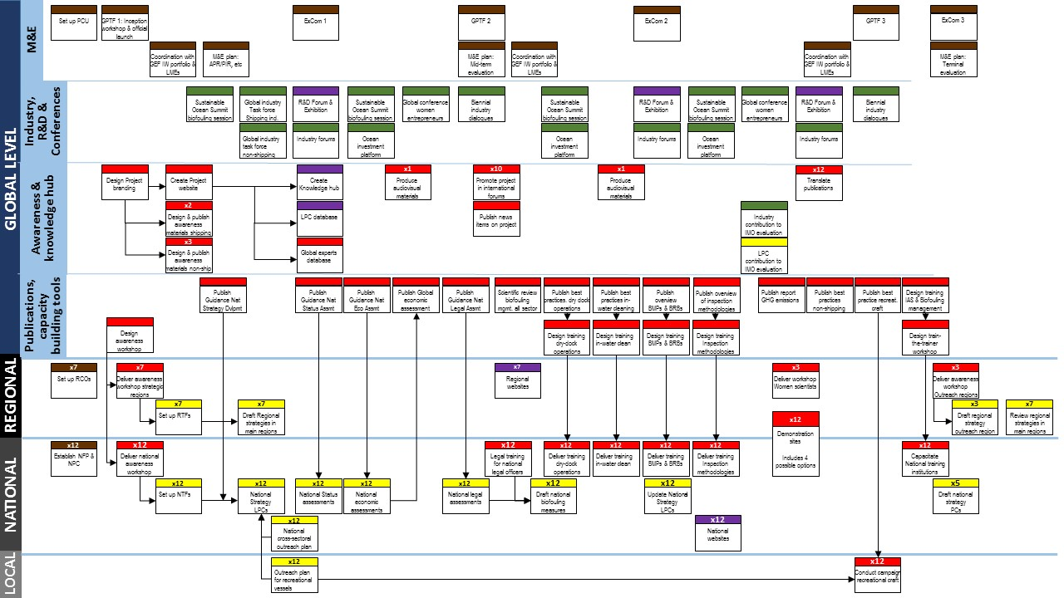

Component 1: LPIR
Component 2: Capacity building, awareness raising and demonstration sites
Component 3: Industry and PPPs
Component 4: Knowledge management and R&D
Component 5: Project management and M&E
COLOUR CODING

Activity  No. | Year 1 |  |  |  | Year 2 |  |  |  | Year 3 |  |  |  | Year 4 |  |  |  | Year 5 |  |  |  | Year 6
Activity  No. | Q1 | Q2 | Q3 | Q4 | Q1 | Q2 | Q3 | Q4 | Q1 | Q2 | Q3 | Q4 | Q1 | Q2 | Q3 | Q4 | Q1 | Q2 | Q3 | Q4 | Q1 | Q2 | Q3 | Q4
1.1.1.1
1.1.1.2
1.1.1.3
1.1.1.4
1.1.1.5
1.1.2.1
1.1.2.2
1.1.2.3
1.1.3.1
1.1.3.2
1.1.4.1
1.1.4.2
1.1.4.3
2.1.1.1
2.1.1.2
2.1.1.3
2.1.1.4
2.1.1.5
2.1.1.6
2.1.1.7
2.1.2.1
2.1.2.2
2.1.2.3
2.1.3.1
2.1.3.2
2.1.3.3
2.1.3.4
2.1.3.5
2.1.3.6
2.1.3.7
2.1.3.8
2.1.3.9
2.1.3.10
2.1.3.11
2.1.3.12
2.1.3.13
2.2.1.1
2.2.1.2
2.2.1.3
2.2.1.4
2.2.1.5
2.2.1.6
2.2.1.7
2.2.1.8
2.2.1.9
2.2.1.10
2.2.1.11
2.3.1.1
2.3.1.2
2.3.1.3
2.3.1.4
3.1.1.1
3.1.1.2
3.1.1.3
3.1.2.1
3.1.2.2
3.1.3.1
3.1.3.2
3.1.3.3
4.1.1.1
4.1.1.2
4.1.1.3
4.1.1.4
4.1.2.1
5.1.1.1
5.1.1.2
5.1.1.3
5.1.1.4
5.1.1.5
5.1.1.6
5.1.1.7
5.1.2.1
5.1.2.2
5.1.2.3

Annex B: GEF Tracking Tool at baseline
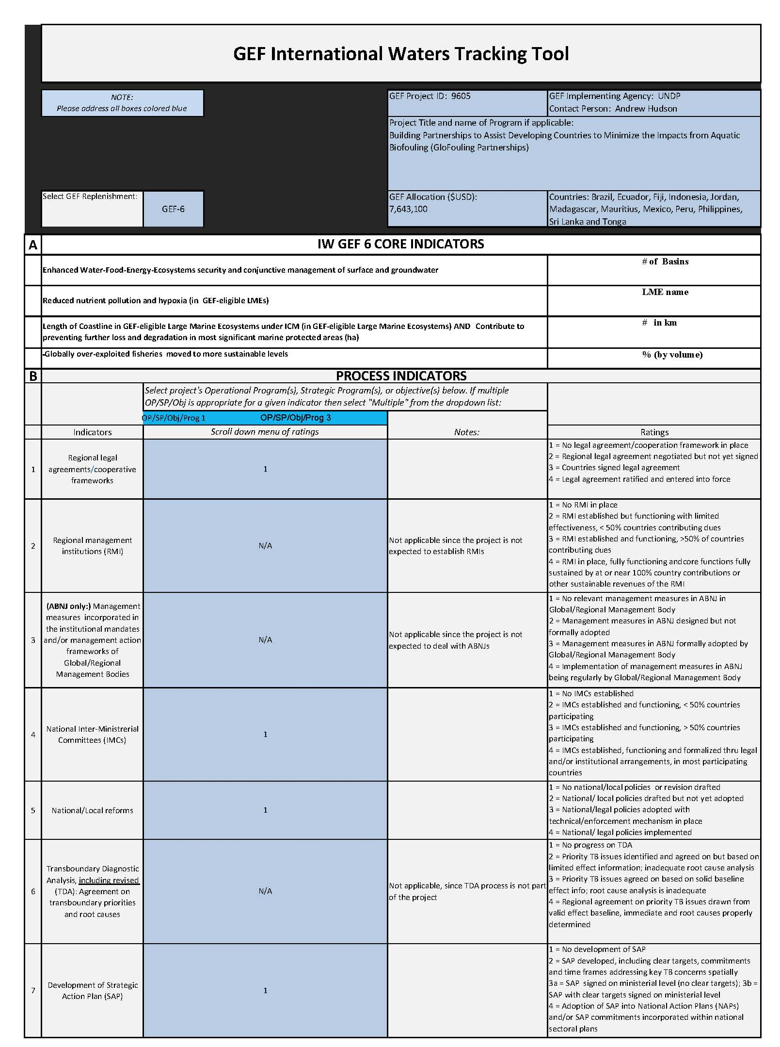
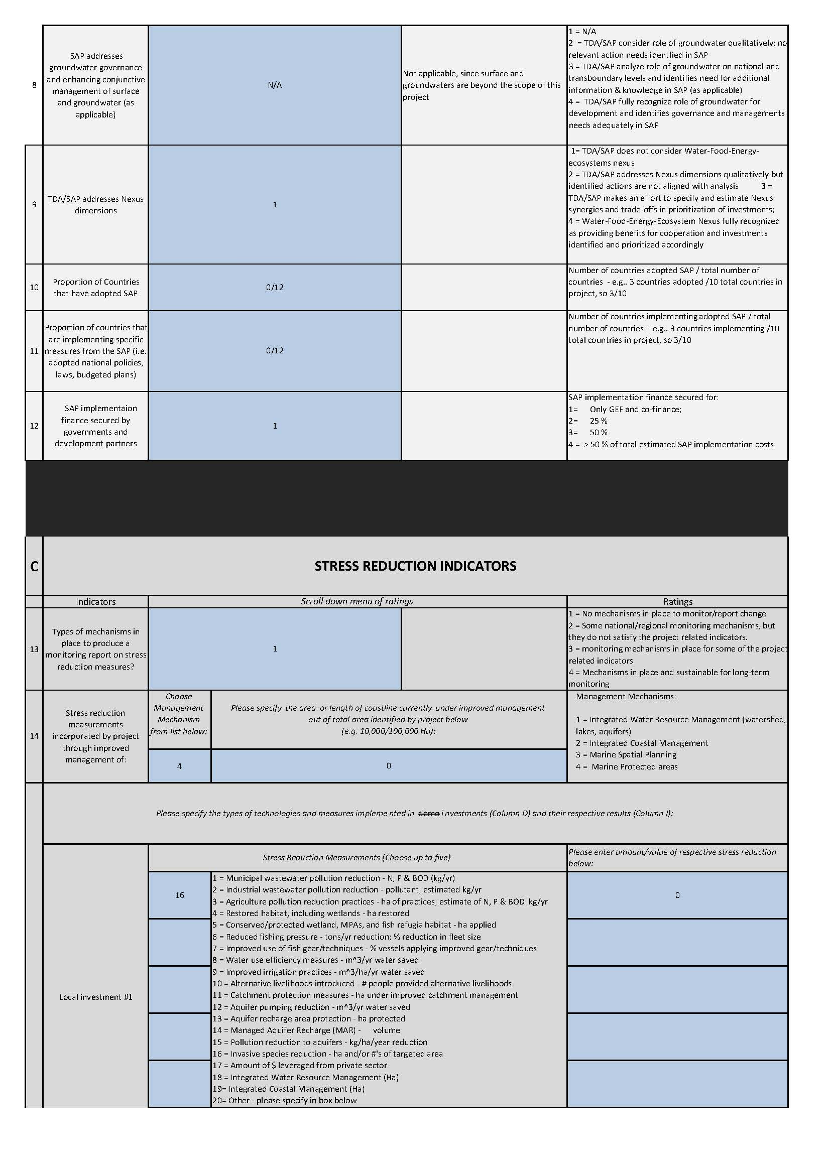
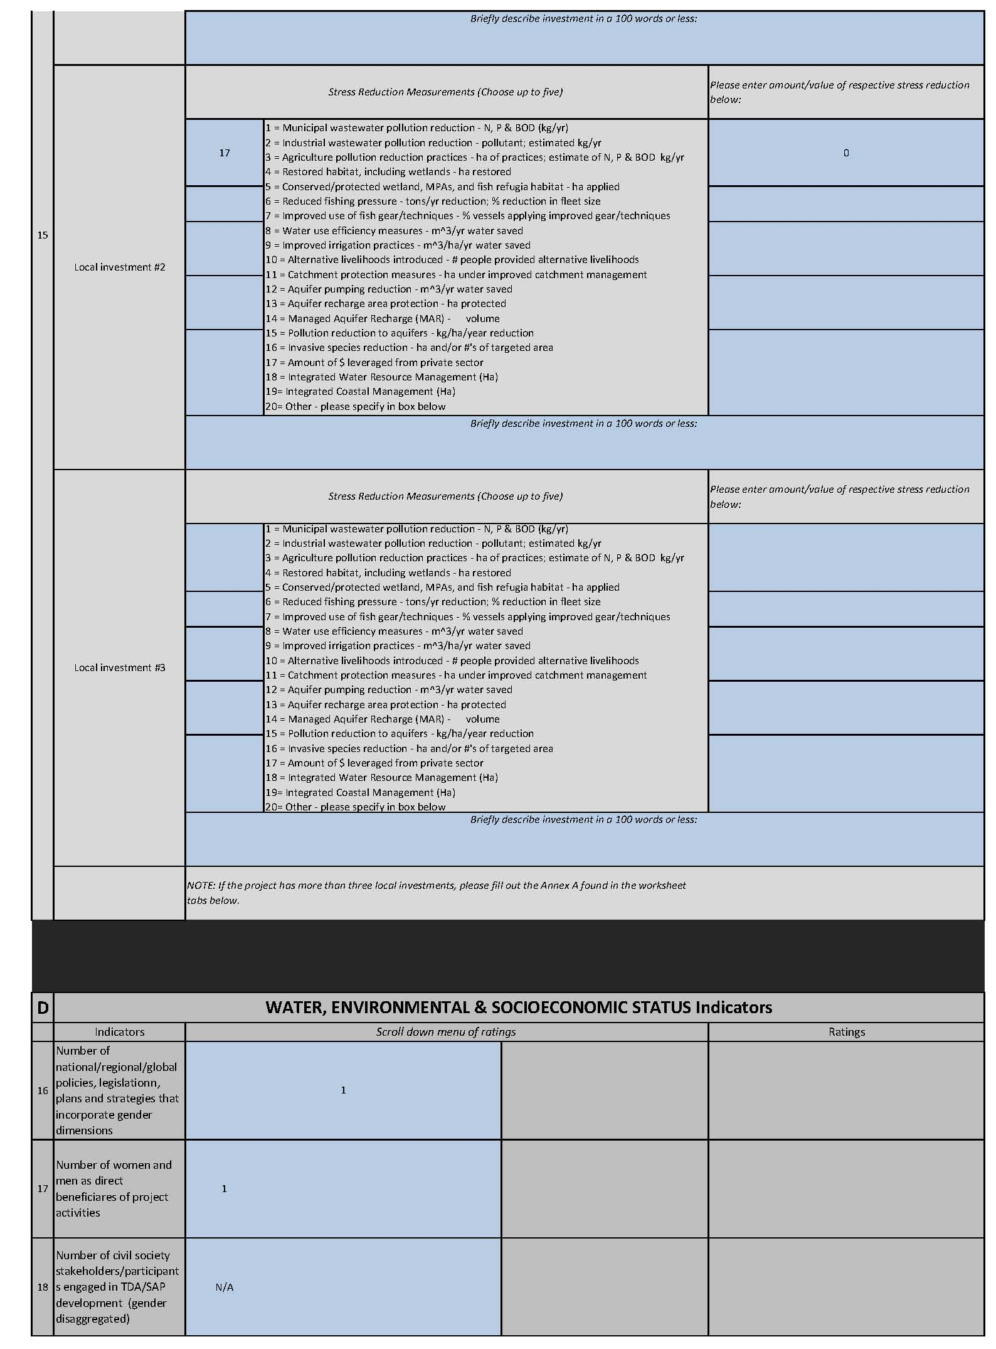
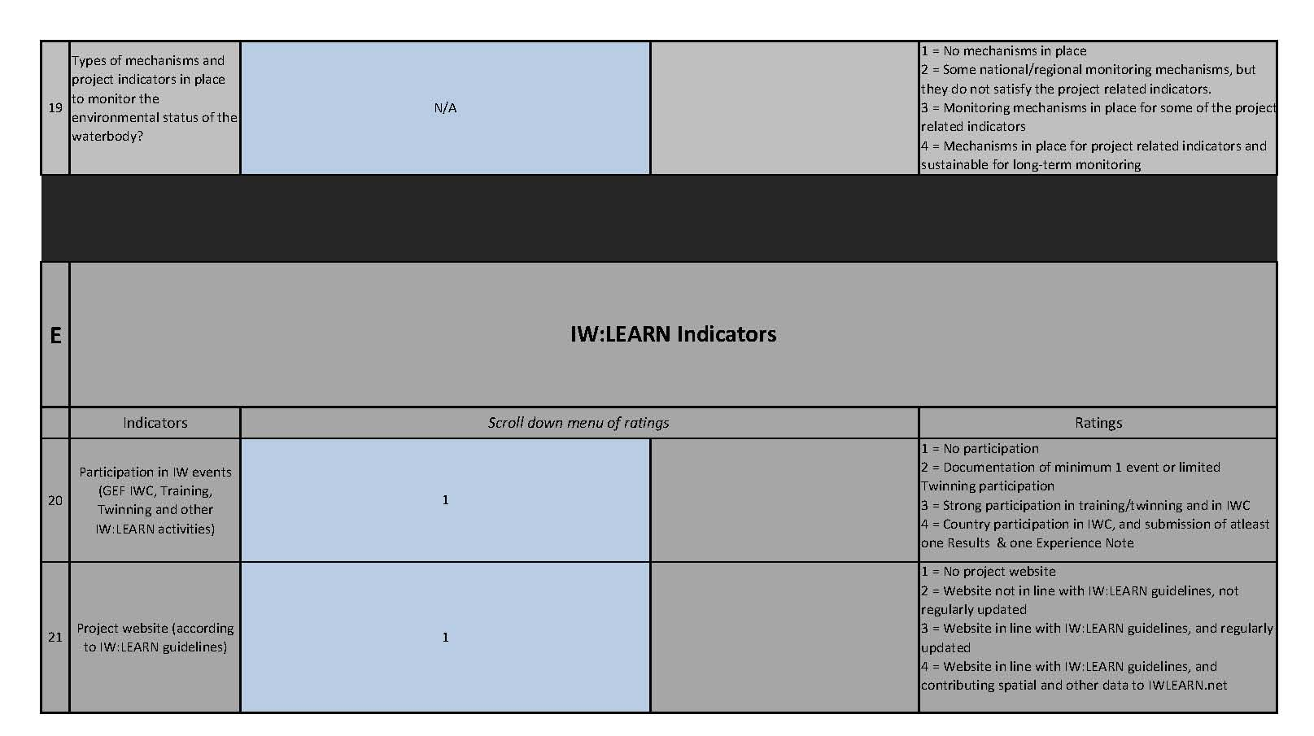

Annex C: Overview of Technical Consultancies

Consultant | Time Input | Tasks, Inputs and Outputs
For Monitoring & Evaluation
International / Regional and global contracting
Mid-term review and Terminal evaluation consultants  Rate: US$500/day | 90 days / over 5 years | The Mid-term review and Terminal evaluation consultants will be responsible for providing overall evaluation of the Project.
For Technical Assistance
Local / National contracting
National Specialist  Rate: US$300/day | 432 days / over 5 years | Under close supervision from the Chief Technical Advisor (CTA) and the Technical Adviser (TA), National Specialist consultants will contribute to the development of national reports and assessments included related to the project under Outputs 1.1.1, 1.1.2, 1.1.3 and 1.1.4, support any other activities at the national and regional level related to the LPIR process and provide specialist knowledge during the delivery of national capacity building activities.
International / Regional and global contracting
International Specialist  Rate: US$500/day | 1511 days / over 5 years | Under close supervision from the CTA and the TA, international specialist consultants will provide international perspective, strategic guidance and technical inputs to the implementation of activities.

Annex D: Terms of Reference

Terms of Reference for the Project Executive Committee (ExCom)

The ExCom will serve as the project’s decision-making body. It will be formed of representatived from the IMO, UNDP and the PCU. It will meet biennially to review project progress, approve project work plans and approve major project deliverables. The ExCom is responsible for providing the strategic guidance and oversight to project implementation to ensure that it meets the requirements of the approved Project Document and achieves the stated outcomes. The ExCom’s role will include:

- Provide strategic guidance to project implementation;
- Ensure coordination between various donor funded and government funded projects and programmes;
- Ensure coordination with various government agencies and their participation in project activities;
- Approve annual project work plans and budgets, at the proposal of the Project CTA;
- Approve any major changes in project plans or programmes;
- Oversee monitoring, evaluation and reporting in line with GEF requirements;
- Ensure commitment of human resources to support project implementation, arbitrating any issues within the project;
- Negotiate solutions between the project and any parties beyond the scope of the project;
- Ensure that UNDP Social and Environmental Safeguards Policy is applied throughout project implementation; and, address related grievances as necessary.

These terms of reference will be finalized during the Project Inception Workshop.

Terms of Reference for the Global Project Task Force (GPTF)

The GPTF will provide strategic and technical advice and inputs relating to project implementation and will be chaired by the ExCom (IMO-UNDP) with support from the PCU. The members of the GPTF will consist of representatives from Governments, UNDP, other relevant government agencies, research and educational organizations, NGOs, technical experts and other relevant stakeholders to be agreed by the Project ExCom. Technical experts may be invited in to discuss specific issues. Indicative Terms of Reference are as follows. These will be reviewed by the Project ExCom during project inception and may be extended as necessary:

- Review planned activities and ensure that they are technically sound and that, wherever possible, there is integration and synergy between the various project components during planning and implementation;
- Promote technical coordination between institutions, where such coordination is necessary and where opportunities for synergy and sharing of lessons exist;
- Share information on project progress and lessons learned with related stakeholders at the national level;
- The GPTF or a subset of its members may be requested to undertake specific project-related tasks, such as preparing or reviewing analytical reports, strategies and action plans, etc.;
- Other tasks as indicated by the Project ExCom.

Terms of Reference for Key Project Staff

Chief Technical Adviser (CTA) – P.4
Duties and Responsibilities
1. Technical advisory support; capacity building at global, regional and national levels
- Analyse the baseline scenario of participating countries, drive the legal, policy and institutional reform that will be required in each LPC and, in collaboration with government counterparts, provide guidance for the formulation of national strategies for biofouling management.
- In collaboration with regional environmental organizations, contribute to the outreach to other countries in the region and the development of regional strategies to be incorporated into existing regional conventions or action plans, with a view to harmonise biofouling management measures.
- Analyse the development needs and lead the provision of technical assistance and capacity building services to the participating developing countries with an aim to ensure that all stakeholders are trained and capacitated for implementation of all the different aspects of biofouling management at the national level.
- Chair discussions and participate as a speaker in international R&D conferences, exhibitions and other outreach activities representing the Project.
- Advise LPCs and RCOs during preparation and implementation of national and regional activities, and provide the necessary technical oversight.
- Supervise the creation of awareness materials and educational programmes in each participating country and for the project at the global level.
- Supervise and make the final review and provide input into all technical reports and publications prepared by the project and by the LPCs.
- Supervise the development of an electronic information and knowledge hub system that will become the leading global resource information centre on biofouling management.
- Follow discussions on biosafety related matters at relevant IMO Committees and Sub-committees such as MEPC and PPR.

2. Stakeholder involvement, partner coordination, knowledge management support
- Ensure and promote regular, adequate and appropriate linkage with other work programmes related to invasive aquatic species and biofouling, such as the Convention for Biological Diversity, and with relevant organizations, including other UN Agencies (FAO, IOC-UNESCO, ISA), non-governmental organizations or academic institutions and industry associations, to explore and promote effective collaboration, partnerships and synergies for the design and implementation of best practices for biofouling management.
- Engage leading private sector industry representatives and lead the creation of the public-private sector partnership component of the GloFouling Partnership Project: the Global Industry Alliance (GIA) for marine biosafety. Act as Secretary of the GIA Task Force and supervise the technical activities identified under the GIA.
- Supervise the cross-sectoral component at the UN-wide and private sector levels, with the appropriate partners identified in the Project Document.
- Establish links, where appropriate, with other International Water GEF programmes and Large Marine Ecosystems (LMEs), and represent the GloFouling Project at the biennial International Waters Conference (IWC).
- Foster strategic partnerships with various international organizations and institutions involved in invasive aquatic species and biofouling issues and technical and scientific cooperation for the implementation of the Project and IMO’s Biofouling Guidelines.
- Facilitate technical discussions, workshops or other regional or global events, such as R&D Forum, organized under the Project framework with multiple stakeholder participation.
- Liaise directly with the representatives of the various governance and technical advisory committees established within the project framework (such as GPTF or ExCom); participate and ensure timely coordination of such governance and advisory meetings.
- Ensure the dissemination of lessons learned and results achieved, through maintaining a Project Knowledge Management System. Ensure adequate outreach, communication and project visibility strategy.
- Support the work of the Subdivision for Major Projects as required.

3. Project implementation (management, team leadership, monitoring and reporting)
- Exercise overall responsibility for planning, implementation, management and coordination of the project operations and personnel.
- Define and orient the main strategy lines for project implementation in consultation with UNDP and the GEF and under the direct supervision of the Deputy Director, Subdivision for Major Projects; overseeing preparation and updating of the project work plan, as required.
- Act as Secretary of the Project Executive Committee (ExCom) and the Global Project Task Force (GPTF) meetings. Oversee the preparation of project review and/or evaluation meetings; prepares background documents, briefs, issue papers, progress reports for the ExCom meetings and for donor reporting; follow up of ExCom and GPTF decisions and recommendations.
- Lead and effectively manage the Project Coordination Unit (PCU), providing proper feedback, guidance and training opportunities for all PCU members. Lead any recruitment process that may be required after the Project is launched.
- Assure timely implementation of all project activities, including quality control and review of all produced technical outputs.
- Lead the establishment of the necessary agreements in order to set up the Regional Coordinating Organizations (RCOs) for implementing the activities programmed by the GloFouling project and coordinate the work in LPCs through the National Focal Points (NFPs) and National Project Coordinators (NPCs).
- Oversee and coordinate the mid-term review and terminal evaluation, the annual budget revisions and potential extension of the Project, and the closure of the Project.

Technical Adviser (TA) – P.2
Duties and Responsibilities
1. Technical advisory support; awareness-raising; and capacity building at global, regional and national levels
- Initiate, contribute and coordinate the development of global guidance documents to assist IMO member States in undertaking national level economic assessments related to marine biofouling. Provide expert advice on developing national, regional and global economic assessment reports and publications on the impact of biofouling and invasive species, providing specialist knowledge from the perspective of environmental and natural resource economics. Review, edit and contribute to other publications developed or commissioned by the Project.
- Supervise and contribute to the development of a global study on the quantitative relationship between biofouling and greenhouse gas (GHG) emissions, with a view to identify a suitable strategy for quantifying the overall contribution from biofouling management to the reduction of GHG emissions from shipping.
- Act as Implementing Officer (IO) for the Project activities co-funded by the IMO Integrated Technical Cooperation Programme (ITCP) and liaise with the Technical Cooperation Division (TCD) and the MED Technical Cooperation Officer to support the ITCP biennium programming for marine biosafety related activities.
- Facilitate the policy dialogue between industry and government representatives within the GloFouling Lead Partnering Countries (LPCs) at the national level, and coordinate their input to the Global Industry Alliance (GIA) created by the Project.
- Support the work of the IMO Secretariat in relation to MEPC and PPR meetings and the review of the 2011 IMO Biofouling Guidelines.
- Produce or oversee production of awareness-raising and information materials on biofouling management, invasive species and project objectives and achievements. Identify language needs and coordinate translation and distribution of awareness-raising materials to LPCs and other developing countries.
- Coordinate the production of a documentary on the different aspects of biofouling and the impact of invasive species, including selection of production partners, technical contribution to the development of scripts, contribution from IMO, LPCs and other stakeholders and institutions, and suitable distribution of the finalised product.
- Draft contributions to GEF and UNDP publications presenting the work and achievements of the Project, the GIA and other stakeholders involved in project implementation. Draft other written outputs, e.g. background papers, briefing notes, presentations to internal and external partners, speeches, mission reports and other inputs for presentations by senior IMO staff on project-related issues for specialist or non specialist audiences.
- Chair technical discussions and participate as a speaker in international conferences, exhibitions and other outreach activities representing the Project and IMO.
- Supervise the organization of training workshops, seminars, expert groups, etc. Participate and make presentations on assigned topics related to the Project.

2. Stakeholder involvement, partner coordination and knowledge management
- Implement the Knowledge Management component of the Project (Component 4) by developing a global central knowledge hub on all aspects related to biofouling management and invasive aquatic species in all ocean industries, including related economic impacts and remediation programmes. Develop and overview the design and content of the data platform, conduct desktop research and establish collaboration agreements with appropriate institutions and specialised initiatives for coordination and content provision.
- Supervise and lead the organization of the biennial R&D Forum and Exhibition, identifying potential Member States to host the event, selecting suitable venues, organising logistics, developing promotion materials and securing sponsors. Publish a call for papers, create a Scientific Review Panel, coordinate the selection of papers and the development the Forum’s programme and identify suitable candidates to chair sessions. Supervise the publication of the R&D Forum proceedings.
- Facilitate and oversee the creation of national and regional databases in LPCs, providing input and content materials to the National Focal Points and the Regional Coordinating Organizations.
- Monitor and identify the needs of the LPCs of the GloFouling Partnerships and, in direct contact with their National Focal Points or other government officers, facilitate project support to those countries to implement the legal, policy and institutional reform process to address the issue of biofouling management and invasive aquatic species.
- Coordinate the cross-sectoral component at the UN-wide and private sector levels, with the Intergovernmental Oceanographic Commission (IOC) of UNESCO, the World Ocean Council (WOC), the Secretariat of the Convention on Biological Diversity (CBD) and other specialised agencies of the UN System. Oversee the integration into the project of non-shipping related activities.

3. Project implementation
- Lead the technical implementation of the monitoring and evaluation component of the Project (Component 5), establishing the tools to monitor progress of project implementation and review achievements in relation to the Project results framework and agreed indicators. Prepare reports and present results to GEF, UNDP and project stakeholders.
- Provide technical expertise in the area of project management, implementation, reporting and Monitoring and Evaluation (M&E) in conformity with best practices, UNDP and GEF M&E policies and the GloFouling Project Document.
- Plan and draft survey initiatives as required by the Project outputs; design data collection tools; review, analyse and interpret responses, identify problems/issues and propose corrective actions that may be required to achieve or improve outputs.
- Coordinate the development and implementation of project planning and oversee the preparation of related documents/reports (pledging, work programme, project budget, etc.).
- Provide management and financial analyses. Review budget revisions and ensure that all operations, financial administration and procurement activities initiated by or assigned to the Project are conducted according to IMO standards and procedures and in coordination with other Secretariat stakeholders.
- Oversee the day-to-day work of administrative project staff, particularly relating to budget monitoring, coordination of workload and logistics for all activities. Provide feedback with a view to developing skills and competencies.
- Manage and oversee procurement for the Project. Draft tenders for expressions of interest for providing services required by the Project, including defining the services, qualifying criteria, requirements, expected deliverables and timeframes. Participate in the analysis and selection of proposals.
- Draft terms of reference for contracting experts and consultants and oversee contractual arrangements. Review and edit consultant reports and provide feedback on performance.
- Perform other related duties, particularly in the absence of the Project Chief Technical Adviser (CTA), as required.

Principal Administrative Assistant – G.6
Duties and Responsibilities
- Provide integrative and adaptive project coordination support, including the day-to-day operational and contractual matters of the Project, implementation and assessment of progress of each activity under the Project.
- Monitor the execution of the Budget (control of procurement aspects of the various contracts) and using IMO’s ERP system (SAP) to manage all procurement aspects of the project including the preparation and control of the project’s budget by maintaining accounts of the status of expenses for travel, contractual arrangements, future planned commitments, etc.
- Review and reconcile quarterly financial reports, cash books and associated documents submitted by Regional Coordinating Organizations; prepare reports for IMO Financial Services and monitor processing into SAP to verify that the financial transactions have been completely and accurately recorded.
- Maintain detailed project accounting, checking, reconciling and clearing expenditure for the three funds (GEF-UNDP, ITCP and Industry) and independently prepare and manage the mandatory project financial reports and any other interim progress reports to be submitted to GEF-UNDP.
- Independently develop, manage and maintain project databases related to project implementation and expenditure.
- Coordinate the communication with IMO Financial Services and Management Accounting Services (MAS) regarding financial and budget matters.
- Communicate with the Project Lead Partnering Countries (LPCs) and Regional Coordinating Organizations (RCOs) regarding the financial procedures, procurement and financial reporting using IMO standards, including accounts reconciliation and planning of activities budget.
- Independently manage all the administrative aspects related to the project financial closure towards end of the Project.
- Arrange recruitment of consultants and experts and coordinate their travel for Project activities.
- Supervise the work of the administrative assistant and any temporary project administrative staff, as and when necessary.
- Address administrative and financial enquiries from LPCs and RCOs and also from IMO internal stakeholders (FS, MAS and Internal Oversight Services - IOS) in coordination with the Technical Adviser (TA) and Chief Technical Adviser (CTA).
- Undertake field missions, if requested, to support any progress meetings and meetings that will discuss financial and budget matters of the Project (such as GPTF or ExCom) as well as global events where extra administrative support will be necessary, such as the Project R&D Forum or the GEF International Waters Conference (IWC).
- Support the TA in the development of awareness materials. Assist in the operation of the project website and the development of communication materials as specified in the project document.
- Prepare specific Project Implementation Documents (PID) and follow up approval and implementation on SAP.
- Undertake other duties related to the implementation of the project as may be required.

Administrative Assistant – G.5
Duties and Responsibilities
- In communication with the Regional Coordinating Organizations and the Lead Partnering Countries (LPCs), coordinate participation in all project workshops and seminars, including sending invitations, receiving and tracking country nominations, reviewing and controlling participant information, securing letters of invitation from the host country, etc.
- Under instructions of the CTA and the TA, organise all the logistics for international conferences, training workshops and seminars organised by the project, including venue requirements with the host country administration, hotel arrangements for all participants, defining hospitality requirements and arrangements, and preparing meeting materials and registration of participants.
- In coordination with host countries, prepare information materials for all workshops and seminars organised by the Project, including drafting an Aide-Memoire, and circulate to all participants.
- Maintain and regularly update information on the project website, including drafting short newsfeeds, and, using Google Analytics or similar website tracking software, prepare monthly reports and statistics on users and impact.
- Maintain communication with IMO’s Media Unit for contributions to the Organization’s media outputs (What’s New, social media, etc.), keep track of project-related threads and report on usage and impact.
- Assist in monitoring and tracking all project outputs, in accordance with established procedures and the Monitoring and Evaluation Plan of the Project.
- Collate information of activities organised by the Project funded by the ITCP, prepare reports on participation and feedback questionnaires, and coordinate information-sharing with IMO’s Technical Cooperation Division.
- Organize and coordinate travel for Project staff, other IMO officers, consultants, participants in project events and workshops and other key project stakeholders. Ensure that all travel administrative arrangements are in place, including visas, insurance and UNDSS security clearance. Monitor travel and coordinate all internal requirements (Travel authorisations, SharePoint mission requests, etc.) with IMO’s Travel Unit using SAP.
- Initiate and draft routine correspondence in English, with minimal instruction, on behalf of the Project officers as necessary.
- Proofread and, when necessary, edit texts and materials prepared for project publications, awareness raising products, reports and IMO documents.
- Maintain lists of key contact points for the Project, create and update documents and reports on the project database and information systems, and keep them correctly archived.
- Assist in the recruitment and support to consultants, and liaise with relevant sections of the Organization in this respect.
- Prepare files for any missions or activities, collecting required data and assembling relevant documentation; make travel arrangements for mission or official leave, of other PCU members and participants in project activities or events.
- Research for background material to support the drafting of reports and other material.
- Provide other administrative support to the Project Coordination Unit as required.

Annex E: UNDP Social and Environmental Screening
Part A. Integrating Overarching Principles to Strengthen Social and Environmental Sustainability
QUESTION 1: How Does the Project Integrate the Overarching Principles in order to Strengthen Social and Environmental Sustainability?
Briefly describe in the space below how the Project mainstreams the human-rights based approach

The project outcomes and activities will contribute to understand the impact of invasive aquatic species on human livelihoods.
Briefly describe in the space below how the Project is likely to improve gender equality and women’s empowerment
Ensuring gender equality and women’s empowerment were part of the stakeholder consultations and gender analysis conducted during the project preparation phase. The outcome of these consultations are a gender action plan which includes specific gender-oriented activities and a results framework for gender mainstreaming.
Briefly describe in the space below how the Project mainstreams environmental sustainability
The goal of the project will contribute to minimize the impacts of Invasive Aquatic Species transferred through biofouling. All project outcomes will to contribute to the achievement of this goal and project activities have been designed taking into consideration the environmental sustainability of the
Part B. Identifying and Managing Social and Environmental Risks
QUESTION 2: What are the Potential Social and Environmental Risks?  Note: Describe briefly potential social and environmental risks identified in Attachment 1 – Risk Screening Checklist (based on any “Yes” responses). If no risks have been identified in Attachment 1 then note “No Risks Identified” and skip to Question 4 and Select “Low Risk”. Questions 5 and 6 not required for Low Risk Projects. | QUESTION 3: What is the level of significance of the potential social and environmental risks?  Note: Respond to Questions 4 and 5 below before proceeding to Question 6 |  |  |  | QUESTION 6: What social and environmental assessment and management measures have been conducted and/or are required to address potential risks (for Risks with Moderate and High Significance)?
Risk Description | Impact and Probability (1-5) | Significance  (Low, Moderate, High) | Comments |  | Description of assessment and management measures as reflected in the Project design. If ESIA or SESA is required note that the assessment should consider all potential impacts and risks.
Risk 1: No Risks Identified. | I = 1  P = 1 | Low | No adverse impacts on the environment during implementation. Although one of the activities proposed for the demonstration sites will be showcasing best practices related to biofouling management in Marine Protected Areas (MPAs), the activity will actually contribute to the enhancement of protection protocols of MPAs.
 | QUESTION 4: What is the overall Project risk categorization?
 | Select one (see SESP for guidance) |  |  |  | Comments
 | Low Risk |  |  | ✔ | Although conducted in the proximity of a Marine Protected Area (MPA), the outcome of the project activity will be to contribute to the overall protection of the MPA. The work developed for the project activity presents no risk to the MPA.
 | Moderate Risk |  |  | ☐
 | High Risk |  |  | ☐
 | QUESTION 5: Based on the identified risks and risk categorization, what requirements of the SES are relevant?
 | Check all that apply |  |  |  | Comments
 | Principle 1: Human Rights |  |  | ☐
 | Principle 2: Gender Equality and Women’s Empowerment |  |  | ☐
 | 1. Biodiversity Conservation and Natural Resource Management |  |  | ☐
 | 2. Climate Change Mitigation and Adaptation |  |  | ☐
 | 3. Community Health, Safety and Working Conditions |  |  | ☐
 | 4. Cultural Heritage |  |  | ☐
 | 5. Displacement and Resettlement |  |  | ☐
 | 6. Indigenous Peoples |  |  | ☐
 | 7. Pollution Prevention and Resource Efficiency |  |  | ☐
Final Sign Off
Signature | Date | Description
QA Assessor |  | UNDP staff member responsible for the Project, typically a UNDP Programme Officer. Final signature confirms they have “checked” to ensure that the SESP is adequately conducted.
QA Approver |  | UNDP senior manager, typically the UNDP Deputy Country Director (DCD), Country Director (CD), Deputy Resident Representative (DRR), or Resident Representative (RR). The QA Approver cannot also be the QA Assessor. Final signature confirms they have “cleared” the SESP prior to submittal to the PAC.
PAC Chair |  | UNDP chair of the PAC. In some cases PAC Chair may also be the QA Approver. Final signature confirms that the SESP was considered as part of the project appraisal and considered in recommendations of the PAC.

Checklist Potential Social and Environmental Risks
Principles 1: Human Rights | Answer  (Yes/No)
1. Could the Project lead to adverse impacts on enjoyment of the human rights (civil, political, economic, social or cultural) of the affected population and particularly of marginalized groups? | No
2. Is there a likelihood that the Project would have inequitable or discriminatory adverse impacts on affected populations, particularly people living in poverty or marginalized or excluded individuals or groups? | No
3. Could the Project potentially restrict availability, quality of and access to resources or basic services, in particular to marginalized individuals or groups? | No
4. Is there a likelihood that the Project would exclude any potentially affected stakeholders, in particular marginalized groups, from fully participating in decisions that may affect them? | No
5. Is there a risk that duty-bearers do not have the capacity to meet their obligations in the Project? | No
6. Is there a risk that rights-holders do not have the capacity to claim their rights? | No
7. Have local communities or individuals, given the opportunity, raised human rights concerns regarding the Project during the stakeholder engagement process? | No
8. Is there a risk that the Project would exacerbate conflicts among and/or the risk of violence to project-affected communities and individuals? | No
Principle 2: Gender Equality and Women’s Empowerment
1. Is there a likelihood that the proposed Project would have adverse impacts on gender equality and/or the situation of women and girls? | No
2. Would the Project potentially reproduce discriminations against women based on gender, especially regarding participation in design and implementation or access to opportunities and benefits? | No
3. Have women’s groups/leaders raised gender equality concerns regarding the Project during the stakeholder engagement process and has this been included in the overall Project proposal and in the risk assessment? | No
4. Would the Project potentially limit women’s ability to use, develop and protect natural resources, taking into account different roles and positions of women and men in accessing environmental goods and services?  For example, activities that could lead to natural resources degradation or depletion in communities who depend on these resources for their livelihoods and well being | No
Principle 3: Environmental Sustainability: Screening questions regarding environmental risks are encompassed by the specific Standard-related questions below
Standard 1: Biodiversity Conservation and Sustainable Natural Resource Management
1.1 Would the Project potentially cause adverse impacts to habitats (e.g. modified, natural, and critical habitats) and/or ecosystems and ecosystem services?  For example, through habitat loss, conversion or degradation, fragmentation, hydrological changes | No
1.2 Are any Project activities proposed within or adjacent to critical habitats and/or environmentally sensitive areas, including legally protected areas (e.g. nature reserve, national park), areas proposed for protection, or recognized as such by authoritative sources and/or indigenous peoples or local communities? | Yes
1.3 Does the Project involve changes to the use of lands and resources that may have adverse impacts on habitats, ecosystems, and/or livelihoods? (Note: if restrictions and/or limitations of access to lands would apply, refer to Standard 5) | No
1.4 Would Project activities pose risks to endangered species? | No
1.5 Would the Project pose a risk of introducing invasive alien species? | No
1.6 Does the Project involve harvesting of natural forests, plantation development, or reforestation? | No
1.7 Does the Project involve the production and/or harvesting of fish populations or other aquatic species? | No
1.8 Does the Project involve significant extraction, diversion or containment of surface or ground water?  For example, construction of dams, reservoirs, river basin developments, groundwater extraction | No
1.9 Does the Project involve utilization of genetic resources? (e.g. collection and/or harvesting, commercial development) | No
1.10 Would the Project generate potential adverse transboundary or global environmental concerns? | No
1.11 Would the Project result in secondary or consequential development activities which could lead to adverse social and environmental effects, or would it generate cumulative impacts with other known existing or planned activities in the area?  For example, a new road through forested lands will generate direct environmental and social impacts (e.g. felling of trees, earthworks, potential relocation of inhabitants). The new road may also facilitate encroachment on lands by illegal settlers or generate unplanned commercial development along the route, potentially in sensitive areas. These are indirect, secondary, or induced impacts that need to be considered. Also, if similar developments in the same forested area are planned, then cumulative impacts of multiple activities (even if not part of the same Project) need to be considered. | No
Standard 2: Climate Change Mitigation and Adaptation
2.1 Will the proposed Project result in significant greenhouse gas emissions or may exacerbate climate change? | No
2.2 Would the potential outcomes of the Project be sensitive or vulnerable to potential impacts of climate change? | No
2.3 Is the proposed Project likely to directly or indirectly increase social and environmental vulnerability to climate change now or in the future (also known as maladaptive practices)?  For example, changes to land use planning may encourage further development of floodplains, potentially increasing the population’s vulnerability to climate change, specifically flooding | No
Standard 3: Community Health, Safety and Working Conditions
3.1 Would elements of Project construction, operation, or decommissioning pose potential safety risks to local communities? | No
3.2 Would the Project pose potential risks to community health and safety due to the transport, storage, and use and/or disposal of hazardous or dangerous materials (e.g. explosives, fuel and other chemicals during construction and operation)? | No
3.3 Does the Project involve large-scale infrastructure development (e.g. dams, roads, buildings)? | No
3.4 Would failure of structural elements of the Project pose risks to communities? (e.g. collapse of buildings or infrastructure) | No
3.5 Would the proposed Project be susceptible to or lead to increased vulnerability to earthquakes, subsidence, landslides, erosion, flooding or extreme climatic conditions? | No
3.6 Would the Project result in potential increased health risks (e.g. from water-borne or other vector-borne diseases or communicable infections such as HIV/AIDS)? | No
3.7 Does the Project pose potential risks and vulnerabilities related to occupational health and safety due to physical, chemical, biological, and radiological hazards during Project construction, operation, or decommissioning? | No
3.8 Does the Project involve support for employment or livelihoods that may fail to comply with national and international labor standards (i.e. principles and standards of ILO fundamental conventions)? | No
3.9 Does the Project engage security personnel that may pose a potential risk to health and safety of communities and/or individuals (e.g. due to a lack of adequate training or accountability)? | No
Standard 4: Cultural Heritage
4.1 Will the proposed Project result in interventions that would potentially adversely impact sites, structures, or objects with historical, cultural, artistic, traditional or religious values or intangible forms of culture (e.g. knowledge, innovations, practices)? (Note: Projects intended to protect and conserve Cultural Heritage may also have inadvertent adverse impacts) | No
4.2 Does the Project propose utilizing tangible and/or intangible forms of cultural heritage for commercial or other purposes? | No
Standard 5: Displacement and Resettlement
5.1 Would the Project potentially involve temporary or permanent and full or partial physical displacement? | No
5.2 Would the Project possibly result in economic displacement (e.g. loss of assets or access to resources due to land acquisition or access restrictions – even in the absence of physical relocation)? | No
5.3 Is there a risk that the Project would lead to forced evictions? | No
5.4 Would the proposed Project possibly affect land tenure arrangements and/or community based property rights/customary rights to land, territories and/or resources? | No
Standard 6: Indigenous Peoples
6.1 Are indigenous peoples present in the Project area (including Project area of influence)? | No
6.2 Is it likely that the Project or portions of the Project will be located on lands and territories claimed by indigenous peoples? | No
6.3 Would the proposed Project potentially affect the human rights, lands, natural resources, territories, and traditional livelihoods of indigenous peoples (regardless of whether indigenous peoples possess the legal titles to such areas, whether the Project is located within or outside of the lands and territories inhabited by the affected peoples, or whether the indigenous peoples are recognized as indigenous peoples by the country in question)?  If the answer to the screening question 6.3 is “yes” the potential risk impacts are considered potentially severe and/or critical and the Project would be categorized as either Moderate or High Risk. | No
6.4 Has there been an absence of culturally appropriate consultations carried out with the objective of achieving FPIC on matters that may affect the rights and interests, lands, resources, territories and traditional livelihoods of the indigenous peoples concerned? | No
6.5 Does the proposed Project involve the utilization and/or commercial development of natural resources on lands and territories claimed by indigenous peoples? | No
6.6 Is there a potential for forced eviction or the whole or partial physical or economic displacement of indigenous peoples, including through access restrictions to lands, territories, and resources? | No
6.7 Would the Project adversely affect the development priorities of indigenous peoples as defined by them? | No
6.8 Would the Project potentially affect the physical and cultural survival of indigenous peoples? | No
6.9 Would the Project potentially affect the Cultural Heritage of indigenous peoples, including through the commercialization or use of their traditional knowledge and practices? | No
Standard 7: Pollution Prevention and Resource Efficiency
7.1 Would the Project potentially result in the release of pollutants to the environment due to routine or non-routine circumstances with the potential for adverse local, regional, and/or transboundary impacts? | No
7.2 Would the proposed Project potentially result in the generation of waste (both hazardous and non-hazardous)? | No
7.3 Will the proposed Project potentially involve the manufacture, trade, release, and/or use of hazardous chemicals and/or materials? Does the Project propose use of chemicals or materials subject to international bans or phase-outs?  For example, DDT, PCBs and other chemicals listed in international conventions such as the Stockholm Conventions on Persistent Organic Pollutants or the Montreal Protocol | No
7.4 Will the proposed Project involve the application of pesticides that may have a negative effect on the environment or human health? | No
7.5 Does the Project include activities that require significant consumption of raw materials, energy, and/or water? | No

Annex F: Stakeholder Engagement Plan

As presented throughout this Project Document (Section 1), the biofouling issue is an inter-disciplinary and multi-sectoral problem, and success of the Project will depend on the full engagement of a broad group of stakeholders.

1. Preliminary analysis
Without precluding the participation of additional partners, Table 1 presents the main groups of stakeholders that are expected to play a role during the implementation of the GloFouling Partnerships Project.

Table 1: Stakeholder groups
Group | Key stakeholders
International Organizations | - Relevant intergovernmental organizations  - Donor community and international financial institutions  - Executing partners
Environmental Organizations & Institutes | - National and regional marine research institutions  - Relevant NGOs
Regional and National Government partners | - Maritime administrations  - Environmental agencies  - Ministries of agriculture (fisheries & aquaculture)  - Ministries of health (quarantine and sanitary services)  - Coast-guard and Navy  - Parliamentary committees for environmental protection
Industry (private sector and industry associations) | - Industry associations and NGOs  - Shipping and ports  - Oil and gas  - Technology developers  - Paint and coatings  - Testing organizations  - Ocean energy  - Ocean instrumentation  - Tourism  - Marinas
Civil Society Organizations | - Women in the maritime sector associations  - Recreational craft owner associations  - Professional associations

Figure 1 classifies the main groups of stakeholders according to their level of interest and/or influence power in the implementation of the Project. The groups are further discussed in detail in section 2, including mention of specific partnering organizations and their expected roles in the project.

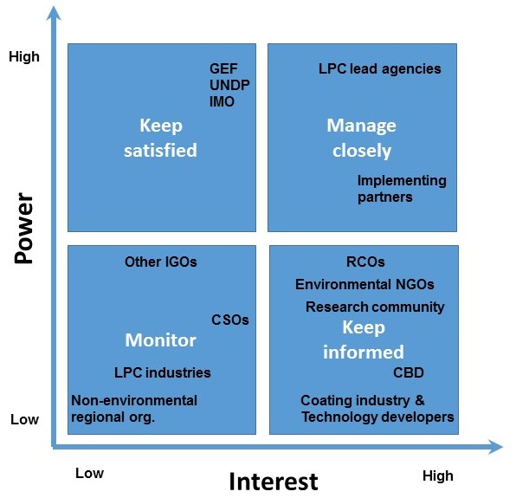
Figure 1: Stakeholder analysis matrix

2. Stakeholder analysis

2.1 International Organizations
The three key players are the GEF (funding), UNDP (implementing) and IMO (executing). In addition, IOC-UNESCO, in cooperation with WOC, will play a key role as an executing partner of IMO to address the non-shipping pathways. To this effect, it is expected that FAO, WMO, ISA and other relevant international organizations will play a supporting role in the review of biofouling management practices in non-shipping industries through their participation in a newly created GESAMP working group. The CBD Secretariat has also provided its endorsement of the project and will provide its expertise on IAS during the implementation phase, particularly through the Inter-Agency Liaison Group on IAS.
International organizations specifically working on the field of nature conservation, such as IUCN, have been engaged as strategic partners with a view to provide technical backstopping and contribute to the implementation of project activities.
Resulting from discussions during the preparation phase, EBRD is contemplating the provision of direct support to the Western Balkans and North African (South Mediterranean) countries, to carry out training on biofouling management using the tools that will be designed by the Project.

2.2 Environmental Organizations and Institutes
During the preparation phase, several research institutions and environmental organizations have expressed their support to the Project by becoming strategic partners, such as the World Maritime University, Florida Institute of Technology, Chalmers University of Technology, Kyung Hee University MERC-IWCC, Cawthorn, the International Ocean Institute, NIWA, etc. Their contribution will be typically in-kind, providing experts and reviewing publications and other outputs of the Project.
In addition to continued involvement through the GPTF, research institutes and environmental organizations will in particular link with the efforts to better understand the marine ecology.

2.3 Regional and National Government Partners
Key stakeholders at the national level will be involved through the establishment of National Task Forces. The National Focal Points, who will take responsibility for the implementation of the project in their respective countries, will act as chairpersons of the National Task Forces. National stakeholders will benefit from studies, workshops, training, reviews and legal and institutional analyses. This is foremost a project designed to stimulate Legal, Policy and Institutional Reforms (LPIR) in the LPCs. The project will include extensive interaction with each country lead agency. Other government ministries, agencies and institutes that have responsibilities relevant to biofouling management and IAS are to be included in National Task Forces. The other participating agencies are expected to include: environment, transportation, agriculture (fisheries and aquaculture), health (quarantine and sanitary services) and port State control authorities (such as coastguards and navy).

2.4 Industry
The GloFouling Partnerships Project recognizes that industry must play a crucial role in any effort to improve biofouling management. A key project stakeholder will be the WOC, an organization that will collaborate with IOC-UNESCO for implementing activities that will engage private sector companies and industry associations belonging to non-shipping pathways, as presented in section 2.2.6, with a strong focus on developing Public Private Partnerships (PPPs).

Engagement and participation of the industry will be done at two levels:
- International industry associations will participate as strategic partners, providing input and expertise related to support project activities, and participating in R&D forums and other meetings. The preparation phase has already secured the support from an ample spectrum of industry associations that represent the shipping industry, classification societies, coatings industry, ports and marinas, etc.

- Private sector companies will participate in two industry task forces, one for shipping-related companies (GIA) and another for private sector companies related to non-shipping pathways (coordinated by WOC with the support of IOC-UNESCO). These industry task forces are PPPs that will provide advice and support as the project gets implemented. Membership of both task forces will be open to private sector companies that contribute to an industry fund to finance activities agreed by the membership. During the preparation phase, five private sector companies have expressed their intention to contribute to the shipping industry fund (listed in Table 5 of this annex and letters of support enclosed in Annex K-8). Industry-funded activities may either address new issues not contemplated in the ProDoc or support activities that have already been included, in particular, demonstration sites, hosting R&D forums, sponsoring research and innovation funds, development of audiovisual materials, etc.

2.5 Civil Society Organizations (CSOs)
There is a tendency for poorer members of coastal-based societies to live immediately adjacent to the seas and to depend on subsistence fishing and mariculture for their food and livelihoods. The IAS can therefore have a direct effect on their health and well-being. To the extent that IAS can out-compete and otherwise decimate local fish populations, this can be debilitating to subsistence fishermen. Also, periodic blooms of toxic algae and dinoflagellates, which may be linked to biofouling, put a direct health threat into the equation for local populations that ingest contaminated shellfish. GloFouling Partnerships, by working to reduce the risk of IAS transfer through shipping, should have a positive impact on vulnerable coastal populations by reducing the chances that biological invaders can arrive with their accompanying economic and health risks. National governments, during their status assessments, and then Biofouling Strategy development efforts, will consider the health and economic consequences of current and potential future marine bio-invasions, and will take note of the particular vulnerabilities of marginal populations (poor, displaced).

To ensure the achievement of its goal, the Project will also have to address other CSOs that are essential for the implementation and intake of best practices in the different aspects of biofouling management. To this effect, the preparation phase has engaged the support from three types of CSOs that can play a key role:
- Regional associations of women in the maritime sector. It is expected that these organizations can support project efforts to increase the attention to gender perspectives and include them in all policy development, and help identify stakeholders and individuals that may participate in Project activities.
- Recreational craft associations. Taking into account the local tier of the of the Project, participation of this kind of CSOs would represent a strong asset to help determine the baseline scenario, identify current barriers to embracing best practices for biofouling management and support outreach efforts.
- Professional associations. There are several CSOs in this category that can support activities developed by the Project. One example could be the Royal Institution of Naval Architects (RINA), to provide expertise in finding better design solutions to reduce areas especially prone to biofouling.

3. Stakeholder discussions and engagement activities already conducted
During the Project preparation phase, following the preliminary stakeholder analysis, a series of activities were conducted to identify and engage the main actors that may contribute to the design and implementation of the GloFouling Project. Table 2 below presents a summary of the activities that the Project Preparation team attended in person or via video call, or with the support of the IMO Secretariat, along with the main categories of stakeholders and the respective outcome. Further below, Table 4 provides a full list of organizations that have already endorsed the Project. All letters of support and endorsement are attached in Annex K.

Table 2: Review of stakeholder engagement activities conducted during the Project Preparation Phase
Meeting | Venue and dates | Stakeholders | Outcome
IMO MEPC 71 – Plenary | London  July 2017 | IMO Member States | Informed IMO Member States on new project and invitation to participate.
ANZPAC workshop on biofouling management | Australia  September 2017 | Developed countries, Research community, Universities, Private sector (including shipping, ports, coatings industry and technology providers) | Technical review of the latest scientific studies related to ships' biofouling. Presentation of Project Strategy to establish a dialogue with all the participants as potential donors, stakeholders, strategic partners and/or consultants.
International Paint & Printing Ink Council - Antifouling Coatings Committee meeting | London  October 2017 | National coating industry associations | Information and discussion of project objectives with main private sector stakeholders within the paint and coatings industry to secure participation.
8th Inter-agency Liaison Group on Invasive Alien Species | Belgium  November 2017 | CBD, FAO, IUCN, OIE, WCO, CABI International, CITES, WTO | Discussion on the possible collaborative work with members of the Liaison Group.
Sustainable Ocean Summit – Parallel session on biofouling | Canada  November 2017 | WOC and Ocean industries | Discussion of WOC role.  Information and discussion of project objectives with main private sector stakeholders from non-shipping industries.
19th Annual Consultative Meeting on LMEs and Coastal Partners | South Africa  November 2017 | IOC UNESCO, UNDP, GEF LME, ICES, NOAA, LME:LEARN | Discussion on the possible collaborative work with meeting participants and coordination with other LME projects.
IMO Assembly – side meetings | London  December 2017 | IMO Member States and Regional environmental organizations | Information and discussion of project objective with representatives from national maritime administrations of IMO Member States.
9th Global TestNet workshop | London  February 2018 | Testing organizations | Support for project activities.
ICES/IOC/IMO Working Group on Ballast and Other Ship Vectors (WGBOSV) | Portugal  March 2018 | IOC-UNESCO, ICES, various national agencies and institutions | Identify collaborative activities to advance research and address knowledge gaps.
IOC-UNESCO / IMO meeting | London  February 2018 | IOC-UNESCO representatives | Discussion of IOC role as executing partner.
WOC – IMO meeting | London  April 2018 | WOC representatives | Discussion of the role of WOC in the project implementation.
IMO MEPC 72 – side meeting | London  April 2018 | Lead Partnering Countries (LPCs), Regional environmental organizations, Strategic Partners, industry associations and developed countries | Review of project planning with LPCs, strategic partners, industry associations and developed countries.
UN Environment Management Group (EMG) Nexus Dialogue for Biodiversity | Switzerland  May 2018 | Partners for Biodiversity (UN System agencies and NGOs) | Identify collaborative activities and coordination for contributing to Aichi Biodiversity Targets and the post 2020 biodiversity framework.
Validation workshop | Videoconference  May 2018 | Lead Partnering Countries, IGOs, Strategic Partners, Industry associations and Developed countries | Final review of the Project Document, including strategy, structure, activities and outcomes.

The Project Document was submitted for review to all LPCs, RCOs, executing partners and strategic partners. All stakeholders were given two weeks to provide their comments. Three validation workshops for the main time zones, were also organised to provide a venue to present the Project Document and discuss the main issues or areas that required clarification. The outcome of these discussions has been incorporated into the final version of this Project Document.

4. Activities planned during implementation and evaluation, including topics, groups involved, and outcomes
Leading to the GPTF Inception meeting, all strategic partners at the several levels will be involved in initial preparations and decision making leading up to the GPTF Inception Meeting. At the national level, LPCs will appoint their respective National Focal Point (NFP) and National Project Coordinator (NPC), who will review the biennial work plan, with special attention to national and regional activities. NFPs will also identify the main stakeholders that will participate in their National Task Forces. Also, during this phase of the Project, the Regional Coordinating Organizations (RCOs) will confirm their focal point to review the Project work plan and identify country representatives that will participate in their respective Regional Task Force. Then at the global level, the GPTF Inception meeting will be held, with decisions and agreements made on the work plan and activities to be carried out during the project.

It is planned that in addition to getting the direct involvement of stakeholders in the National Task Forces, partner countries will also involve stakeholders through the several stakeholder meetings that are planned for consideration of the draft National Biofouling Management Strategies (NBMS). These stakeholder meetings at the national level are included as activities 1.1.2.1, 1.1.2.2 and 1.1.2.3 in the Project Results Framework.

During the mid-term review and the terminal evaluation, the independent evaluators will receive a list of stakeholders at the global, regional and national levels. A selected number of LPCs will be visited during each evaluation to hold interviews with the stakeholders and participants. Where feasible, the evaluations may be timed so as to enable the opportunity for the evaluators to participate in some of the NTF and RTF meetings, to see first-hand the level of stakeholder involvement. Table 3 of this annex presents the role to be played by the different stakeholder groups during the project implementation phase.

5. Long-term involvement of stakeholders in decision making and implementation
Ultimately, it will be the national governments that are called upon to maintain a long-term involvement in biofouling management and marine coastal protection. Sustainability requires that Legal Policy and Institutional Reforms (LPIR) are carried out, supported by national experts and national training institutes that have been capacitated at all levels to implement measures. This is the basis for the LPIR intervention made by the GloFouling Project.
Equally important for long-term success is the close cooperation and active participation of the maritime industries. It is essential that the pace of research and development continue and even escalate, so that cost-effective technologies are tested and ready.

Table 3: Role of stakeholder groups during project implementation
Stakeholder Group | Type of activities | Main Outputs
International Organizations | Funding, Implementation partners and M&E | 4.1.2, 5.1.1, 5.1.2
Environmental Organizations & Institutes | Capacity building tools, R&D, Knowledge management | 2.1.1, 2.1.3, 4.1.2
Regional and National Government partners: | LPIR, M&E | 1.1.1, 1.1.2, 1.1.3, 1.1.4, 2.1.2, 5.1.2
Industry (private sector and industry associations): | PPPs, R&D, Technology demonstration and transfer | 2.1.3, 2.3.1, 3.1.1, 3.1.2, 3.1.3
Civil Society Organizations | LPIR | 1.1.2, 1.1.3, 1.1.4

Table 4: List of organizations and developed countries endorsing the GloFouling Project
Strategic Partners
American Bureau of Shipping (ABS)
Arab Women in Maritime Association (AWIMA)
Association of Women Managers in the Maritime Sector in Eastern and South Africa (WOMESA)
BIMCO
Cawthron Institute
Convention on Biological Diversity
Chalmers University of Technology
DHI
DNV GL
European Bank for Reconstruction and Development (EBRD)
Florida Institute of Technology
Golden Bear Facility (GBF – California State University Maritime Academy)
Global TestNet
Helsinki Commission-Baltic Marine Environment Protection Commission (HELCOM)
International Association of Maritime Universities (IAMU)
International Council for the Exploration of the Sea (ICES)
International Council of Marine Industry Associations (ICOMIA)
International Chamber of Shipping (ICS)
Institute of Marine Engineering, Science and Technology (IMarEST)
Intergovernmental Oceanographic Commission (IOC-UNESCO)
International Ocean Institute (IOI)
International Paint and Printing Ink Council (IPPIC)
International Union for Conservation of Nature (IUCN)
Korean Institute of Ocean Science and Technology (KIOST)
Korean Register (KR)
Kyung Hee University
Maritime Environmental Resource Centre (MERC - University of Maryland)
NACE International
National Institute of Water and Atmospheric Research (NIWA)
National University of Singapore
Pacific Women in Maritime Association (PACWIMA)
Port Management Association of West and Central Africa (PMAWCA)
Plymouth Maritime Laboratory (PML)
The Royal Institute of Naval Architects (RINA)
Women in Maritime Asia (WIMA)
Women in Maritime Philippines (WIMA Phil)
Women’s International Shipping and Trading Association (WISTA)
World Maritime University (WMU)
World Sailing
Strategic Partners - Developed Countries
Australia (Department of Agriculture and Water Resources)
Canada (Transport Canada)
Germany (Federal Maritime and Hydrographic Agency)
New Zealand (Ministry of Primary Industries)
Sweden (Swedish Transport Agency)

Table 5: List of private sector partners that have endorsed the GloFouling Project
Industry (private sector)
AkzoNobel
CleanSubSea
ECOsubsea
HullWiper
PPG

6. Linkages to other relevant interventions and projects
To ensure global and regional coordination and sustainability of the Project efforts, particularly for knowledge development and sharing, the Project will strengthen linkages to other relevant interventions and projects such as the ICES-IMO-IOC Working Group on Ballast and Other Ship Vectors (WGBOSV) or the Baltic Marine Environment Protection Commission (HELCOM) COMPLETE Project (Completing management options in the Baltic Sea Region to reduce risk of invasive species introduction by shipping).

Annex G: Gender Analysis and Action Plan

UNDP and the Implementing Agency (IMO) recognise the necessity of providing equal opportunities for the conservation of biodiversity and the specific skill-set each gender group can bring to the management of IAS and marine biosafety. IMO's Strategic Plan for the six-year period 2018 to 2023specifically mentions that IMO, in all aspects of its work, will always attach the utmost importance to education and training, as well as the promotion of gender equality and the empowerment of women. At the operational level, the Programme for the Integration of Women in the Maritime Sector (IWMS Programme) remains the primary vehicle for supporting the UN SDG 5 to “Promote gender equality and empower women”. The project will operate in accordance with the above-mentioned SDG and Strategic Plan.

Gender mainstreaming looks to increase the attention to gender perspectives and make them more central to all policy development, research, advocacy, development, implementation and monitoring of norms and standards. A participatory consultation processes was conducted to ensure that specific interventions are accepted and owned by participating countries and are gender-sensitive and equitable. The project proponents have worked in collaboration with IMO’s IWMS Programme to ensure that there is a satisfactory score card for gender considerations and have engaged the support and participation of global and regional associations of women in the maritime sector, such as the Women’s International Shipping and Trading Association (WISTA International), the Arab Women in Maritime Association (AWIMA), the Pacific Women in Maritime Association (PacWIMA), the Association of Women Managers in the Maritime Sector in Eastern and Southern Africa (WOMESA), the WIMA Asia and the WIMA Philippines.

Measures taken during the project preparation phase strived to ensure that:

- Project design fully integrates gender concerns.
- Project implementation ensures gender equitable participation in, and benefit from, project activities.
- Project monitoring and evaluation give adequate attention to gender mainstreaming.

The LPIR aspects of the project have been designed taking the above considerations into account. Gender mainstreaming and gender equity have also been built into all other project activities and its components at the global, regional and national levels. Furthermore, the project will encourage the creation of cross-sectoral and gender-balanced technical advisory groups in all LPCs.

Targeted initiatives focusing specifically on women or the promotion of gender equality are important for reducing existing disparities, serving as a catalyst for promotion of gender equality and creating a constituency for changing the mainstream. Women-specific initiatives can create an empowering space for women and act as an important incubator for ideas and strategies than can be transferred to mainstream interventions. To this effect, the project includes specific activities aimed at women in the maritime administrations, in the scientific community and in the private sector. During the implementation of the project, the PCU will work with IMO’s IWMS Programme to coordinate participation of regional maritime women organizations and developing alliances with other networks of individuals and organizations that work on gender equality to implement gender-specific activities to help ensure that women play a significant role in this project. Inputs to promote the empowerment of women should facilitate women’s articulation of their needs and priorities and a more active role in promoting these interests and needs.

The other main focus during project implementation will be encouraging equality in participation and benefit sharing related to project activities and achievements. The capacity building aspects of the project will provide the main opportunity for achieving this objective. The PCU will prioritise the nomination and participation of women in all national capacity-building activities, with special attention to female scientists and women in maritime industries.

In parallel, the PCU will take the necessary steps to identify and secure a pool of female consultants in each region to develop and deliver capacity-building initiatives.

The communication strategy and all awareness-raising tools designed during project implementation will highlight any gender-specific issues that could be significant for getting the message across to the relevant audience and users. In this context, as part of the project's consideration of local-level sectors and engagement of local communities, due attention will also be given to the role of women involved in those sectors at the local community level.

Finally, to identify and minimise the gender-differentiated consequences of negative environmental and social impacts of Invasive Aquatic Species, the project will seek to draw attention to the socio-economic impact of IAS in coastal communities with particular attention to gender considerations in preventive measures.

To help monitor gender mainstreaming throughout the Project implementation, the PCU will use the following tools:

- A Gender Marker, to be applied for rating activities and reports and to track expenditure towards gender mainstreaming (refer to table 1); and
- Gender-sensitive indicators included in the M&E plan to review how outputs and outcomes promote equal benefits for men and women and that gender inequality is not reinforced in project implementation (table 2).

Table 1: Gender Marker ratings
Rating | Activities | Reports
0 | Activities that are not expected to contribute noticeably to gender equality. | Gender is not discussed at all in the report.
1 | Activities that will contribute in some way to gender equality, but not significantly. | Reports with one or two sections on gender equality and women’s empowerment, but with many other sections that do not discuss gender issues at all.
2 | Activities that have gender equality as a significant objective. | Reports not specifically dedicated to gender, but gender issues are specifically discussed in all sections of it, with inclusion of sex-disaggregated data where relevant.
3 | Activities that have gender equality as a principal objective. | Reports fully dedicated to one or more gender issues.

Table 2: Results framework for gender mainstreaming
Outcomes | Gender indicators | Verification | Targets
A. Project implementation ensures gender equitable participation in and benefit from project activities | 1. Share of women and men as direct beneficiaries of the project:  - Gender disaggregated participation in training activities (% Male/Female)  - Gender disaggregated participation in regulatory activities (% Male/Female)  - Gender disaggregated participation of experts and consultants  (% Male/Female)  - Gender disaggregated participation in project management (focal points, project coordinators, etc.) (% Male/Female)  - Gender disaggregated general participation by country and/or region  (% Male/Female) | National and regional reports, Project reports and publications, APR/PIR, Mid-Term Review and Terminal Evaluation Report | Baseline: n/a  Objective: 50%
 | 2. Share of related national and regional reports incorporating gender dimensions (e.g. NBMS, TDA/SAP, etc.). |  | Baseline: n/a  Objective: 50%
 | 3. Share of project expenditure in activities that include gender mainstreaming |  | Baseline: n/a  Objective: 50%
B. Project monitoring and evaluation give adequate attention to gender mainstreaming | 1. Percentage of monitoring and evaluation reports (e.g. Project Implementation Reports, Mid-term Review and Terminal Evaluation Reports) that incorporate gender equality/women’s empowerment issues and assess results/progress | Project activity reports, APR/PIR, Mid-Term Review and Terminal Evaluation Report | Baseline: n/a  Objective: 90%

Annex H: UNDP Risk Log

# | Description | Date Identified | Type | Impact &  Probability | Countermeasures / Mngt response | Owner | Submitted, updated by | Last Update | Status
1 | Non-mandatory international regulatory framework.  (In Atlas, use the Description field. Note: This field cannot be modified after first data entry) | At Project conception  (In Atlas, select date. Note: date cannot be modified after initial entry) | Political  Subcategories for each risk type should be consulted to understand each risk type (see Deliverable Description for more information)  (In Atlas, select from list) | Low level of engagement or commitment from countries and industry stakeholders.  Enter probability on a scale from 1 (low) to 5 (high)  P = 2  Enter impact on a scale from 1 (low) to 5 (high)  I = 3  (in Atlas, use the Management Response box. Check “critical” if the impact and probability are high) | Project outcomes will deliver commercial benefit (reduced fuel consumption) to ship operators, facilitating commitment.  +Global political pressure to reduce GHG emissions is expected to boost commitment.  (in Atlas, use the Management Response box. This field can be modified at any time. Create separate boxes as necessary using “+”, for instance to record updates at different times) | CTA  (in Atlas, use the Management Response box) | Who submitted the risk  (In Atlas, automatically recorded) | When was the status of the risk last checked  (In Atlas, automatically recorded) | e.g. dead, reducing, increasing, no change  (in Atlas, use the Management Response box)
2 | Different levels of hygiene required to address hull resistance versus IAS transfer. | At Project conception | Environmental | Level of commitment to biofouling management may be limited to reducing hull resistance and drag.  P =2  I = 1 | By moving towards better biofouling management practices in general, the overall risk of IAS introductions will be diminished significantly. | CTA
3 | High level of complexity of the relevant processes related to biofouling, IAS and hull resistance, entailing a host of biological and environmental variables | At Project conception | Other (technical) | Difficult to quantify contribution of biofouling management to reducing the transfer of IAS and GHG emissions.  P =3  I = 1 | A measure of the actual implementation of the IMO Biofouling Guidelines across the various ship types/sectors will provide some basis for evaluation. In addition, reductions in hull resistance, which equate to reductions in GHG emissions, are expected to be possible to quantify with significant confidence. | CTA

Annex I: Contribution to UN Sustainable Development Goals

The table below provides a framework to monitor contribution of the GloFouling Partnerships Project to the SDGs. For the purpose of M&E, specific project indicators have been included and aligned to the SDG indicators:

SDG 5 – Gender Equality
Goal 5: Achieve gender equality and empower all women and girls
SDG Targets | SDG Indicators | Project contribution indicators
5.5 Ensure women’s full and effective participation and equal opportunities for leadership at all levels of decision-making in political, economic and public life | 5.5.1 Proportion of seats held by women in national parliaments and local governments  5.5.2 Proportion of women in managerial positions | Proportion of women participating in National Task Forces for biofouling management of LPCs  Number of women managers attending Project capacitation workshop on biofouling management business opportunities
SDG 9 – Industry, Innovation and Infrastructure
Goal 9: Build resilient infrastructure, promote inclusive and sustainable industrialization and foster innovation
SDG Targets | SDG Indicators | Project contribution indicators
9.4 By 2030, upgrade infrastructure and retrofit industries to make them sustainable, with increased resource-use efficiency and greater adoption of clean and environmentally sound technologies and industrial processes, with all countries taking action in accordance with their respective capabilities | 9.4.1 CO2 emission per unit of value added | Estimated CO2 emission reduction through the implementation of biofouling management best practices
SDG 13 – Climate Action
Goal 13: Take urgent action to combat climate change and its impacts
SDG Targets | SDG Indicators | Project contribution indicators
13.3 Improve education, awareness-raising and human and institutional capacity on climate change mitigation, adaptation, impact reduction and early warning | 13.3.2 Number of countries that have communicated the strengthening of institutional, systemic and individual capacity-building to implement adaptation, mitigation and technology transfer, and development actions | Number of countries that have developed a National Biofouling Management Strategy
SDG 14 – Life below Water
Goal 14: Conserve and sustainably use the oceans, seas and marine resources
SDG Targets | SDG Indicators | Project contribution indicators
14.2 By 2020, sustainably manage and protect marine and coastal ecosystems to avoid significant adverse impacts, including by strengthening their resilience, and take action for their restoration in order to achieve healthy and productive oceans | 14.2.1 Proportion of national exclusive economic zones managed using ecosystem-based approaches | Number of MPAs incorporating biofouling management best practices developed by the Project
14.7 By 2030, increase the economic benefits to Small Island developing States and least developed countries from the sustainable use of marine resources, including through sustainable management of fisheries, aquaculture and tourism | 14.7.1 Sustainable fisheries as a percentage of GDP in small island developing States, least developed countries and all countries | Number of countries that have included cross-sectoral approaches in their National Biofouling Management Strategy
14.A Increase scientific knowledge, develop research capacity and transfer marine technology, taking into account the Intergovernmental Oceanographic Commission Criteria and Guidelines on the Transfer of Marine Technology, in order to improve ocean health and to enhance the contribution of marine biodiversity to the development of developing countries, in particular small island developing States and least developed countries | 14.A.1 Proportion of total research budget allocated to research in the field of marine technology | Number of scientists and researchers trained by the project on biofouling management issues
14.C Enhance the conservation and sustainable use of oceans and their resources by implementing international law as reflected in UNCLOS, which provides the legal framework for the conservation and sustainable use of oceans and their resources, as recalled in paragraph 158 of The Future We Want | 14.C.1 Number of countries making progress in ratifying, accepting and implementing through legal, policy and institutional frameworks, ocean-related instruments that implement international law, as reflected in the United Nation Convention on the Law of the Sea, for the conservation and sustainable use of the oceans and their resources | Number of countries that developed national regulations for biofouling management, based on the IMO Biofouling Guidelines
SDG 15 – Life on Land
Goal 15: Protect, restore and promote sustainable use of terrestrial ecosystems, sustainably manage forests, combat desertification, and halt and reverse land degradation and halt biodiversity loss
SDG Targets | SDG Indicators | Project contribution indicators
15.8 By 2020, introduce measures to prevent the introduction and significantly reduce the impact of invasive alien species on land and water ecosystems and control or eradicate the priority species | 15.8.1 Proportion of countries adopting relevant national legislation and adequately resourcing the prevention or control of invasive alien species | Number of countries that have developed a National Biofouling Management Strategy
SDG 17 – Partnerships for the Goals
Goal 17: Strengthen the means of implementation and revitalize the global partnership for sustainable development
SDG Targets | SDG Indicators | Project contribution indicators
17.6 Enhance North-South, South-South and triangular regional and international cooperation on and access to science, technology and innovation and enhance knowledge sharing on mutually agreed terms, including through improved coordination among existing mechanisms, in particular at the United Nations level, and through a global technology facilitation mechanism | 17.6.1 Number of science and/or technology cooperation agreements and programmes between countries, by type of cooperation | Number of South-South collaborations established through the Project (twining agreements or collaboration)
17.7 Promote the development, transfer, dissemination and diffusion of environmentally sound technologies to developing countries on favourable terms, including on concessional and preferential terms, as mutually agreed | 17.7.1 Total amount of approved funding for developing countries to promote the development, transfer, dissemination and diffusion of environmentally sound technologies | Total amount of funding contributed by technology developers to the GloFouling GIA Fund (in USD)
17.9 Enhance international support for implementing effective and targeted capacity-building in developing countries to support national plans to implement all the sustainable development goals, including through North-South, South-South and triangular cooperation | 17.9.1 Dollar value of financial and technical assistance (including through North-South, South-South and triangular cooperation) committed to developing countries | US dollar value of South-South collaborations established through the Project (twining agreements or collaboration)
17.15 Respect each country’s policy space and leadership to establish and implement policies for poverty eradication and sustainable development | 17.15.1 Extent of use of country-owned results frameworks and planning tools by providers of development cooperation | Number of countries that have developed an Action Plan for biofouling management
17.17 Encourage and promote effective public, public-private and civil society partnerships, building on the experience and resourcing strategies of partnerships | 17.17.1 Amount of United States dollars committed to public-private and civil society partnerships | Total amount of funding contributed to the GloFouling GIA Fund (in USD)

Ocean Conference Commitments – Letter Mr. Peter Thomson
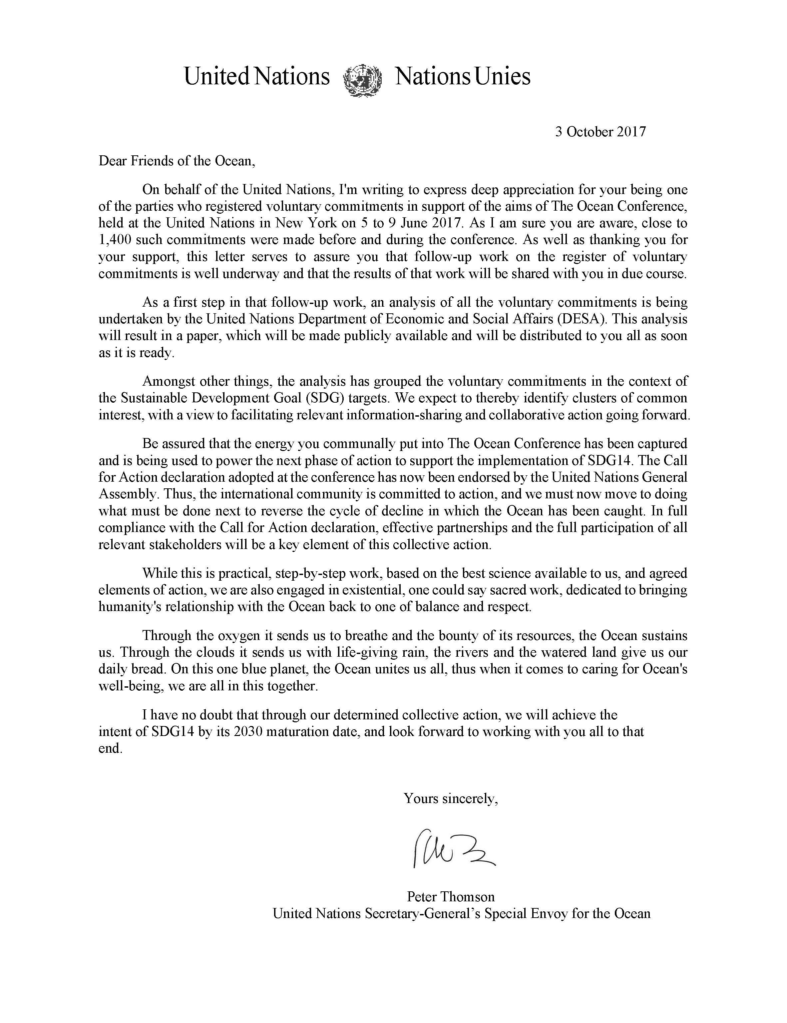

Annex J: IMO Circular Letter and Questionnaire
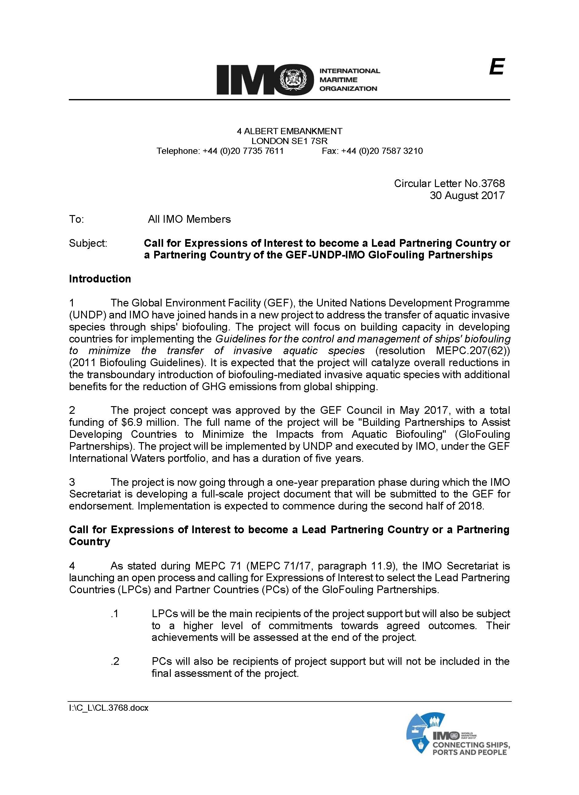

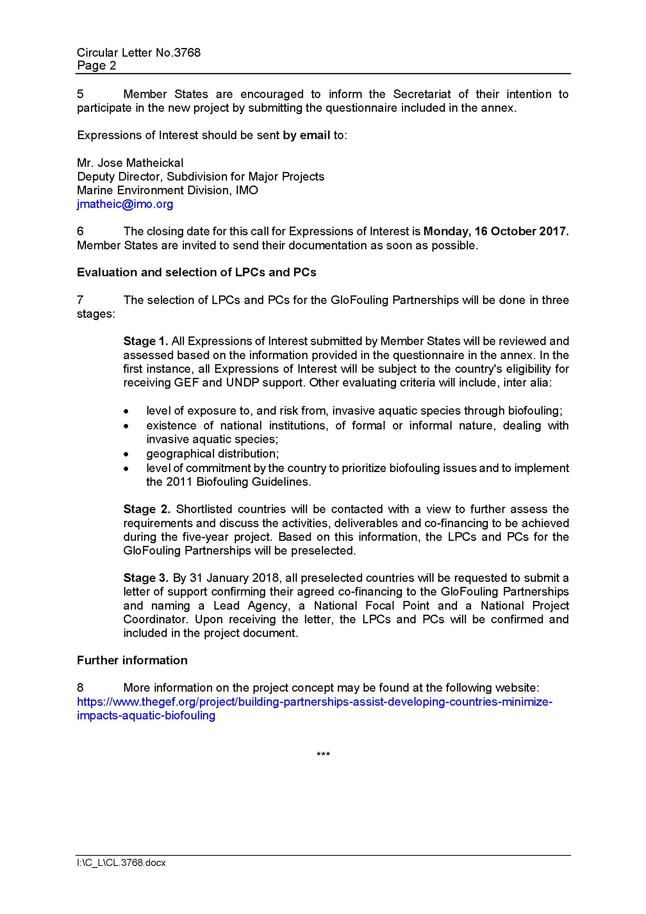

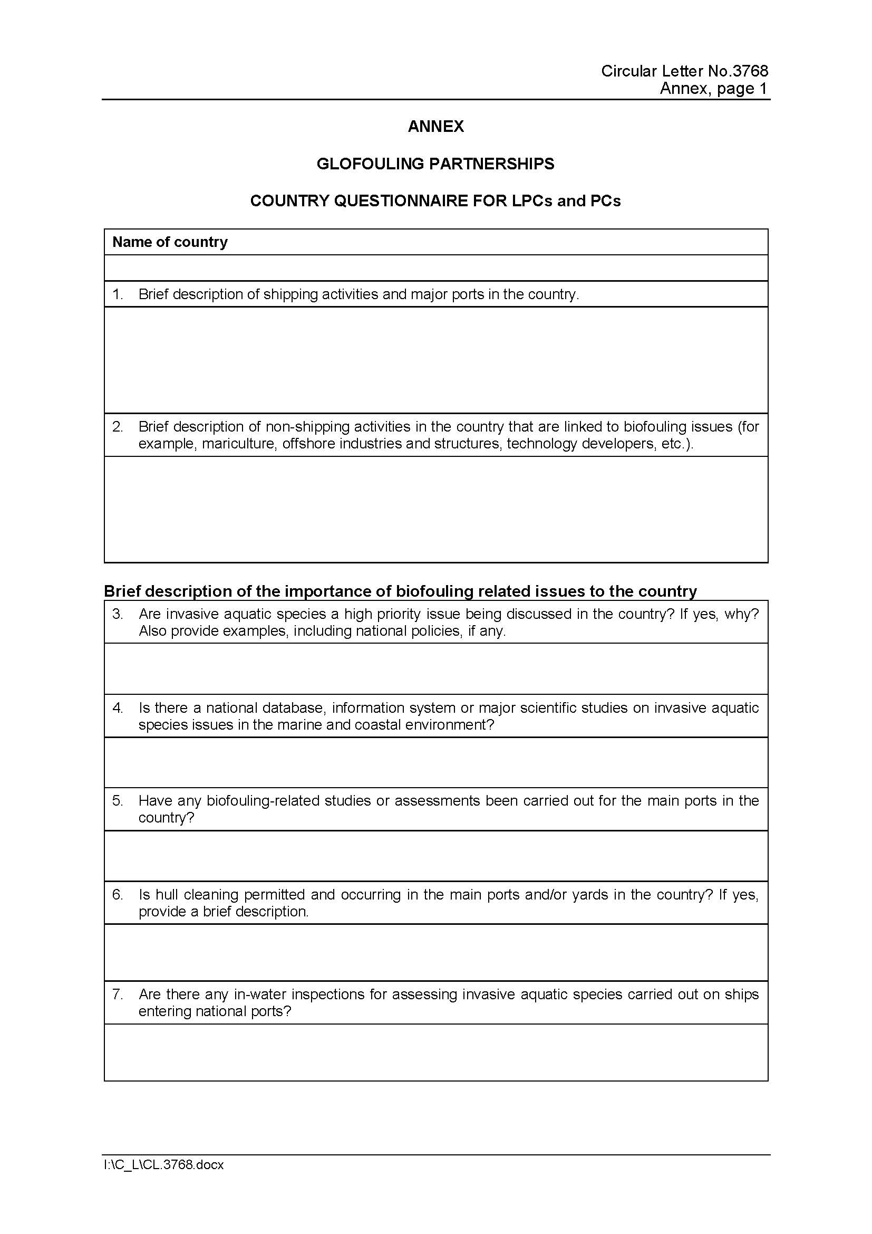
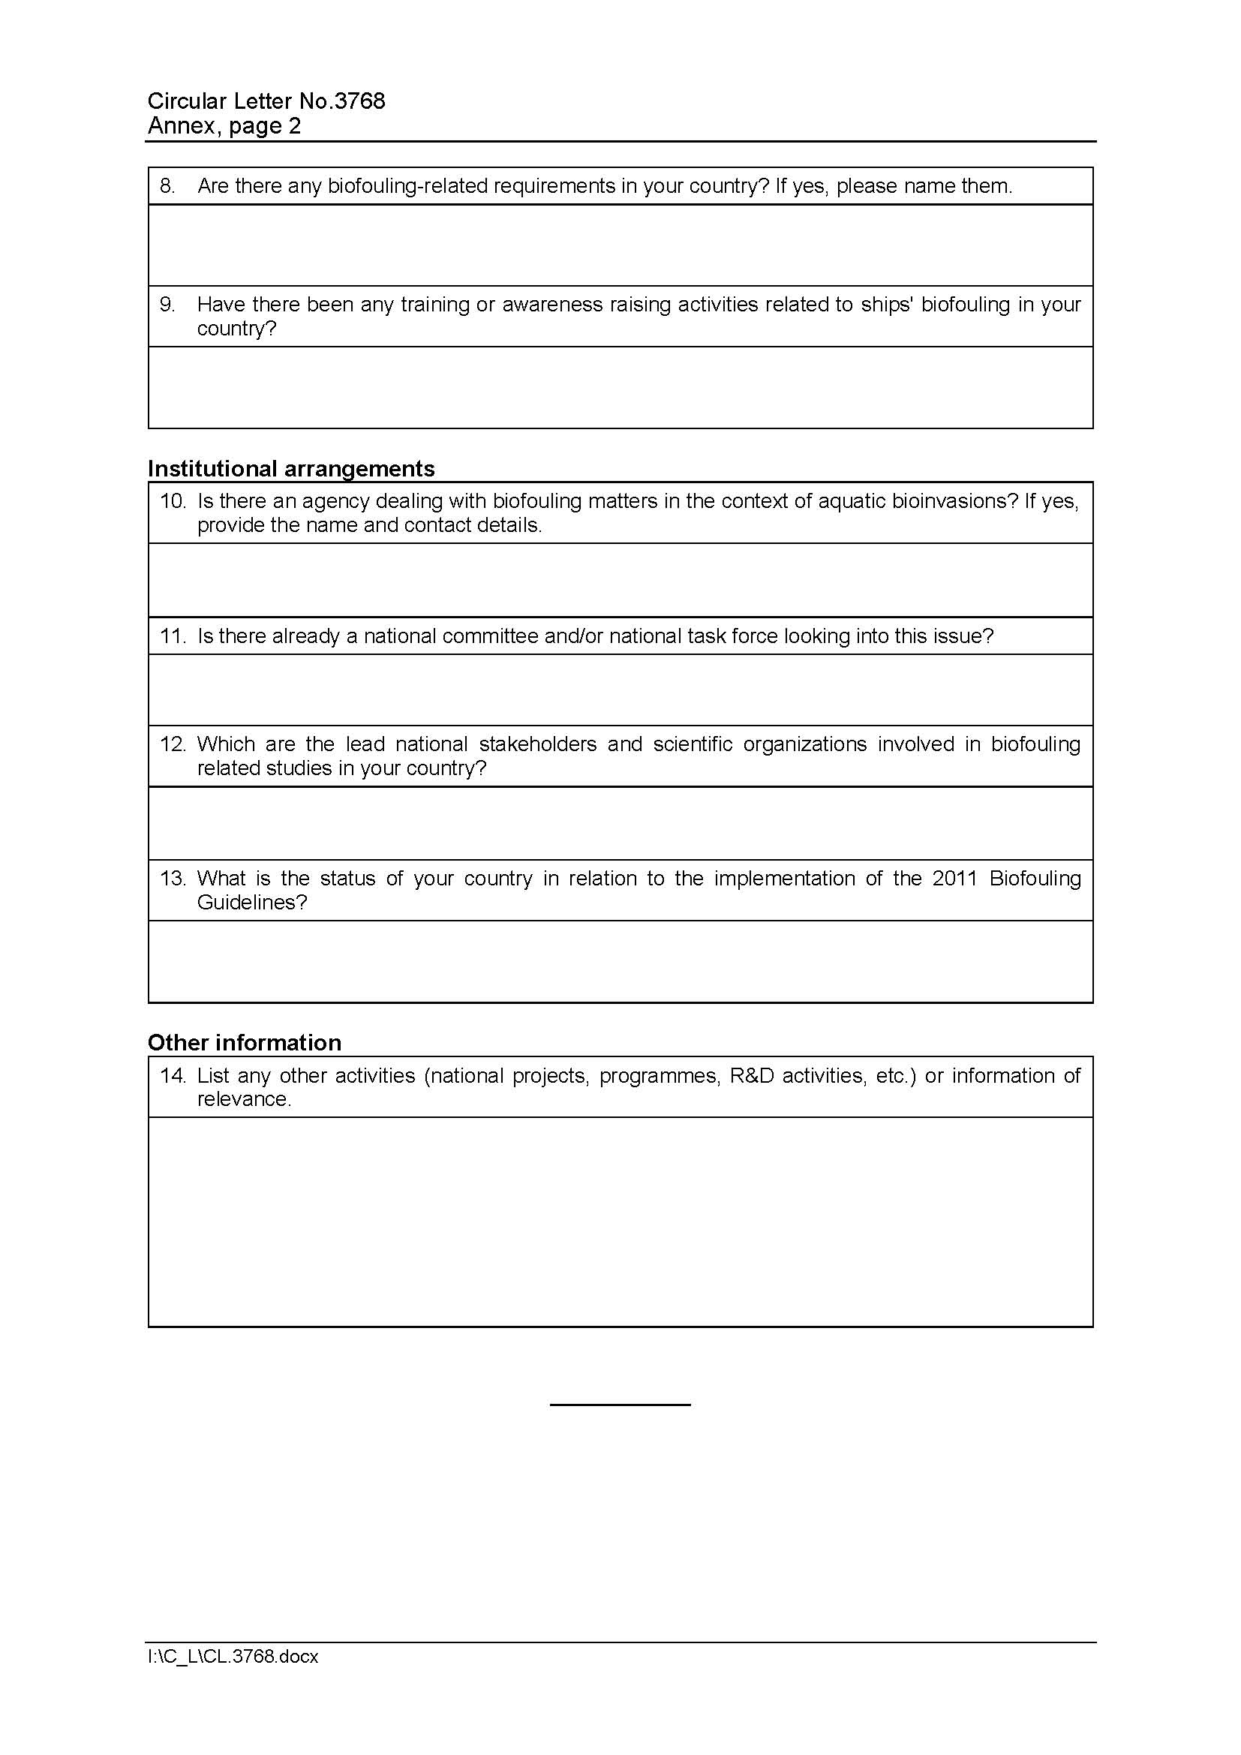

Annex K: Additional agreements

1) IMO – Letter of endorsement and co-financing table
Refer to PDF version of the Project Document

2) Executing partners – Letters of endorsement
Refer to PDF version of the Project Document

3) Lead Partnering Countries – Letters of endorsement and co-financing tables
Refer to PDF version of the Project Document

4) Partnering Countries – Letters of endorsement
Refer to PDF version of the Project Document

5) Regional Coordinating Organizations – Letters of endorsement and co-financing tables
Refer to PDF version of the Project Document

6) Developed Countries – Letters of endorsement
Refer to PDF version of the Project Document

7) Strategic Partners – Letters of endorsement
Refer to PDF version of the Project Document

8) Private sector – Letters of endorsement
Refer to PDF version of the Project Document

This number of vessels is likely to be an underestimate of the actual number of vessels transiting world oceans and some estimates of active vessels range from 120 000 to 190 000 (see Moser et al., 2016).
GEF-UNDP-IMO GloBallast Partnerships Project – Building Partnerships to Assist Developing Countries to Reduce the Transfer of Harmful Aquatic Organisms in Ships’ Ballast Water. The project ended on 30 June 2017.
The State of World Fisheries and Aquaculture 2016. Contributing to food security and nutrition for all. FAO, 2016. Rome.
An entire class of US naval destroyers, 56 ships in total as of 2011, when the report was published.
IPCC 2014 - Climate Change 2014: Mitigation of Climate Change, Working Group III Contribution to the Fifth Assessment Report of the IPCC.
Third IMO GHG Study, 2014.
Third IMO GHG Study, 2014.
Third IMO GHG Study, 2014.
LR and DNV report for IMO “Assessment of IMO Mandated Energy Efficiency Measures for International Shipping”, MEPC 63/INF.2, October 2011.
ICCT White Paper, “Reducing Greenhouse Gas Emissions from Ships Cost Effectiveness of Available Options”, 2011
ICCT White Paper, “Reducing Greenhouse Gas Emissions from Ships Cost Effectiveness of Available Options”, 2011.
IMO MEPC 72: Report of the Working Group on Reduction of GHG emissions from ships, Document MEPC 72/WP.7, 12 April 2018.
ICCT White Paper, “Reducing Greenhouse Gas Emissions from Ships Cost Effectiveness of Available Options”, 2011.
LR and DNV report for IMO “Assessment of IMO Mandated Energy Efficiency Measures for International Shipping”, MEPC 63/INF.2, October 2011.
CBD/COP/DEC/XIII/28: “Decision adopted by the Conference of the Parties to the Convention on Biological Diversity”.
Specifically Target 14.2: By 2020, sustainably manage and protect marine and coastal ecosystems to avoid significant adverse impacts, including by strengthening their resilience, and take action for their restoration in order to achieve healthy and productive oceans; Target 14.3: Minimize and address the impacts of ocean acidification, and Target 14.c: Enhance the conservation and sustainable use of oceans and their resources by implementing international law as reflected in UNCLOS, which provides the legal framework for the conservation and sustainable use of oceans and their resources, as recalled in paragraph 158 of The Future We Want.
Specifically Target 13.3: Improve education, awareness-raising and human and institutional capacity on climate change mitigation, adaptation, impact reduction and early warning.
Specifically Target 15.8: By 2020, introduce measures to prevent the introduction and significantly reduce the impact of invasive alien species on land and water ecosystems and control or eradicate the priority species.
GEF-UNDP-IMO GloBallast Partnerships Project – Building Partnerships to Assist Developing Countries to Reduce the Transfer of Harmful Aquatic Organisms in Ships’ Ballast Water.
GEF-UNDP-IMO GloMEEP Project – Transforming the Global Maritime Transport Industry towards a Low Carbon Future through Improved Energy Efficiency.
See http://www.undp.org/content/undp/en/home/operations/transparency/information_disclosurepolicy/
See https://www.thegef.org/gef/policies_guidelines
See https://www.thegef.org/gef/policies_guidelines
Excluding project team staff time and UNDP staff time and travel expenses.
see https://info.undp.org/global/popp/ppm/Pages/Closing-a-Project.aspx
See https://popp.undp.org/_layouts/15/WopiFrame.aspx?sourcedoc=/UNDP_POPP_DOCUMENT_LIBRARY/Public/PPM_Project%20Management_Closing.docx&action=default.
Prohibited grounds of discrimination include race, ethnicity, gender, age, language, disability, sexual orientation, religion, political or other opinion, national or social or geographical origin, property, birth or other status including as an indigenous person or as a member of a minority. References to “women and men” or similar is understood to include women and men, boys and girls, and other groups discriminated against based on their gender identities, such as transgender people and transsexuals.
In regards to CO_{2,} ‘significant emissions’ corresponds generally to more than 25,000 tons per year (from both direct and indirect sources).
Forced evictions include acts and/or omissions involving the coerced or involuntary displacement of individuals, groups, or communities from homes and/or lands and common property resources that were occupied or depended upon, thus eliminating the ability of an individual, group, or community to reside or work in a particular dwelling, residence, or location without the provision of, and access to, appropriate forms of legal or other protections.

